RESERVOIR FISHERIES HABITAT PARTNERSHIP
Annual Meeting
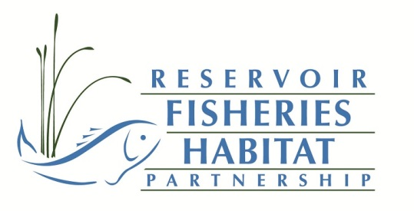
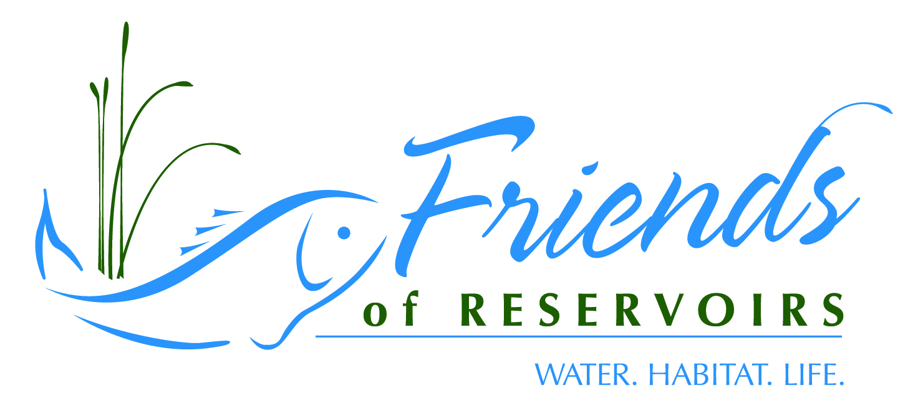
5-7 October 2018
Texas Freshwater
Fisheries Center
Athens, TX
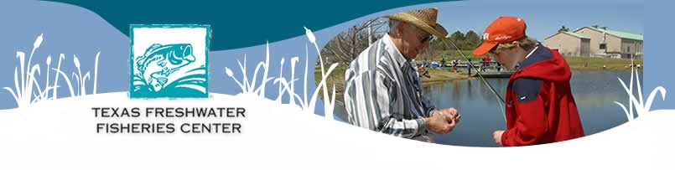

Habitat Restoration Workshop
SPONSORED BY: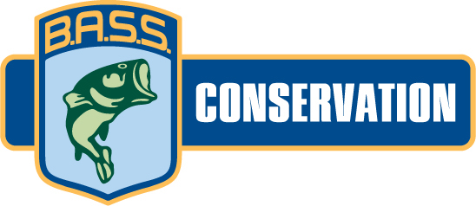
Reservoir Fisheries Habitat Partnership/Friends of Reservoirs Annual Meeting
5 October 2018 1300-1900

Reservoir Habitat Restoration Workshop
6 October 2018

Topics/Presenters
- Introduction-Jeff Boxrucker (RFHP)/Stewart Jacks (USFWS) | 0800-0810
- Permitting-Greg Pitchford (Allstate Consultants) | 0810-0840
- Woody/artificial Structure-Ben Page (PFBC) | 0840-0910
- Nuisance/Invasive Aquatic Vegetation Control-John Findeisen (TPWD) | 0910-0940
- Restoring Native Aquatic Vegetation-Rick Ott (TPWD) | 0940-1010
BREAK | 1010-1030
- Sedimentation-Mark Porath (NGPC) | 1030-1100
- Nutrient Control-Reed Green (USGS) | 1100-1130
- Shoreline Stabilization-Lynde Dodd (USACE) | 1130-1200
- Funding-Jeff Boxrucker (RFHP) | 1200-1230
LUNCH | 1230-1315
- Discussion | 1315-1400

TECHNICAL SESSIONS
1400-1420 | Quantifying Fish Habitat Impairment in Iowa's Lakes and Reservoirs- Erin Haws, Iowa Dept. of Natural Resources
1420-1440 | An Overview of Arkansas Game and Fish Large Scale Fisheries Habitat Projects- Cody Wyatt, Arkansas Game and Fish Commission
1440-1500 | Overview of Kansas' Fish Habitat Efforts- Doug Nygren, Kansas Wildlife, Parks & Tourism
1500-1520 | Turning License Plate Revenue into Fish Habitat- Dave Terre, Texas Parks & Wildlife
1520-1540 | Break
1540-1600 | Fisheries Habitat Enhancement Efforts at Possum Kingdom- Fisheries Habitat Enhancement Efforts at Possum Kingdom-Wes Dutter, Texas Parks & Wildlife
1600-1620 | Triumphs and Trials in Texas: the Enduring Tale of Lake Wichita- Tom Lang, Texas Parks & Wildlife
1620-1640 | Ft. Buenaventura Pond Rehabilitation- Kent Sorenson, Utah Division of Wildlife
1640-1700 | Preserving the Legend of Lake Fork-Carolyn West, Larry Marler and Ed Swenson, Lake Fork Sportsman’s Association
1700-1800 | Break
1800-2100 | Awards Banquet

Sunday October 7
0900-0920 | Humble Beginnings: The Lake Shelbyville Fish Habitat Alliance- Mike Mounce, Illinois Dept. of Natural Resources
0920-0940 | A New Strategic Plan for the Lake Livingston Friends of Reservoirs Restoration Project-Adding a Better Science Approach to Ensure Success and Provide Accountability-Beth Miller and Scott Ball -Lake Livingston FOR
0940-1000 | John Paul Landing-A Lesson in Partnerships- Niki Ragan-Harbison, Texas Parks & Wildlife
1000-1020 | Lake Conroe, a History of Invasive Grasses and Restoration of Native Habitat -Jeff Melton, Seven Coves Bass Club
1020-1040 | Break
1040-1100 | Incorporating terrestrial vegetation into reservoir fish habitat projects- Earl Conway, New Mexico B.A.S.S. Nation
1100-1130 | Enhancing Fish Habitat in the Highland Lakes in Central Texas- Mukhtar Farooqi, TPWD and Ron Abshier, Lake Buchanan Conservation Corps
 | Enhancing Fish Habitat at Canyon Lake, Texas- Mukhtar Farooqi, TPWD and Carl Adkins and Randy Brudniki, Canyon Bass Club of San Marcos
 | Restoring Fish Habitat at Lake Austin, Texas- Muktar Farooqi, TPWD and Brian Booker , Texas Tournament Zone

ABSTRACTS
Quantifying Fish Habitat Impairment in Iowa's Lakes and Reservoirs-Erin Haws, IA DNR (erin.haws@dnr.iowa.gov)

Freshwater ecosystems provide a diverse and extensive supply of resources to fauna and flora living within, to surrounding ecosystems, and human economies. As bodies of water evolve, so do the methods used to protect and restore them. Over the past decade, emphasis on sustaining freshwater ecosystems has led to a large expansion in the development of protective policies and restoration programs aiming to improve aquatic habitat. A recurring challenge to fish habitat restoration lies in defining impairment factors, their scale and the rate at which they are occurring in a system. Comprehensive assessments are therefore needed to identify impairments, prioritize waterbodies in need of restoration, and provide improved methods to measure local fish habitat using feasible metrics. This study provides an expansive look into lake and reservoir fish habitat in Iowa based on a survey reporting on all significant publicly owned lakes recognized by the Iowa Department of Natural Resources (DNR). The survey asked Iowa DNR Fisheries Biologists to report the degree of impairment of a set of variables for each individual waterbody in their management area. Multivariate factors were classified using the methods of Krogman and Miranda (2016), characterizing twelve broad constructs of fish habitat impairment. Study objectives include describing fish habitat impairment trends and identifying differences across lake type, watershed location, and status in the Lake Restoration Program. Future research plans aim to quantify relationships between fish habitat impairment constructs and measured water quality, physical, and biological parameters within existing datasets to evaluate the resources available to adequately measure fish habitat.

An Overview of Arkansas Game and Fish Large Scale Fisheries Habitat Projects –Cody
Wyatt, Arkansas Game and Fish Commission (christopher.wyatt@agfc.ar.gov)

In an attempt to address the loss of fisheries habitat in Arkansas’s aging lakes and respond to anglers increasing desire for additional fishable habitat, the Arkansas Game and Fish – Fisheries Division has committed to conduct two large scale habitat projects per year in Arkansas waterbodies. Since Spring 2017, three large scale projects have been conducted across Arkansas. The lakes receiving habitat are chosen by Arkansas Game and Fish Biologist from a list of waterbodies with little or dilapidated fisheries habitat structure. The type of habitat placed is dependent upon availability and the ability to feasibly get that habitat to the water. Natural woody structures (trees and brush) have been placed in Bull Shoals Lake while PVC structures have been placed in Lakes Chicot and DeGray. Labor on these projects range from 15 to 32 people per day and from 1 to 15 workdays in length. The cost of these structures range from $70 to $93 per structure with the natural woody structures being more expensive due to higher labor cost than PVC structures. Overall project costs range from $17,200 to $60,500. The efforts and logistics of these large scale habitat projects since 2017 are presented and discussed in this presentation.

Overview of Kansas' Fish Habitat Efforts-Doug Nygren, Kansas Dept. of Wildlife, Parks & Tourism (doug.nygren@ks.gov)

Kansas has a long history of fish habitat enhancements, for many years most were habitat enhancements associated with new or renovated impoundments, aquatic plant management, or by placing fish attractors. They were one-off projects as the department had no formal fish habitat enhancement program. In the mid-ninety's the agency created Federal Aid Project F34 - Fish Population Enhancement which included annual appropriations of about $200,000 per year that can be used for habitat work. This program was recently enhanced again by an additional $100,000 to fund placement of 1,000 Georgia Cubes/year in public waters. Volunteers have been an important part of our program with many individuals and NGOs assisting with the work. The El Dorado Prison has been a big partner with Georgia Cube production. Georgia Cube raw materials are cut, partially assembled, and shipped to the destination by the prison. The Department recently implemented a plan to greatly increase the number of FOR Chapters in Kansas. Currently we have 11 chapters. Most of the chapters are local governments who participate in our Community Fisheries Assistance Program (CFAP). We hope to have over 40 Chapters by the end of 2019. We intend to leverage our CFAP program with Friends of Reservoirs to greatly increase our capacity to conduct fish habitat work. We are developing a volunteer fish habitat installation training program and intend to certify successful volunteer students as "Certified Fish Habitat Specialists".Kansas also is in the process of purchasing a small scale dredge for near-shore habitat enhancements. The dredge specifications are under development and the dredge should be in-hand next spring. The dredge use will be discussed.

Turning License Plate Revenue into Fish Habitat-Dave Terre, Texas Parks and Wildlife (dave.terre@tpwd.texas.gov)
Anglers in Texas currently benefit from a unique program that turns license plate sales revenue into fish habitat projects that are supported by the Texas Parks and Wildlife Department (TPWD). Twenty two dollars of every Largemouth Bass-branded license plate sold ($30) in Texas are applied to projects that improve reservoir structural habitat, water quality, shoreline-based angling opportunities and access. Plate sales generate approximately $40,000 per year to support these projects. Since 2015, 43 projects have been conducted on 35 reservoirs statewide. Expenditures of $133,625 in plate funds have leveraged $47,380 in funding from outside sources. Project partners also provided in-kind support with materials and labor for 29 of the projects. Partners assisting in some of these projects include our Friends of Reservoir chapters; a coalition of private groups who are working with TPWD to improve fish habitat in
Texas Reservoirs
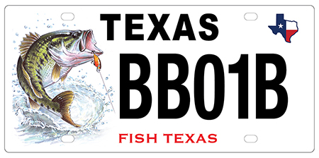

Fisheries Habitat Enhancement Efforts at Possum Kingdom-Wes Dutter, Tom Lang, Robert Mauk, and Ben Yeager, Texas Parks and Wildlife Department; (wes.dutter@tpwd.texas.gov)

Possum Kingdom (PK) is a 15,588 acres reservoir constructed in 1941 on the Brazos River approximately 75 miles west of Fort Worth, Texas. PK is a highly popular recreational boating location and has traditionally provided excellent fishing for a variety of species including Largemouth and Striped Bass. However, drought, Golden Alga, and habitat degradation through the reservoir aging process have limited the fisheries potential of PK. Despite seemingly little ability to avoid the impacts of drought or Golden Alga, in the winter of 2012, our office began dissecting the habitat issues at PK and creating a plan to mitigate their negative fisheries impacts. Developing a partnership with the controlling authority, the Brazos River Authority (BRA), ensured our efforts did not conflict with their objectives, and yielded logistical benefits. Relationships with the Hells Gate Bass Club and Mineral Wells Bass Club developed into their becoming FOR Chapters and provided a great boost to efforts as well by aiding with fundraising, logistical support, volunteer help, and providing additional perspectives on plans. Through multiple diverse funding streams including the TPWD Kills and Spills Team restitution funds, BRA contributions, Reservoir Fish Habitat Partnership grant, and local FOR Chapter matching funds; multiple habitat enhancement efforts occurred including deployment of artificial structures, aquatic vegetation planting, and natural brush sinking. Efforts began in a 1,300 acres arm of the reservoir and have spread to more than half of the reservoir to date with artificial structures seeming to be the most successful of the efforts. Vegetation plantings were hampered by water level fluctuations and archeological assurances, and natural brush efforts were delayed by an endangered bird species, which has since been delisted. While habitat enhancement efforts are relatively straightforward, efforts to streamline regulatory barriers, additional funding, and increased engagement by our FOR Chapters could further yield greater habitat enhancement efforts in the future.

Triumphs and Trials in Texas, the Enduring Tale of Lake Wichita- Tom Lang, Texas Parks and Wildlife (tom.lang@tpwd.texas.gov)
Built in 1901, Lake Wichita in Wichita Falls, Texas has served the region as a recreation destination, driving economic force, as a home for the wise-use and conservation of fish and wildlife resources, and as a foundation for community growth by serving as a drinking water source. At 117 years, Lake Wichita is the third oldest reservoir in Texas and consequently the proverbial canary in the coal mine of Texas reservoirs. Essentially, the natural reservoir aging-process (among other issues) has led to its present state of no longer being able to provide significant social, economic, ecological, or recreational benefits to the community. In 2013, an effort consisting of community volunteers, local and state government entities, foundations, and Friends of Reservoirs began the marathon process of fixing this 1,224-acre reservoir. While understanding the ecological issues and how to solve them was relatively straightforward, they are but a small portion of the efforts needed to accomplish the goal of making Lake Wichita a viable reservoir for another century. The background studies and required permitting efforts have been mountainous. Educating a community on the project efforts and benefits, cultivating and maintaining their belief in the project, acquiring and including community desires, dispelling myths, and mobilizing support have required sustained Herculean efforts. Cultivating and maintaining relationships with key community leaders, businesses, foundations, and donors have proven invaluable as the daunting price tag of the project and successful fundraising efforts and milestones have raised the attention and subsequent ire from groups supporting other community efforts and groups with conflicting ideologies. With both medals and scars acquired from the past five year’s events in hand, the Lake Wichita Revitalization Project is in the process of growing and transforming into the organization required to attain its goals. This presentation should serve as a valuable example for other reservoir projects across the country.
Ft. Buenaventura Pond Rehabilitation-Kent Sorenson, Utah Division of Wildlife (kentsorenson@utah.gov)
Ft. Buenaventura Pond is a small (3 acre) urban fishery in downtown Ogden, UT. Administration of the property has been batted around between various government entities for several years but finally brought under county control. Discussions with the county parks director resulted in a plan to restore the pond and its associated fishery accompanied by a plan to increase the longevity of the improvements. Two sediment retention ponds were planned in order to improve water quality entering the pond and various fish habitat enhancements were targeted for the pond itself. A cooperative effort between Weber County Parks and Utah Division of Wildlife resulted in a complete restoration of the pond and associated fishery for less than $18,000. Much of the associated costs were in-kind labor and equipment provided by Weber County. Nearly 900 dump truck loads of sediment were removed from the pond, gravel and rock were added to provide spawning locations and artificial habitat was placed off shore. The park has again become widely used by local anglers.

Preserving the Legend of Lake Fork-Carolyn West, Larry Marler and Ed Swenson, Lake Fork Sportsman’s Association (cwest212@hotmail.com)
The Lake Fork Sportsman’s Association (LFSA) works with partners, including the Sabine River Authority, Texas Parks and Wildlife and surrounding area citizenry to improve and promote the fishery at Lake Fork. To this end, LFSA has number of active programs, including:
  - Button Bush cultivating and planting in cooperation with Yantis High School and TPWD;
  - Aquatic grass experiment to replenish the vegetation now missing from Lake Fork, again in cooperation with Yantis High School Ag Class and TPWD;
  - LFSA’s Live Release Boat is staffed with members who work fishing tournaments and provide proper care of fish caught and weighed. These fish are diligently nurtured and released back into the lake;
  - The High School Tackle Program receives used tackle, rods, reels and lures, refurbishes them and awards the tackle to local high school fishing teams;
  - The Christmas Sharing Program is an effort to give back to the community as a special time of the year by collecting food and toys for those in need;
  - The Fingerling Release Program has developed into a community involved release of fingerlings in conjunction with TPWD. LFSA provides personnel and boats specifically to release the fingerlings in areas of good cover to increase their survivability;
  - Members are trained to become members of the TPWD Angler Education Program, teaching the smartest and safest way of catching, handling and releasing fish;
  - Complex Habitat Restoration Program is an effort in conjunction with TPWD to develop areas for fish to thrive. Using Pond King donated structures and building “Georgia Cube Style Fish Attractors”, these structures are placed in Lake Fork in various areas. Coordinates are posted on TPWD and LFSA websites.
Humble Beginnings: The Lake Shelbyville Fish Habitat Alliance-Mike Mounce, Illinois Dept. of Natural Resources and Chip Christensen, Lake Shelbyville Habitat Alliance (mike.mounce@illinois.gov)

The Lake Shelbyville Fish Habitat Alliance (LSFHA) was proposed and formed in spring 2017. It was a development due to the desperate need for coarse physical habitat in Lake Shelbyville, a typical 40+ year old Midwestern flood-control reservoir. From the initial Illinois Department of Natural Resources’ (IDNR) proposal to the U.S. Army Corps of Engineers (USACE) to purchase materials and permit the placement of 20-25 Georgia cubes in Lake Shelbyville in 2015, the chance encounter of invaluable information from underwater photographer, Eric Engbretson, a chance meeting with Chip Christensen in 2016, and angler and advocate, Bob Kerans, always asking what he can do to help the lake, the LSFHA was formed to seek funding to improve coarse fish habitat in Lake Shelbyville, specifically the Lake Shelbyville cube. In addition, an additional request to the USACE for the development of an aquatic plant nursery was realized when the USACE’s Natural Resource Specialist, Lee Mitchell, was approached by an Eagle Scout nominee, Dawson Boys, about a project for the lake. Individual anglers, fishing organizations and clubs, businesses, local communities, and additional non-governmental organizations came together in support of the LSFHA to apply, successfully, for a $30K Friends of Reservoirs’ habitat grant in fall 2017. By the end of 2018, 413 Shelbyville (66%) and/or Georgia Cubes and 100 artificial stumps will have been placed in Lake Shelbyville through the combined efforts of local donors, the LSFHA volunteers and organization, USACE, and the IDNR. In addition to the FOR grant funds, the LSFHA is seeking additional grants and local and state support for continued habitat development for years to come. Anglers have reported and documented outstanding fish use and fishing success on these structures within as little as 48 hrs. after deployment. The benefits of these fish attractors have been documented through research collaboration with the Illinois Natural History Survey. Hundreds of pots of multi-species plants have been planted in protective-exclosures in the lake in the past two years in an effort to establish a natural, self-perpetuating and self-sustaining fisheries habitat component, which is vital to the development of quality angling and improved water quality. These activities are not only considered essential for the benefit of the fisheries and angling community, but the economic health of the local and state economy as well.

A New Strategic Plan for the Lake Livingston Friends of Reservoir Restoration Project – Adding a Better Science Approach to Ensure Success and Provide Accountability-Scott Ball and Beth Miller, Lake Livingston Friends of Reservoirs (henryball415@gmail.com)

The Lake Livingston Friends of Reservoir (LLFoR) project has been underway for over 3 years. Per initial Texas Parks & Wildlife (TPWD) recommendations, we have introduced over 10,000 American Water Willows into the lake at 18 sites with the help of the local community. Per RFHP guidelines, the objective is to improve the littoral habitat, preserve shoreline and assist in improving water quality and aquatic habitat. That being said, success has not been optimal. With input from a variety of science advisors including TPWD, Texas A&M-AgriLife, Lee College Horticulture program, the Lewisville Aquatic Research Facility, the Texas Riparian Association, and the Meadows Center for Water & Environment, we have introduced an updated strategic plan to ensure better results. The new strategic plan incorporates very selective planting site selection, adding new plant species to eliminate mono-culture establishment, and establishing founder colonies for the first time. Further, to provide accountability and monitor progress, we now continually survey planted sites for growth, monitor the presence of near shore invertebrates for habitat assessment, and measure water quality at planted sites. All of the strategic additions were developed from input from a variety of science advisors and sources and will be presented to show how the new project has evolved for a better chance of success. An example from our recent May high school planting of 2,500 plants will be shown as an illustration and upcoming challenges will be presented.

John Paul Landing – A Lesson in Partnerships-Niki Ragan-Harbison, Texas Parks and Wildlife (niki.ragan@tpwd.texas.gov)

As the Houston area population continues to grow, so does the need for family recreation and angling opportunities. Harris County Precinct 3, a far-sighted Parks and Recreation Department, has been developing better ways to meet those recreation needs with many new parks and conservation areas. The newest of these, John Paul’s Landing, stands out from the rest because it was purposefully built for fishing and will eventually boast approximately 400 surface acres of water just north of Katy. The concept of John Paul’s Landing was created over 10 years ago, with the idea that lake excavation would provide soil for the inevitable construction of major development projects nearby. Not being ones to do anything half-way, Harris County Precinct 3 sought out input on all aspects of the lake, wetlands, prairie, and nature center in preparation for the day they would finally break ground. In addition to partnering with Texas Parks and Wildlife, local developers, and other conservation groups, last year HCP3 granted the Magnolia West Anglers Club (the high school fishing team) permission to enlist as a Friends of Reservoirs Chapter for the lake.

Lake Conroe, a History of Invasive Grasses and Restoration of Native Habitat-Jeff Melton, Seven Coves Bass Club (jeff_melton@sbcglobal.net

Lake Conroe has a long standing history of invasive species, eradication, and regrowth of invasive species. Seven Coves Bass Club has an 11+ year history of working with Texas Parks and Wildlife, and the San Jacinto River Authority to control invasive species and restore native vegetation, and artificial fish habitat. Projects have included constructing an aquatic nursery using Federal Grant Money, transplanting native grasses into the lake, constructing “Spider Blocks” of cinder blocks, bamboo, and flexible irrigation tubing, and “Georgia Style" PVC fish attractors. As a result of historic flooding down-stream of Lake Conroe during Hurricane Harvey, Lake Conroe’s lake levels will now be seasonally lowered during the peak of hurricane season. This potentially will leave newly transplanted native grasses high and dry during much of the growing season. Seven Coves Bass Club looks to the future to help restore shallow water cover in Lake Conroe to enhance the survival rates of fry.

Incorporating terrestrial vegetation into reservoir fish habitat projects-Earl Conway, New Mexico B.A.S.S. Nation (way2busy2fish@aol.com)
Field observations from New Mexico reservoirs have led to some initial conclusions about the role of terrestrial plants on fish habitat and some novel opportunities for human intervention to expedite the propagation of beneficial native plant species. Surface area matters when it comes to growing fish food in an aquatic environment. While installing artificial habitats and brush piles is beneficial, there is no way to compete with the substrate natural aquatic and flooded terrestrial vegetation provides for periphyton. But in fluctuating reservoirs, where aquatic vegetation is severely limited or just high and dry most of the year, then terrestrial plants can fill an important gap in the ecosystem by providing carbon, surface area, structure and soil stabilization. Western plants have had less than 200 years to evolve to an environment where it may be submerged for half of the year and far fro the shoreline the rest of the year. Being limited to only local native plants, over 100 plant species were evaluated for fish habitat. Each plant has its own quirks and challenges that have to be overcome ranging from seed collection and preparation to protection from beavers and other herbivory. Only a handful of plants were selected for long-term propagation based upon costs, availability of seeds or pole cuttings, rate of growth, durability after inundation, soil match, and many other factors. Priority plants selected include cocklebur, Goodding’s willow, honey mesquite, four-winged saltbush, Pennsylvania smartweed and broom dalea. A variety of sedges occur naturally and provide dense ground cover in some areas. The Elephant Butte project provides some answers to creating an annual new lake effect, but begs for more research in this field.

Enhancing Fish Habitat at Canyon Lake, Texas- Mukhtar Farooqi, Texas Parks and Wildlife and Randy Brudnicki, Canyon Bass Club of San Marcos

Enhancing Fish Habitat in the Highland Lakes in Central Texas- Mukhtar Farooqi, Texas Parks and Wildlife and Ron Abshier, Lake Buchanan Conservation Corps

Restoring Fish Habitat at Lake Austin, Texas - Mukhtar Farooqi, Texas Parks and Wildlife and Brian Booker, Texas Tournament Zone
Correspondence author: Marcos DeJesus (Marcos.DeJesus@tpwd.texas.gov)

Texas is home to numerous public reservoirs, mostly built during the mid-20th century. Many of these reservoirs are showing signs of aging, though they still support very important fisheries of the state. Texas Parks and Wildlife Department (TPWD) fisheries biologists have been dedicated to restoring degraded habitat to maintain angler success for decades. These projects are costly and labor intensive; therefore, hard for small management teams to do on their own and be effective. Partnerships with stakeholders are key to completing these projects at a scale that makes an impact. Friends of Reservoirs (FOR) has created a platform for agencies to generate dedicated partnerships to complete higher scale fish habitat projects. In central Texas, three FOR chapters have partnered with TPWD for several years to complete fish habitat projects at four major reservoirs. Canyon Lake, Lake Buchanan, Inks Lake, and Lake Austin have ongoing projects that utilize a diversity of fish habitat structures to enhance their fisheries. Diversifying habitat structure types is a strategy used to address multiple species or even maintaining effectiveness within a site for longer periods, as seen in these cases. With these partnerships, we can maintain enhanced fishing experiences in central Texas for years to come.

