Reservoir Fisheries Habitat Partnership
Annual Meeting Minutes (October 4, 2019),
Hollywood Casino, Kansas City, Kansas
(Minutes are intended to complement reports in the 2019 Briefing Book (appended to this report)

- Meeting called to order by RFHP Coordinator, Jeff Boxrucker at 1300 CST.
- Call for Proxies:
  - Doug Nygren for Gary Martel (NEAFWA)
  - Dave Terre for Ken Kurzawski (AFS)
  - Don Wiley for Craig Walker (WAFWA)
  - Lynde Dodd for Jeremy Crossland (USACE)
- Executive Committee (EC) members present: Doug Nygren, Dave Terre, Brad Tribby, Reed Green, Jeff Lucero, Reed Green, Kevin Pope and Gene Gilliland, ; 12 Board members present (including proxies); quorum established.
- Welcome and Introductions of attendees:
  - Jeff Lucero, US Bureau of Reclamation (EC)
  - Dave Terre, Texas Parks and Wildlife, SEAFWA (EC)
  - Gene Gilliland, B.A.S.S. (EC)
  - Doug Nygren, Kansas Department of Wildlife Parks and Tourism, MWFWA and NFHP Board(EC) (Proxy for Gary Martel)
  - Brad Tribby, BLM (EC)
  - Reed Green, NALMS (EC)
  - Kevin Pope , USGS (EC)
  - Reed Green, NALMS (EC)
  - Don Wiley, Utah Division of Wildlife, W Working Group (Proxy for Craig Walker)
  - Mark Porath, Nebraska Game and Parks Commission, MW Working Group
  - Jeff Boxrucker, RFHP Coordinator
  - Ben Page, PA Fish and Boat Commission, NE Working Group
  - Mark Fowlkes, NC Wildlife Resources Commission, SE Working Group
  - Sandra Clark-Kolaks, Indiana DNR, MW Working Group
  - Rebecca Krogman, IA DNR, MW Working Group
  - Jeremy Shifflet, KY Dept. of Fish & Wildlife, SE Working Group
  - Joseph Zimmerman, KY Dept. of Fish & Wildlife
  - Pat Sollberger, NV Dept. of Wildlife, W Working Group
  - Michael Homer, TX Parks and Wildlife, SE Working Group
  - Karin Eldridge, FWS
  - Kent Sorenson, Utah Division of Wildlife
  - Natalie Boren, Utah Division of Wildlife
  - Jeff Conley, KS Wildlife Parks & Tourism

Old Business:
- Meeting minutes from 2018 Annual Meeting minutes (Atens, TX) were provided to Executive Committee and Working Group members prior to the meeting.
  - Motion to accept minutes by Terre; Second by Tribby. Motion passed unanimously.
- Financial Report given by Boxrucker, details in Briefing Book.
  - Motion to accept by Pope; Second by Krogman. Motion passed unanimously.

EC welcomed Lynde Dodd (USACE) and Michael Homer (TPWD) to the SE Working Group

Accomplishments under FY2019 Work Plan
- See report in Briefing Book

FY2019 Work Plan
- See report in Briefing Book
  - Sandy-Clark Kolaks suggested that a 2-page color with pictures Annual Report would be valuable as an outreach tool; concurrence was expressed by those in attendance;
    - Coordinator stated that he would provide a draft to EC and WG members of the 2019 Annual Report for review
    - Work Plan edited to reflect above.
Project Updates
- See Briefing Book
- FWS Allocation for RFHP was a level 2 for FY2019
  - Lack of climate change consideration in project-selection criteria stated as reason for Level 2
    - Reed Green volunteered to provide additional information on reservoir effects on climate change for FY2020 Allocation Report

Project Selection (Proposals in Briefing Book)
- 13 proposals submitted for FY2020 funding
  - Total funding request: $289,790; Total project costs: $1,317,456
- Boxrucker recommended funding Proposals ranked 1 - 4 for $150,000 total and to fully fund FOR Operations at $85,000. Krogman/Gilliland; passed unanimously
- EC voted to restrict funding to projects that have previously been funded at the 2017 Annual Meeting; system was approved to deduct 25 points for funded projects that were resubmitted within 3 fiscal years
  - 2 projects ranked in the top 4 were deducted 25 points (Shelbyville-ranked 2; Carlyle-ranked 3)
- Discussion followed on how to further address funding resubmitted proposals
  - Several ideas discussed; motion (Krogman/Gilliland) was made to fund projects at 100% of request on first proposal submission; 50% on second submission; 25% on third submission; motion passed 6/5
- Discussion on partner-funding period in proposal; suggested that only partner funds attributed to the project timeline be counted (as opposed to previously funded projects on impoundment)
- Coordinator suggested that the Working Groups get together on a conference call to discuss changes to the FY2021 RFP and project scoring
Small Projects Grant
- 7 grant proposals received
- Discussion followed re: the need to develop scoring criteria given that increased number of proposals is expected in coming years
- Coordinator recommended that all 4 Small Grant Proposals be accepted
  - Discussion followed and motion made to fund 5 small project grants (Pope/Terre); Passed unanimously
    - Friends of Barren River Lake
    - Tri-County Bass Anglers
    - Friends of Lake Livingston
    - Lake Fork Sportsman’s Association
    - City of Cherryvale
Mossback Grant
- Mossback agreed to fund 3-$1000 product grants for FY2019
  - 8 applications received
  - Discussion followed and motion made to fund VA B.A.S.S. Nation, Ft. Worth Fly Fishers, and Friends of Horse Thief Reservoir (Pope/Terre); Passed unanimously

FOR Updates: These updates constituted the FOR Executive Committee Meeting (called
to order at 1500; members present were Dave Terre, Gene Gilliland, Rebecca Krogman, Doug Nygren)
- Boxrucker provided update on FOR progress. Seventeen new FOR Chapters and five Group Member joined in 2019
  - 21 Kansas Community Fishing Program members added (not included in above counts; KWPT paid membership for first year)
  - As of September 30, 2019, FOR has 64 Chapter and 36 Group Members (100 total in 30 states)
    - Texas-26 members
    - Illinois-14 members
    - Pennsylvania-7 members
    - B.A.S.S. Nation-18 State Conservation Affiliates
- Grant programs are the single most effective recruiting tool
  - Numerous organizations have joined in the past few years to either get bonus points for the large grant program (FWS-funded) or to become eligible for the FOR Small Grants Program and the Mossback Grant
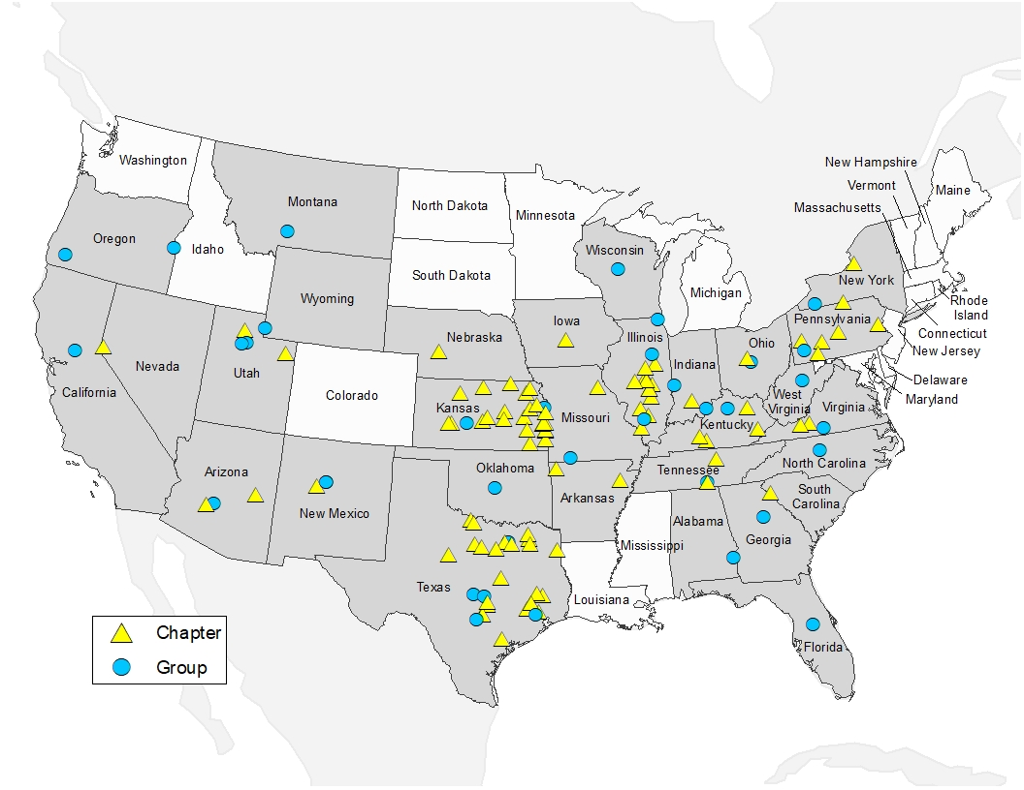
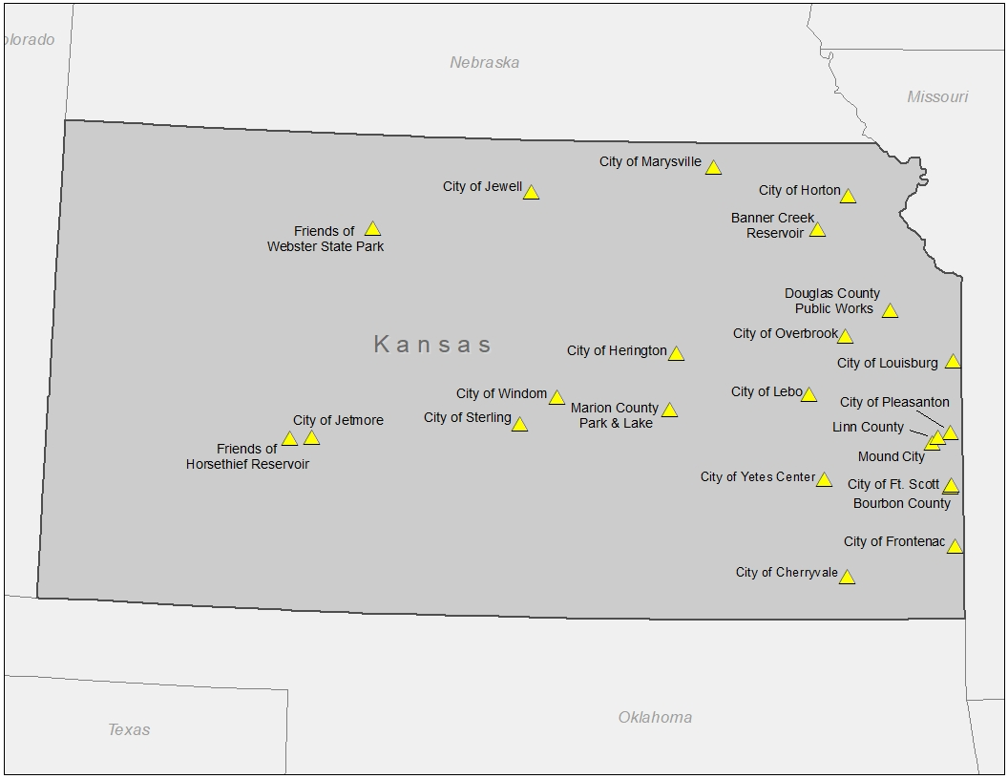
FY2019 Budget
- See Budget in Briefing Book
  - Considerable discussion was held on means to increase social media presence
    - Targeted fund raising around events (Bassmaster Classic, ICAST)
    - Targeted fund raising around individual projects
  - Coordinator will work with Outreach Committee (Terre, Gilliland, Krogman, Tribby) to bring ideas to EC via conference calls
      - $10,720 in FY2020 budget
  - Motion to approve FY2020 budget by Pope; Second by Nygren; Motion passed unanimously
- FOR meeting was adjourned at 1600

Technical Program
- Geoform (Sam Minnich) provided information on small hydraulic dredge and attendees could view dredge in parking garage
  - KWPT purchased dredge in 2019; reporting that may need to dedicate staff to dredge operation to be efficient
- Envirotubes gave presentation on using tubes to dispose of/ form berms with dredge material
- Habitat Restoration Workshop (1/2-day) was attended by 55 people (see program appended to the minutes)
  - Very positive feedback on content and applicability
- Welcome message was given by Brad Loveless (Secretary, Kansas Wildlife Parks and Tourism)
- Representatives from 5 Kansas Community Fishing Program municipalities were in attendance
- An open discussion on potential effects of microplastics resulting from artificial fish habitat structures was held
  - Concerns were noted but no definitive science was available
  - Agreed to continue to follow the issue in the scientific literature and work with the Southern Division American Fisheries Society Reservoir Committee to keep members apprised of the latest developments/information
- The Technical Program was highlighted by a presentation by Dr. Andrew Norris from the Queensland (Australia) Department of Agriculture and Fisheries
  - Dr. Norris attended the 2015 RFHP Annual Meeting in Ogden, UT and made site visits to several states (PA, MO, TX, NE) to learn of aquatic habitat programs in the U.S.
  - Dr. Norris reported on advances in the Queensland habitat programs over the past 4 years
- Technical presentations (15) covered projects several statewide habitat programs (NC, IN, TX), 3 presentations on watershed programs and how they relate to reservoir water quality (AR and KS)
  - The program is appended to these minutes
  - Annual Meeting Sponsors:
    - Kansas Wildlife Parks & Tourism ($3000)
    - B.A.S.S. Conservation ($500)

2020 Annual Meeting
- Site will be in the MWAFWA region; Shelbyville, IL suggested
  - Coordinator work with Local Arrangements Committee to secure venue

Meeting adjourned at 1800

RESERVOIR FISHERIES HABITAT PARTNERSHIP
Annual Meeting
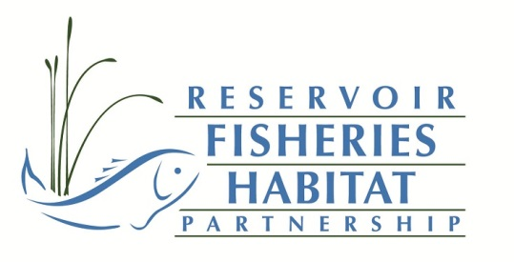
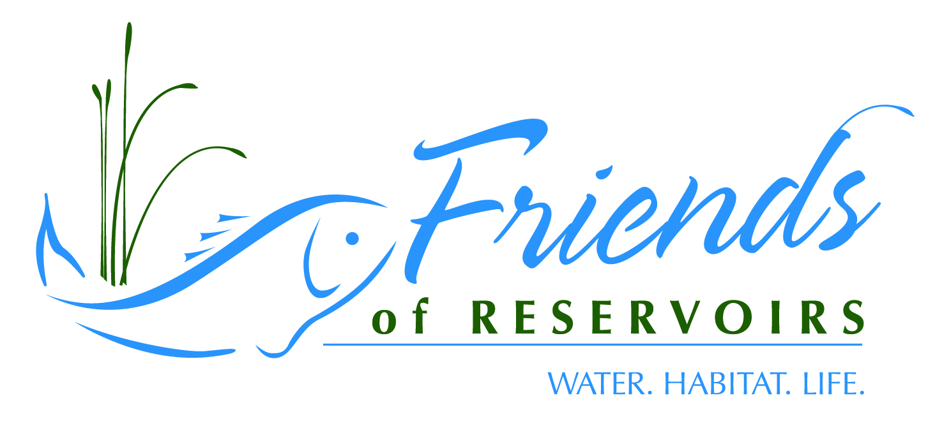
4-6 October 2019
Hollywood Casino
Kansas City, KS

Sponsored By:

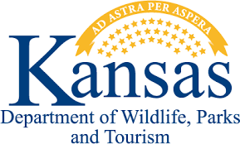

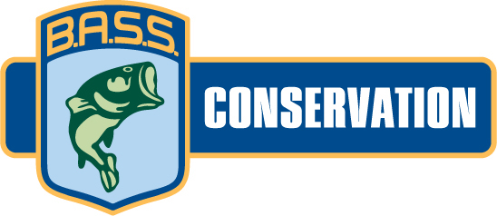
Reservoir Fisheries Habitat Partnership/Friends of Reservoirs Annual Meeting
4 October 2019
0900-1130 | Dredge Demonstration-Sam Minnich, Geoform
1130-1300 | Lunch
1300-1700 | RFHP/FOR Business Meeting

Reservoir Habitat Restoration Workshop
5 October 2018
Topics/Presenters
- Introduction/How to Select a Project-Jeff Boxrucker (RFHP) | 0800-0830
- Permitting-Greg Pitchford (Allstate Consultants) | 0830-0900
- Woody/artificial Structure-Ben Page (PFBC) | 0900-0930
- Nuisance/Invasive Aquatic Vegetation Control-Jeff Slipke-Midwest Lake Management | 0930-1000
- Restoring Native Aquatic Vegetation-Gene Gilliland (B.A.S.S.) | 1000-1030
BREAK | 1030-1050
- Sedimentation-Mark Porath (NGPC) | 1050-1120
- Nutrient Control-Reed Green (USGS) | 1120-1150
- Shoreline Stabilization-Lynde Dodd (USACE) & Jeremy Shiflet (KY Wildlife Resources) | 1150-1220
LUNCH | 1220-1300

TECHNICAL SESSIONS
1300-1320 | Welcome-Brad Loveless, Secretary KWPT, Introductions-Jeff Boxrucker
1320-1340 | Reservoir Fisheries Habitat Restoration is too Big a Job for Any one Agency to Tackle: Partnering and the Friends of Reservoirs Role in its Promotion-Jeff Boxrucker, RFHP
1340-1410 | Open Discussion on Microplastics-Dave Terre
1410-1440 | The value of sharing knowledge – Queensland’s experience with reservoir fisheries habitat management-Andrew Norris, Dept. of Agriculture & Fisheries, Queensland, Australia
1440-1500 | Water Injection Dredging (WID) Demonstration at Tuttle Creek Lake-Josh Olson, Kansas Water Office
1500-1630 | Break
1530-1550 | Conserving Water Quality in Kansas through the WRAPS Program-Travis Sieve, Kansas Department of Health and Environment
1550-1610 | Habitat Restoration at Harris Lake, North Carolina-Clinton Morgeson and Mark D. Fowlkes, NC Wildlife Resources Commission
1610-1630 | Friends of Lake Livingston: New Approaches to Restoring Aquatic Plants to a Turbid Reservoir-James Langley, Lee College
1630-1800 | Break
1800-2100 | Banquet

Sunday October 7
0900-0920 | Rockport Reservoir Habitat Augmentation-Kent Sorenson, Utah Division of Wildlife Resources
0920-0940 | Watershed Protection – How It Is Being Approached by the Beaver Watershed Alliance, Clell Ford, Beaver Watershed Alliance
0940-1000 | Status of the Watershed-Upper White River Basin-David Casaletto, Ozarks Water Watch
1000-1020 | Sediment Management in the Desert-Earl Conway, Sun Country Outdoors
1020-1040 | A Summary of Habitat Enhancement Efforts at Reservoirs Within the Lone Star State-Michael D. Homer Jr., Texas Parks & Wildlife Department
1040-1100 | Lessons in Establishing Aquatic Plants in Lakes and Reservoirs- Michael J. Mounce, IL DNR
1100-1120 | The Lake Shelbyville Fish Habitat Alliance: Year 2 update- Michael J. Mounce, IL DNR
1120-1140 | Indiana’s Reservoir Habitat Enhancement Program: Four Lake in Four Years-Sandy Clark-Kolaks, IN DNR
 | Lunch

ABSTRACTS
Reservoir Fisheries Habitat Restoration is too Big a Job for Any one Agency to Tackle: Partnering and the Friends of Reservoirs Role in its Promotion-Jeff Boxrucker, Reservoir Fisheries Habitat Partnership; jboxrucker@sbcglobal.net
The task of restoring habitat in the nation's reservoirs is a multijurisdictional challenge and cost prohibitive for a federal and/or state agency to accomplish without partnering with other public and private organizations or individuals. The Reservoir Fisheries Habitat Partnership (RFHP) recognizes that reservoir fisheries habitat impairments are often extensions of poor land-use practices in the respective watersheds. RFHP works to bring agencies and local organizations and individuals together to address habitat impairments at the local scale. RFHP and the Friends of Reservoirs Foundation have a membership and grant program that encourages local groups to work with state fisheries biologists to ensure that projects enhance fisheries management plans. RFHP has conducted a habitat impairment assessment of reservoirs nationwide to help prioritize activities. Funded projects have focused on native vegetation restoration, structure addition and shoreline stabilization. Future projects look to partner with organizations to address watershed impairments to improve water quality and habitat in downstream impoundments.

The value of sharing knowledge – Queensland’s experience with reservoir fisheries habitat management- Dr Andrew Norris, Senior Fisheries Biologist, Department of Agriculture and Fisheries, Queensland, Australia

Knowledge can be acquired in many ways. It can be gained through observation, trial and error, experimentation or mimicry. However, one of the most effective and efficient ways is through knowledge sharing. Learning what works and what does not work from others means past mistakes and learnings are not repeated, and instead the pool of knowledge is expanded. Organizations such as the Reservoir Fisheries Habitat Partnership and Friends of Reservoirs enable the willing exchange of knowledge and ideas, facilitating more rapid learning for individual partners as well as the collective group. Learning from these organizations and their partners has led to the commencement of impoundment fisheries habitat projects in Queensland, Australia. The value of managing aquatic habitats in impoundments to improve fisheries has typically been overlooked in Australia. In 2015 I visited the USA to investigate how reservoir habitats were managed to benefit recreational fisheries. Meeting with many members of the Reservoir Fisheries Habitat Partnership and Friends of Reservoirs allowed me to access data and knowledge which helped convince Australian fisheries and waterways managers that habitat enhancement was management tool worth exploring further. Habitat enhancement trials have been established in three impoundments in Queensland, Australia, with each waterbody addressing the response of a different suite of native fish to the introduction of structural habitat. Key goals for these projects include assessing fish response to various structure types, assessing angler attitudes and catch rates, determining the most cost effective and appropriate structure types for Australian conditions and demonstrating to waterway managers that the introduction of fish attraction structures do not have detrimental impacts to waterway operation or safety.
Water Injection Dredging (WID) Demonstration at Tuttle Creek Lake-Josh Olson, Kansas Water Office

Tuttle Creek Lake, like many of the other Kansas reservoirs, is losing storage capacity due to sedimentation at an accelerated rate. Recent estimates from the Kansas Water Office (KWO) indicate that approximately 48% of Tuttle Creek Lake’s original capacity has been lost due to sedimentation, causing a variety of negative impacts to the reservoir, including the reduction of fish habitat. In order to address this issue and promote sustainable long-term reservoir sediment management, the KWO, in partnership with the Corps of Engineers, plans to implement a Water Injection Dredging (WID) demonstration project at Tuttle Creek Lake. WID is a process in which large volumes of water are injected at low pressure into the sediment bed near the bottom of the reservoir through the use of pumps and a series of nozzles located on a horizontal pipe positioned above the sediment bed. The injected water effectively fluidizes the sediment creating a ‘density current’ that allows the sediment to flow by gravity to deeper areas. In the case of Tuttle Creek Lake, the proposed WID demonstration project would be aimed at moving the sediment toward the existing low-level outlet in the dam and monitoring the flow of the density current through the outlet during controlled discharges, restoring lost reservoir storage.

Conserving Water Quality in Kansas through the WRAPS Program-Travis Sieve, Kansas Department of Health and Environment; travis.sieve@ks.gov
The Kansas Department of Health & Environment (KDHE) implements the Watershed Restoration and Protection Strategy (WRAPS) program with the intent to repair and maintain water quality in Kansas water bodies. Through this holistic approach, Kansas citizens become involved in a framework to identify watershed restoration and protection needs, establish local goals, create action plans, and to ultimately implement the outlined strategies in the plans. Funded through Clean Water Act section 319 and Kansas State Water Plan funds, the WRAPS program continues to build partnerships with state/federal agencies, local governments, as well as industry. WRAPS strategies involved traditional cost-sharing, information and education, incentives, and equipment purchases. Each strategy implemented in the WRAPS program is dependent on the culture of the watershed, its unique individuals, and the water quality impairments needing mitigation.
Kansas reservoir protection is of great importance to the state and has become a high priority to the WRAPS program. KDHE supports WRAPS projects around each of the major reservoirs in Kansas to not only improve water quality, but to address future sustainability.

Habitat Restoration at Harris Lake, North Carolina-Clinton Morgeson and Mark D. Fowlkes, NC Wildlife Resources Commission

Harris Lake is a 1,680-ha impoundment of White Oak and Buckhorn creeks, tributaries of the Cape Fear River, and is located 35-km southwest of Raleigh, North Carolina. It is a productive eutrophic reservoir that supports a multi-species fishery consisting of Largemouth Bass Micropterus salmoides, Black Crappie Pomoxis nigromaculatus, sunfish species, Channel Catfish Ictalurus punctatus, White Catfish Ameiurus catus, Bullhead Catfishes Ameiurus spp., and White Perch Morone americana. Bassmaster Magazine ranked it 4th in the nation for best bass lakes in America and first in the southeast region in 2017. Hydrilla Hydrilla verticillata, a federally noxious weed, has been in the reservoir since the late 1980’s. It has been identified as a source population and Hydrilla has spread into other water bodies, including the Cape Fear River and Jordan Lake. To control Hydrilla, the North Carolina Division of Water Resources stocked 1,400 triploid Grass Carp Ctenopharyngodon idella in December 2018. The potential loss of habitat may result in changes in fish behavior and could decrease angler catch rates. Offering other natural and artificial structures, including native aquatic vegetation for fish to utilize could help maintain angler catch rates and satisfaction. The North Carolina Wildlife Resources Commission is leading efforts to improve aquatic habitat in the reservoir. The project objectives are to: 1) develop and implement a 5-year aquatic habitat enhancement project in Harris Lake with public input and assistance, and 2) establish and expand coverage of native aquatic macrophyte communities (0.4 hectare of founder colonies) and install at least 12 hectares of artificial and natural structure (≈700 fish attractors) to improve physical habitat by 2023. The Commission sought input from anglers and other partners to develop a 5-year Habitat Enhancement Plan for Harris Lake. Between 2018 and 2019, the Commission installed 63 additional artificial reef sites (323 structures) and planted aquatic vegetation at 33 locations.

Friends of Lake Livingston: New Approaches to Restoring Aquatic Plants to a Turbid Reservoir-James Langley, Lee College
FOLL has been working with six Independent School Districts in the Lake Livingston area to culture and plant water willow in suitable areas of Lake Livingston. success has not been optimal. With input from a variety of science advisors including TPWD, Texas A&M-AgriLife, Lee College Horticulture program, the Lewisville Aquatic Research Facility, the Texas Riparian Association, and the Meadows Center for Water & Environment, we have introduced an updated strategic plan to ensure better results. The new strategic plan incorporates very selective planting site selection, adding new plant species to eliminate mono-culture establishment, and establishing founder colonies for the first time. Our partners at TDC Ellis/Lee Horticultural have begun experimenting with six new aquatic plant species. Once they've perfected propagation techniques, plants will be distributed to the high schools in preparation for fall planting. The new plants include:
- Emergent Species: Bulrush: Giant (Schoenoplectus califoricus) & American Water-Willow (Justica Americana)
- Submerged Species:Water Stargrass& (Heteranthera dubia)
- Floating Leaved Species:&Yellow Water Lily, Spatterdock or Cow Lily (Nuphar luteum) and American Lotus (Nelumbo lutea)
Rockport Reservoir Habitat Augmentation-Kent Sorenson, Utah Division of Wildlife Resources
Yellow perch are a popular sport fish in Utah and creel surveys indicate those waters with strong populations typically rank as some of the most used waters in the state. Fishery managers in Utah have been looking to improve the consistency of yellow perch recruitment in their steep, canyon shaped reservoirs for a number of years as fisheries can often go five years or more without a strong year class of perch. It was thought this inconsistency was due to a lack of nursery cover in the littoral zone during the early life stages of fish as Utah’s reservoirs typically experience annual drawdowns of up to 55 vertical feet, rendering the shallow areas of the reservoir devoid of cover at all but full pool elevations. Now new research in North America and Europe is demonstrating that yellow perch and their closely related cousins, European Perch, are tolerant of moderately hypoxic water (4.5-2.0 mg/L) and may not need littoral cover to recruit fish and maintain populations. European perch (Perca fluviatilis) juveniles have been abundantly found in areas associated with deep moderately hypoxic waters, suggesting they are using these waters as refuge from predators and exclusive feeding areas. In 2018 and 2019, fishery managers in Utah observed similar activity by juvenile yellow perch, capturing them in gill nets in the deep, moderately hypoxic waters of the hypolimnion of Rockport Reservoir, Utah. This new research has led Utah to shift its focus from enhancement of littoral habitat to enhancing habitat in deep water areas where portions of the juvenile yellow perch population are now suggested to reside. Shortly after documenting fish using bathypelagic areas of the reservoir, proposals were then drafted to place artificial habitat in deep water areas of the reservoir as refuge for young perch to utilize during periods when the reservoir is mixed. Several structure types (all BOR/water district approved) were added over the deep basin portion of the reservoir. Bathymetric mapping pre- and post-placement of structure was completed and netting was done to substantiate sonar evidence. Subsequent sampling planned over the next few years will determine if consistency in recruitment has been achieved.
Summary of Habitat Enhancement Efforts at Reservoirs Within the Lone Star State-Michael D. Homer Jr., Texas Parks & Wildlife Department, Michael.Homer@tpwd.texas.gov
Reservoir ageing greatly diminishes quality of fisheries by impairments such as siltation, loss of littoral and aquatic vegetation as well as structural habitat, changes in water regimes, and eutrophication. Reservoir habitat impairments will worsen and further degrade quality of fisheries unless major steps are taken to remediate them. In Texas, the Largemouth Bass Conservation License Plate Program has funded numerous fish habitat restoration and enhancement projects in reservoirs. Since 2015, about $200,000 of CLP funding has been used to support nearly 60 habitat enhancement projects in Texas’ reservoirs. Partnerships such as the Reservoir Fish Habitat Partnership, the Brazos River Authority, and others have been crucial to the success of the fish habitat improvement projects by generating funding support, manpower support, and further communicating the need of habitat enhancement to communities. Strategies for fish habitat enhancement efforts have included the development of brush piles, deployment of fabricated artificial structures, pier enhancements, installation of aerators, and erosion control. Development of improved evaluation strategies is necessary to ensure habitat enhancement efforts are producing desired results and to assess changes in habitat and angling quality.

Watershed Protection – How It Is Being Approached by the Beaver Watershed Alliance, Clell Ford, Beaver Watershed Alliance
The Beaver Watershed Alliance, a 501(c)3 non-profit based in Springdale, Arkansas, was formed in 2011 to carry out the mission of proactively protecting, enhancing and sustain the water quality of Beaver Lake and maintaining the integrity of its watershed. Beaver Lake, a USACE reservoir completed in 1965, serves as the drinking water supply for nearly a half-million Arkansans, and is the engine that drives the continued growth of corporations such as JB Hunt Trucking, Tyson Foods, and of course Wal Mart. For an 1192 square mile watershed, with land uses dominated by pasture and poultry agriculture, and with Arkansas’ third largest city in its headwaters, there are a lot of challenges and opportunities that daily help us address meet our mission. The Alliance approaches the task armed with the Beaver Lake Watershed Protection Strategy, the first EPA approved nine-element watershed protection strategy in Arkansas. This talk will introduce the Beaver Lake Watershed, the Alliance, and the many activities that we are undertaking to help the development that is inevitable in a rapidly growing area, grow in concert with the needs to protect the Lake and its Watershed.
Status of the Watershed-Upper White River Basin-David Casaletto, Ozarks Water Watch
The Upper White River Basin Foundation, now doing business as Ozarks Water Watch (OWW), was formed as a 501(c) 3 charitable foundation in 2002 by a group of local businessmen with a vision to have the four lakes in the Upper White River watershed, Beaver, Table Rock, Taneycomo and Bull Shoals, the cleanest manmade lakes in North America. The mission of OWW is to promote water quality in the Ozarks area through bi-state collaboration and research, education, public policy and action projects basin-wide, in both Arkansas and Missouri. OWW provides water quality education and awareness to the business community, elected officials and the general public about the status of the water quality throughout the upper White River watershed through the publication and distribution of the annual Status of the Watershed report. This report compiles water quality monitoring samples collected by volunteers. This monitoring work is essential to providing an accurate assessment of where water pollution problems may exist in the watershed. OWW administers this volunteer water quality monitoring network throughout the Upper White River watershed in Arkansas and Missouri. OWW was also instrumental in bringing the governors of Arkansas and Missouri together to sign the Bi-State Shared Water Agreement on November 28, 2008 that allows the states to work on mutual water quality and quantity issues across state boundaries
Sediment Management in the Desert, Earl Conway, President, Sun Country Outdoors
Dams don’t last forever, but the sediments that move within the watersheds do. A vision of New Mexico without reservoirs is pretty dismal. Agriculture in the Lower Rio Grande and Pecos communities would be gone. Farmlands would revert to worthless weeded fields. Economic development in Las Cruces and El Paso would be curtailed due to domestic water shortages. Subsistence farming in Texas and Mexico would also be severely impacted. Any recreational or environmental use of the reservoir would also be lost and the dams would become a threat to anyone downstream of them, for fear of that inevitable day when it will breach and all of the trapped sediments will make their way down the river in uncontrollable floods. Picture a 200-foot wall of dirt piled up behind the dam as a flood tops the aging spillway. A new whitepaper, Reservoir Sediment Management: Building a Legacy of Sustainable Water Storage Reservoirs, was recently released that roadmaps a path to avert a national crisis.

Lessons in Establishing Aquatic Plants in Lakes and Reservoirs- Michael J. Mounce, IL DNR
Desirable species of aquatic vegetation can provide significant aquatic habitat, curb shoreline erosion, improve water quality, and can become self-establishing, resulting in enhanced aesthetics and improved angling quality. Illinois has many species of aquatic plants and some are very well suited to providing habitat in small impoundments as well as large. Methods of establishing aquatic plants are not well studied and long-term success can be difficult to achieve. Substrate and propagule treatments, like rooting hormone, soil sulfur, macro-nutrients, and aeration enhance planting survival and allow for increased area affected. Planting site variation is highly significant and successful plantings are expanded. Additionally, methods and timing of planting and maintenance practices that have been used, with some evaluated in central Illinois and elsewhere will be presented and discussed.

The Lake Shelbyville Fish Habitat Alliance: Year 2 update- Michael J. Mounce, IL DNR
The Lake Shelbyville Fish Habitat Alliance (LSFHA) was proposed and formed in spring 2017. Typical 48+ year old Midwestern flood-control reservoir, Lake Shelbyville was in desperate need for coarse-physical and aquatic-macrophyte habitat. Through chance encounters of invaluable information from underwater photographer, Eric Engbretson, the Lake Shelbyville cube developed, modeled after the original Georgia Cube design. Through additional chance meetings with local businessman, Chip Christensen, and long-time angler advocate, Bob Kerans, the LSFHA was formed. In addition, a long-desired aquatic plant nursery was developed by Dawson Boys, an Eagle Scout nominee. Individual anglers, fishing organizations and clubs, businesses, local communities, and additional non-governmental organizations came together in support of the LSFHA to apply, successfully, for a $47K Friends of Reservoirs’ habitat grant in fall 2017. Through donations by only angler and local business, 413 Shelbyville (66%) and/or Georgia Cubes and 70 artificial stumps were placed in the lake by December 2018, with many additional structures to be built in 2019 with FOR funds (300+). In February, 2018 the first Annual Fish Habitat Banquet was held, with an unexpected $20,900 dollars of profit realized. The recently developed “Adopt-a cube” program has raised over $3,000 since October, 2018. Anglers have reported and documented such outstanding fish use of the Lake Shelbyville cube, they have suggested discontinuing building the Georgia cube in the future. The benefits of these fish attractors have been documented through research collaboration with the Illinois Natural History Survey. Hundreds of pots of multi-species plants have been planted in protective-exclosures in the lake in the past three years, with some outstanding success. However, long-term summer flooding in 2019 devastated some of the most successful plantings but has not yet been fully evaluated. These activities are not only considered essential for the benefit of the fisheries, the angling community, and local businesses directly tied to angling, but the economic health of the local and state economy as well.

EXECUTIVE COMMITTEE BRIEFING BOOK
2019 RESERVOIR FISHERIES HABITAT PARTNERSHIP
Hollywood Casino
Kansas City, Kansas
4 October 2019

Friday, October 4
1300-1310 | Welcome/Introductions
1310-1320 | Approval of Minutes/Financial Statement¹(Pages 2-7)
1320-1330 | 2018 Coordinator Work Plan Accomplishments (Pages 8-10)
1330-1345 | 2019 Work Plan (Pages 11)
1345-1400 | Project Updates (Pages 12)
1400-1515 | FY2019 Project Selection¹ (Pages 13-22)
1515-1530 | BREAK
 | FOR MEETING
1530-1545 | FOR Membership Update (Page 23-24)
1545-1600 | FY2019 Budget¹ (Page 25)
1600-1615 | Raystown Lake-Ben Page
1615-1730 | Expand outreach efforts

Proxies
Doug Nygren for Gary Martel (NEAFWA)
Dave Terre for Ken Kurzawski (AFS) ¹Action Items
Don Wiley for Craig Walker (WAFWA)
Lynde Dodd for Jeremy Crossland (USACE)

Annual Meeting Minutes (October 5, 2018),
Texas Freshwater Fisheries Center, Athens, TX
(Minutes are intended to complement reports in the 2018 Briefing Book (appended to this report)

- Meeting called to order by RFHP Coordinator, Jeff Boxrucker at 1400 CST.
- Call for Proxies:
  - Doug Nygren for Gary Martel (NEAFWA)
  - Mark Porath Kevin Pope (USGS)
  - Don Wiley for Craig Walker (WAFWA)
- Executive Committee (EC) members present: Doug Nygren, Dave Terre, Brad Tribby, Reed Green, Jeff Lucero, Ken Kurzawski, Reed Green and Gene Gilliland; 11 Board members present (including proxies); quorum established.
- Welcome and Introductions of attendees:
  - Jeff Lucero, US Bureau of Reclamation (EC)
  - Dave Terre, Texas Parks and Wildlife, SEAFWA (EC)
  - Gene Gilliland, B.A.S.S. (EC)
  - Doug Nygren, Kansas Department of Wildlife Parks and Tourism, MWFWA and NFHP Board(EC) (Proxy for Gary Martel)
  - Brad Tribby, BLM (EC)
  - Reed Green, NALMS (EC)
  - Ken Kurzawski , AFS (EC)
  - Reed Green, NALMS (EC)
  - Don Wiley, Utah Division of Wildlife, W Working Group (Proxy for Craig Walker)
  - Mark Porath, Nebraska Game and Parks Commission, MW Working Group (proxy for Kevin Pope)
  - Jeff Boxrucker, RFHP Coordinator
  - Ben Page, PA Fish and Boat Commission, NE Working Group
  - Mike Swartz, PA Fish and Boat Commission
  - Tom Lang, AFS Fish Habitat Section and NFHP Board
  - Sandra Clark-Kolaks, Indiana DNR, MW Working Group
  - Rebecca Krogman, IA DNR, MW Working Group
  - Jeremy Shifflet, KY Dept. of Fish & Wildlife, SE Working Group
  - Joseph Zimmerman, KY Dept. of Fish & Wildlife
  - Pat Sollberger, NV Dept. of Wildlife, W Working Group
  - Rick Ott, TX Parks and Wildlife, SE Working Group
  - Karin Eldridge, FWS
  - Stewart Jacks, FWS
  - Kent Sorenson, Utah Division of Wildlife
  - Colton Dennis, Arkansas Game and Fish, SE Working Group
  - Cody Wyatt, Arkansas Game and Fish

Old Business:
- Meeting minutes from 2017 Annual Meeting minutes (State College, PA) were provided to Executive Committee and Working Group members prior to the meeting.
  - Motion to accept minutes by Green; Second by Porath. Motion passed unanimously.
- Financial Report given by Boxrucker, details in Briefing Book.
  - Motion to accept by Green; Second by Gilliland. Motion passed unanimously.

NFHP Performance Evaluation:
- See Briefing Book
  - Doug Nygren and Tom Lang, NFHP Board Members, comprised one of three 2-member review teams
    - RFHP scored in the top 5 of the 20 FHPs
    - Discussion ensued on how to improve the scores
      - Coordinator and review team members led the discussion
        - Focus was on how diverse the FHPs were and that many of the scoring criteria were focused on flowing waters
        - The low score on Criteria 11 (Conservation Priorities) was problematic for many other FHPs; time bound metrics are problematic to develop for a national scale effort over a 3-year period

Accomplishments under FY2018 Work Plan
- See report in Briefing Book
  - Strategic Plan was completed
  - “News” items submitted on the website and distributed to those signed up to receive them has taken place of the formal newsletter
    - 29 “News” items were distributed from January-September, 2018
  - Annual reports were not developed
  - Online project proposal submission and scoring were completed
FY2018 Work Plan
- See report in Briefing Book
  - Coordinator discussed coordination efforts with USACE re: the Sustainable Rivers Program and development of a strategy to include natural resources concerns with any strategy to address infrastructure updating associated with aging reservoirs
    - Current discussions include flood control, navigation, water supply, hydropower
    - Jeff Lucero asked to have BOR included in those discussions
    - Coordinator plans to continue to work with USACE and other partners to address this issue and develop a “white paper” or similar strategy to take to USACE and BOR
    - MSCG ($20,000) was submitted to NFHP and approved by AFWA to help fund this effort

FY2018 Budget
- See Budget in Briefing Book
  - Considerable discussion was held on needs to update website
    - Outreach Committee has several suggestions on needs after working with content over the past 9 months
      - Suggestion to poll FOR partners on needed updates
    - R. Krogman will work with Wood Street to get cost estimate for designated needs
  - Motion to increase website budget to $10,720 by Nygren; Second by Porath; Motion passed unanimously

FOR Updates: These updates constituted the FOR Executive Committee Meeting (called
to order at 1530; members present were Dave Terre, Gene Gilliland, Rebecca Krogman, Doug Nygren
- Boxrucker provided update on FOR progress. Four new FOR Chapters and one Group Member joined in 2018
  - As of Sept 30, 2018 FOR has 47 Chapter and 31 Group Members (78 total in 26 states)
    - Texas-22 members
    - Illinois-12 members
    - Pennsylvania-6 members
    - B.A.S.S. Nation-14 State Conservation Affiliates
  - Grant programs are the single most effective recruiting tool
    - Numerous organizations have joined in the past few years to either get bonus points for the large grant program (FWS-funded) or the to become eligible for the FOR Small Grants Program and the Mossback Grant
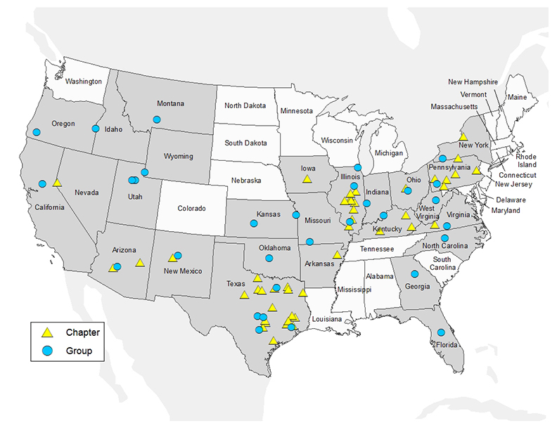
- Habitat Restoration Workshop was attended by 75 people (see program appended to the minutes)
  - Very positive feedback on content and applicability
- Technical presentations (16) covered projects in Texas (8) and several statewide habitat programs (IA, AR, KS)
  - The program is appended to these minutes
  - Annual Meeting Sponsors:
    - B.A.S.S. Conservation ($500)
- URL for new website: www.friendsofreservoirs.com
  - Online project submission and scoring system was discussed
  - Suggestion to include “Youth Involvement” in RFP
    - Coordinator will update RFP and send to Working Groups for review
- FOR meeting was adjourned at 1600
2019 Annual Meeting
- Site will be in the WAFWA region; location to be determined
Project Updates
- See Briefing Book

Project Selection (Proposals in Briefing Book)
- 12 proposals submitted for FY2019 funding
- Anticipate a Level 2 funding for FY2019
  - Total funding at Level 2 expected to increase over $140,000 from FY2018
    - Continued reduction in FWS indirect costs
- Boxrucker recommended funding Proposals ranked 1 - 5 for $150,000 total and to fully fund FOR Operations at $75,000.
- Given that an undetermined increase in project funds are expected, FWS (Eldridge) recommended submitting additional projects to FWS for funding consideration
- Motion was made to submit projects ranked 1-9 to FWS for funding consideration and fund projects in numerical order until funds are depleted. If the last project in the ranking cannot be fully funded, Coordinator will contact the project leader to see if their objectives can be met with funds available. If so, those funds will be applied to that project. If not, funds will be offered to the highest ranked project that will accept them. Gilliland/Porath; Passed unanimously.
- Coordinator noted that the Executive Committee voted in 2017 to only fund those projects that are “shovel ready”. The Hiddenwood project (ranked 8) was predicated on a dam rebuild. Coordinator will check with SD Game and Fish to determine if the project is shovel ready by the time that projects need to be submitted.
Small Projects Grant
- Coordinator recommended that all 4 Small Grant Proposals be accepted (see Briefing Book). Motion made by Nygren/Krogman. Passed unanimously.
- Mossback announced at the meeting that they would fund 3-$1000 product grants similar to 2017;
  - EC thanked Mossback for contribution
  - Coordinator will get RFP out ASAP with a November 15 deadline for proposals
  - Proposals will be ranked; forwarded to Mossback for review and projects selected prior to December 31. Meeting adjourned at 1800
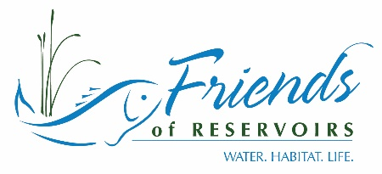
Financial Report
(1 Oct 2018- 30 Sept 2019)

Friends of Reservoirs (Bank of America)
Beginning Balance (1 October 2018) $ 24,450.87
Deposits
Grants | $ 85,000.00
RFHP Operations | 75,000.00
NFHP MSCG Grant (Workshop/BMP Manual update) | 10,000.00
FOR membership | $ 2,645.75
Sponsorship | $ 3,000.00
KWPT (2019 Annual Meeting | 3,000.00
Meeting Registration | $ 7,169.55
2018 Annual Meeting | 3,700.00
SDAFS Workshop | 1,369.55
2019 Annual Meeting | 2,100.00
Donations | $ 367.17
Amazon Smile | 25.17
Rebeca Krogman-Rising Star Award | 250.00
Chip Christensen | 50.00
Network for Good (off Facebook) | 42.00
TOTAL | $ 98,182.47
Expenses
Coordinator Salary | $ 60,000.00
Bank Fees | $ 14.00
PayPal Fees | $ 46.70
Travel | $ 5,828.81
Postage | $ 72.69
2018 Tax Return | $ 275.00
ASA Membership | $ 500.00
Website | $ 708.25
2018 Meeting Expense | $ 6,861.33
Grant Distribution | $ 9,600.78
2018 Small Projects Grants | 4,000.00
MS State Univ (Climate Change-BMP) | 5,000.00
7 Coves Bass Club (Conroe project) | 600.78
Office Expense | $ 192.59
Legal (CMP; 501(c)(3) renewal) | $ 260.06
TOTAL | $ 84,360.21
Ending Balance (30 September 2019) | $ 38,273.13

ANNUAL MEETING INCOME/EXPENSE-2018
Texas Freshwater Fisheries Center,
Income
Donations (B.A.S.S.) |  | $ 500.00
Registration |  | $ 3,700.00
Total Income |  | $ 4,200.00
Expenses
Food/Breaks |  | $ 2,802.83
Copies |  | $ 233.19
 | Speaker Travel |  | $ 1,210.74
Days Inn (Rooms) |  | $ 2,870.13
Awards |  | $ 684.79
Total Expenses |  | $ 7,801.88
Net |  | $ 3,601.88

RESERVOIR FISHERIES HABITAT COORDINATOR
2018-2019 Work Plan

- Work with Communication Committee to promote/market FOR/RFHP
  - Develop annual report of RFHP/FOR activities to host on website for distribution to partners
    - No annual report was developed
  - Attend scientific meetings
    - Southern Division of AFS
      - Habitat Restoration Workshop at SDAFS
        - 50 attendees at Workshop
          - Registration=$1,369.55
          - Speaker Travel=$2,236.13
    - AFS (Reno, NV)
      - Did not attend (conflict with RFHP Annual Meeting)
    - Explore options to host Habitat Restoration Workshop at MWFWC and Western Division AFS Meeting
      - Plan to hold next workshops at SDAFS in Little Rock and 2020 Annual Meeting in Columbus, OH
  - Continue populating/updating website
    - See meeting minutes for website updates (Rebecca Krogman)
- Solicit projects for funding
  - Refine project selection criteria (as needed)
    - Modify online submission and review on website (as needed)
      - Changes made as recommended by Working Groups (minor tweaks)
  - Distribute RFP (late May)
    - Proposal deadline (15 August)
    - Distribute project proposals to Regional Working Groups for scoring
    - Summarize projects and scores for 2019 RFHP Annual Meeting
    - Provide information to FWS
      - Received 13 large grant applications
      - Received 8 Mossback; 7 Small Grant applications
      - Scoring and ranking accomplished by deadline-See Briefing Book
  - Ensure timely reporting and accounting of funded projects
    - All FY2017 and earlier projects completed, and final reports submitted
    - FY2018:
      - Glendale and Minsi completed final reports due December 31;
    - Shelbyville and Elephant Butte on schedule for December 31 completion
  - Work with project partners and FWS to submit project compliance documents
    - FY2019
      - IAA for Lewisville and Nolin River being processed
      - Compliance documents for Harris nearing completion
      - Compliance documents for Buckeye in development
  - Update RFHP and NFHP Project Databases
    - Updates completed through FY2018
- Liaise with other NFHP Partnerships
  - Advance goals of NFHP
    - Attend NFHP Board Meetings (either in person or via webinar)
      - Attended October 2018 Board Meeting and FHP workshop
    - Serve on Partnership Committee
      - Participated in FHP and Partnership Committee conference calls
  - Work with Ohio River Basin FHP and partners on wetland construction effort on Harsha Lake
    - Participated in discussions (conference calls) with OH DNR, OH River Basin FHP and USACE on plans to move forward
      - OH DNR working with USACE to develop comprehensive watershed management plan and appropriate “on-the-ground” restoration strategies
  - Continue efforts to partner with USACE on Sustainable Rivers Program
    - Multiple conference calls to discuss program; specifically, SRP activities on the Des Moines River
    - Working with partners to develop strategy to include in-reservoir restoration practices in addition to restoration of riverine portions of system
    - Attended workshop in Des Moines to brainstorm opportunities and related strategies
- Serve as Business Manager for RFHP
  - Work with Executive Committee to:
    - Establish budget for operations of RFHP (excluding project funding)
      - See Briefing Book
    - Produce financial report for annual meeting
      - See Briefing Book
    - Compile income/expense statement and provide to accountant for completion of FOR tax return
      - Income tax filed by deadline
  - Continue bi-monthly Executive Committee conference calls
    - Calls in February, April, June, August
  - Complete FWS Allocation packet
    - Packet completed by deadline
    - RFHP received 2 out of 3 (limited by climate change activities)
      - Total allocation: $209,118
        - RFHP Operations: $83,118
        - Projects: $126,000
          - Funded top 4 scoring projects (Harris, Lewisville, Buckeye, Nolin River)
  - Work with local arrangements to schedule/arrange accommodations for RFHP meetings
    - Produce and distribute minutes of Annual Meeting
      - Accomplished and distributed after meeting
      - See Briefing Book
    - 2019 meeting in West (Arizona, Nevada)
      - Held 4-6 October at the Hollywood Casino, Kansas City, KS

RESERVOIR FISHERIES HABITAT COORDINATOR
FY2020 Work Plan

- Develop FY2019 Annual Report; provide draft for review
  - Upon establishment of template work on reports from previous years
- Work with Communication Committee to promote/market FOR/RFHP
  - Attend scientific meetings
    - Southern Division of AFS
      - Habitat Restoration Workshop at SDAFS
    - AFS (Columbus, OH)
  - Add content to website and expand available features;
  - Expand social media presence
- Solicit projects for funding
  - Refine project selection criteria (as needed)
    - Modify online submission and review on website (as needed)
  - Distribute RFP (late May)
    - Proposal deadline (15 August)
    - Distribute project proposals to Regional Working Groups for scoring
    - Summarize projects and scores for 2019 RFHP Annual Meeting
    - Provide information to FWS
  - Ensure timely reporting and accounting of funded projects
  - Work with project partners and FWS to submit project compliance documents
  - Update RFHP and NFHP Project Databases
- Liaise with other NFHP Partnerships
  - Advance goals of NFHP
    - Attend NFHP Board Meetings (either in person or via webinar)
    - Serve on Partnership Committee
  - Continue efforts to partner with USACE on Sustainable Rivers Program
- Serve as Business Manager for RFHP
  - Work with Executive Committee to:
    - Establish budget for operations of RFHP (excluding project funding)
    - Produce financial report for annual meeting
    - Compile income/expense statement and provide to accountant for completion of FOR tax return
  - Continue bi-monthly Executive Committee conference calls
  - Complete FWS Allocation packet
  - Work with local arrangements to schedule/arrange accommodations for RFHP meetings
    - Produce and distribute minutes of Annual Meeting
- 2020 meeting in Midwest (Iowa?)

PROJECT UPDATES:
2014
Rockport Reservoir Fish Habitat Improvement
Completion was delayed while details of a new MOU with BOR were being worked out; project completed, and final report submitted
2015
All projects completed
2016
Lake Russell Shoreline and Deepwater Habitat Enhancement
All 5 of these USACE projects were covered under a single IAA; final report submitted and approved.
Underwater Structure Enhancement for West Point Project
Rend Lake Fishery Habitat Enhancement Project
Delaware Lake Fish Habitat Structure and Monitoring
Dale Hollow Lake- Trooper Island Improvement Project
2017
Easter Lake Restoration Project
Completed and final report submitted and approved
Carlyle Lake Habitat Improvement
Final report submitted and approved
Roosevelt Lake Habitat Enhancement Project
Final report submitted and approved
Reservoir Fisheries Habitat Partnership Coordination and Operational Support
Final report submitted and approved
2018
Lake Shelbyville Fish Habitat Development and Restoration Project
Project end date 12/31/2019
Glendale Lake Habitat Improvement Project
Project completed; final report being developed
Minsi Lake Habitat Improvement Project
Project completed; final report being developed
Elephant Butte Adapt-a-Cove
Project end date is 3/31/2020
Reservoir Fisheries Habitat Partnership Coordination and Operational Support
Project end date is 10/31/2019
2019
FWS award letter did not go out until 8/20/2019; compliance documents canot be submitted prior to that date.
Control Hydrilla and enhance aquatic habitat in Harris Lake, North Carolina
Compliance documents nearing completion (lacking SHPO)
Nolin River Lake Habitat Improvement Project
IAA drafted by USACE and submitted to FWS
Lewisville Lake Fisheries Restoration
IAA drafted by USACE and submitted to FWS
Buckeye Lake Fish Habitat Partnership
Compliance documents in development
Reservoir Fisheries Habitat Partnership Coordination and Operational Support
Project approved: start date-11/1/2019; end date-10/31/2020

RESERVOIR FISHERIES HABITAT PARTNERSHIP
Project Proposal Summary-FY2020

Lake Barkley Habitat Improvement Project -submitted by USACE (FOR Partners)*
Lake Barkley is a mainstem impoundment created in 1966 and is the last and largest reservoir in the Cumberland River system. It is managed by the USACE for flood control, navigation, power generation, and recreation. The fisheries are managed jointly by the Kentucky Department of Fish and Wildlife Resources (KDFWR; 45,600 acres) and the Tennessee Wildlife Resources Agency (TWRA; 12,000 acres). The Land Between the Lakes National Recreation Area makes up the majority of the western shoreline and provides a relatively undeveloped shoreline. According to creel surveys in both states, anglers make an average of over 300,000 fishing trips to Lake Barkley annually. As the reservoir has aged it has lost most of its original flooded terrestrial cover. Large expanses of open water, heavy recreational boating activity, and the current water regime have resulted in a shoreline prone to erosion and largely devoid of vegetation. For much of the lake’s history, the drawdown to winter pool began on June 15th and the initial drawdown was quite rapid which allowed for the proliferation of button bushes out to an elevation of 357 ft above sea level. However, in 1980 the summer pool duration was extended by delaying the start of the winter drawdown to July 5th. Although unintended, this extension of 20 more days of summer pool likely resulted in the eventual mortality of the deeper button bushes. Current stands of button bush are limited to a depth of ~358 ft above sea level. Because summer pool elevation is 359 feet above sea level, this leaves only 1 foot of water depth with useful woody cover during normal reservoir operations. Furthermore, submerged aquatic vegetation has been very uncommon in the reservoir’s history due to a combination of the water regime and the high levels of turbidity which prevent suitable light penetration in most years. In the backs of embayments, the siltation and current water regime have created vast mudflats that provide few biological benefits for most species. In recent years, many bass anglers have noticed a decline in their catch rates. KDFWR and TWRA have seen a similar trend of reduced largemouth bass recruitment in their electrofishing surveys (Figure 4; Figure 5). Catch rates of bass in all size classes have declined over the last 20 years, especially in the last decade. Much of the littoral woody fish cover that once existed in Lake Barkley is no longer pre-sent, leaving huge expanses of shoreline with little cover in some places. This project will include deliverables that include:
- 1000 cypress trees to the shoreline of Lake Barkley.
- 1200 laydowns, 320 shallow water attractors, and 450 artificial spawning beds will be placed in the shallow water area of Lake Barkley.
- During the project KDFWR will refurbish different fish attractor types.
- 206 shallow water stakebeds will be updated in 2021.
- 32 deepwater sites will be refurbished with hardwood trees.
- 15 sites in Kentucky will be marked with new fish attractor buoys by USACE.
Funds requested: $31,540; total cost: $101,684; total score: 271; rank: 1
Lake Shelbyville Fish Habitat Development and Restoration Project-submitted by USACE (multiple FOR Partners)*
Lake Shelbyville is located in Shelby and Moultrie Counties of east-central Illinois. The dam site is located on the Kaskaskia River about one-half mile east of Shelbyville, Illinois. Much of the land in the Lake Shelbyville watershed is flat or gently sloping. However, the many small tributaries entering the river above the dam site have created ravines and valleys to form a very irregular shoreline. Many coves, both large and small, can be found as a result. Shoreline erosion at Lake Shelbyville is caused by a combination of factors: fluctuating lake level, waves created by wind and boat actions, and the soil surrounding Lake Shelbyville being predominately glacial sandy clay with little resistance to erosion. Erosion was considered during project design to have minimal impact on pool storage in early years. However, because the last full sedimentation survey was conducted in 1984, there is no way of knowing exactly what that impact is today. The 1984 survey concluded that although the lake was estimated to lose 6.8% of its storage capacity in 50 years (by 2034), that rate of deposition was 2.5 times higher than original estimates. Due to the standard aging process, Lake Shelbyville which has been impounded for 46+ years, has lost a significant portion of its’ woody habitat to natural forces. Very little dead standing timber remains in coves as most have decayed over the last 40 years. Long-duration floods, on occasion in excess of 12’, have further stranded woody habitat in uplands resulting in additional habitat loss. Flooding has made conditions difficult for aquatic macrophytes to establish without help. This lack of habitat and associated erosion and reduced water quality are affecting the quality of the fishery significantly and efforts to replenish and develop habitat have not kept up with losses. Standard management practices help maintain the quality of the fishery, but the standard reduction in quality with reservoir age continues with rippling economic effects throughout the community and region.This project is proposed to introduce long-lasting structural and biological habitat, inhibit shoreline erosion of key areas, inhibit mobilization of sediment and nutrients, and maintain connectivity of coves to the main lake. The benefits expected include increased complexity and diversity of habitat for fish and other wildlife, decreased turbidity, siltation, and nutrient loading for improved water quality. It is also expected to improve deep water refuge availability during summer stratification to provide increased density of priority game fishes and other desirable organisms for greater quality of experiences for anglers, hunters, ecotourists, and in- crease local business revenue for increased quality of life for all residents within the influence of the reservoir. The project will provide usables that include:
- A minimum of 150 Shelbyville cubes (10,830 ft³),
- at least 30 Georgia cubes (1,083 ft³),
- 200 artificial stumps (1,884 ft³),
- 4,800ft² of planting area, and
- create ~50 rock piles on main lake points (245,000 ft³).
These structures will be added to the already deployed: 400 Shelbyville cubes (28,880 ft³), 125 Georgia cubes (4,512 ft³), 151 artificial stumps (2’ dia., 942 ft³), 4,000ft² of planting area, 20 rock piles/2 tons each (98,000 ft³, soon to be deployed), and stabilized approximately 5,000 feet of severely eroding lake shoreline. Note: this project was funded in FY2018. The scoring system included a 25-point deduction for projects funded in the last 3 fiscal years. The point value and ranking below reflect that 25-point reduction.
Funds requested: $40,000; total cost: $490,000; total score: 236; rank: 2

Coles Creek (Lake Carlyle) Habitat Improvement Project-submitted by USACE (FOR Partner)*
Carlyle Lake, the largest reservoir in Illinois, is located approximately 50 miles east of St. Louis. Construction was completed in 1967. Carlyle Lake (26,000 acres) is a multi-purpose lake with flood control, recreation, water supply, environmental stewardship, and downstream navigation among its intended purposes. The lake has a significant economic impact to the area with an average visitation of approximately 3 million, $580,000 in revenue collected, and $67.6 million in visitor spending within 30 miles of Carlyle Lake. The lake hosts 40–45 fishing tournaments annually. High water levels have resulted in significant shoreline erosion contributing to habitat loss in shallow water spawning areas and degraded deep water habitat. The proposed project would re-establish depth and stabilize a section of shoreline (adjacent to the Coles Creek brood pond outlet) that is located on the eastern portion of Carlyle Lake. In addition, an artificial reef structure and habitat islands will be created adjacent to the shoreline giving fish protection during the critical transition from deep to shallow water and vice versa. This will also help support recruitment of fingerling fish and will create an additional area that is favorable for spawning to occur. Stabilization will be provided by placing 400-pound rip rap (1,000 ton) as a barrier around the existing clay bank of the point. The stone toe protection will be approximately 175’ in length, 10’ feet wide at the base, with a top elevation of approximately 450.0 NGVD (5 feet above normal summer pool). The toe of the structure will be at elevation 443.0 NGVD (normal winter pool) to allow approximately two feet of rock structure in the water for spawning purposes during a normal pool year. The reef will be constructed adjacent to the rip rap area and will be made up of artificial fish structures. These structures (approx. 500) will include Honey Hole trees and stumps, spider blocks, and submerged plastic culverts to enhance spawning. Over the past 15 years, these structures have been tested and proven successful in Carlyle Lake.
Note: this project was funded in FY2017. The scoring system included a 25-point deduction for projects funded in the last 3 fiscal years. The point value and ranking below reflect that 25-point reduction.

Funds requested: $30,000; total cost: $90,000; total score: 222; rank: 3

Carlsbad Fisheries Revival -submitted by Sun Country Outdoors (FOR Partner)*
This project is needed to support the City of Carlsbad and the New Mexico Department of Game and Fish to restore and enhance the fish habitat and fishing access in a stretch of the Pecos River know as Carlsbad Municipal Lake. The lakes currently hold the state record for spotted bass and is being considered for management by NMGF as a trophy bass lake. However, the habitat-poor pools will need additional forage and game fish habitat to reach this goal. The lake provides an additional tourism draw and economic value for world-wide visitors that come to see the Carlsbad Caverns National Park. The original “Tansil Dam” is very old (1930s) and silted in, averaging <15 feet. However, it provides a recreational pool that supports a city park that is a part of the city’s history, culture and fabric. Water has been diverted from the Pecos since the 1890s for irrigation upriver of the lake and is carried by an aqueduct over the original stream bed. The city now relies solely on artesian springs from the Capitan Reef aquifer to feed the lake. This water supply is also at risk of drought, aquifer depletion and salt infiltration. An additional dam referred to as the lower Tansil or Bataan Dam was built in the 1970s to provide additional recreational opportunities and created the Bataan Recreation Area. Nutrient loading is of concern because of storm water runoff and other non-point sources of nutrients. The City of Carlsbad wastewater treatment plant is near the tailwater area. Any nutrient reduction within the lake or spillway will help control nutrient loads which attribute to golden algae blooms. The project hopes to continue experimentation with floating wetlands and river swales to reduce nutrients near the lower dam. The floating wetlands will also provide shade which is almost non-existent. This may be a more important habitat consideration for climate change scenarios. Carlsbad has invested in about 5 miles of pathways but have not developed the angling potential of the shoreline. In total it is estimated that over 300 artificial fish structures and 50 floating wetlands will be used to enhance the fishery. The goal is to also restore native vegetative cover and shade to approximately one mile of shoreline by:
- acquire and/or build fish attractors, spawning habitats and forage fish habitats based on best management practices and lake needs. SCO has extensive knowledge of the various fish habitat designs and techniques, including robust construction to survive floods and storms.
- integrate early AIS detection and AIS public awareness through modification of one Carlsbad Lake angler access dock and one fishing and sampling dock in the tailwater below the Bataan Recreation Area (lower) dam. This will be supported by similar BLM projects on the river below Carlsbad.
- floating wetlands in “refuge coves” will be deployed near areas known as the flume and in the cove at Bataan Recreation Area. These floating structures and a river swale in the tailwater should help control nutrient imbalances from non-point sources. Use of these methods have not been tried on desert low-flow rivers that also have potential for torrential flood. These structures may provide some potential solutions to new problems caused by the changing climate in the region. Construction and anchoring experience gained from the Elephant Butte Adapt-a-Cove project will be used to deal with inevitable floods. The floating wetland also serves as a food source for fish and will attract baitfish, enhancing shoreline fishing opportunities.
In all, approximately three miles of shoreline will be positively affected by additional fish habitat structures and shoreline vegetation. (There is an assumption that the City Parks will approve of the vegetative cover in public areas.) It is estimated that over 3000 plants (mainly cottonwoods and willows) may be needed for optimal coverage. The project is part of a larger initiative to restore fish habitat in the lower Pecos and control golden algae fish kills. Other SCO projects in the area are being financially supported by the BLM, City of Roswell and the City of Fort Sumner (Bosque Redondo). Project proposal for Brantley Dam (BOR) are also under development.
Funds requested: $40,000; total cost: $100,300; total score: 219; rank: 4
Mark Twain Lake Shoreline Fishing Development Project, Missouri -submitted by USACE (FOR Partner)*
Clarence Cannon Dam was developed on the Salt River system, approximately 63 miles upstream from its confluence with the Mississippi River. The public lands and waters of Mark Twain Lake occupies 54,741 acres within Ralls and Monroe County, Missouri. At normal pool, the reservoir provides 18,600 acres of warm water fisheries habitat. The associated watershed of Mark Twain Lake is comprised of 2,318 square miles of lands primarily in agricultural production. Instead of clearing the entire basin, standing timber was retained in the tributaries and associated flood plains to provide aquatic structure. The resulting management strategy created an environment that supported a strong, sustainable and vibrant fisheries that has been enjoyed by anglers since 1984. The reservoir, though, has progressed through the natural maturation process associated with man-made impoundments. The standing timber is deteriorating, and the underwater structure it creates is diminishing. The goal of this proposed project is to develop new artificial habitat that will replace what has deteriorated through the natural maturation process, or through the authorized operational requirements imposed upon the reservoir. This project proposes the installation of artificial structural components at five locations to restore approximately 10 acres of underwater fisheries habitat. The artificial structure will be constructed of materials that will provide long-term durability, capable of withstanding the stresses of submerged and dry environments and designed to reduce snagging of traditional fishing tackle and equipment. The structures will be placed at differing elevations in the basin of reservoir in a pattern to provide for stability and integrity of development. Furthermore, this project proposes the development of direct shoreline access to the restoration site which will appeal to a broad demographic spectrum, including families, youth, senior citizens, and novice anglers.
Funds requested: $10,000; total cost: $32,000; total score: 217; rank: 5

Lake Coleman Habitat Renovation-submitted by: Texas Parks and Wildlife (FOR Partner)
Lake Coleman, with a current surface area of approximately 40 acres, is located within the city limits of Sulphur Springs in Hopkins County. The lake was constructed in the early 1900s as a water supply for the City of Sulphur Springs. A comprehensive renovation of the lake was conducted in 2002 as part of an urban park development to reverse the effects of over 100 years of reservoir aging. However, this renovation only focused on the physical aspects of the lake and did not address habitat for sport fishes. Texas Parks and Wildlife has established water American Water Willow in the system and this is currently the only habitat available in most areas. To meet the objective, an area of approximately 8 acres (20% of the surface area) will be improved with a combination of habitat types. Since the substrate of Lake Coleman is primarily sand and silt, wind and wave action can cause significant erosion and high turbidity. To meet project objectives, an area of approximately 8 acres (20% of the surface area) would need to be improved with a combination of habitat types. Since the substrate of Lake Coleman is primarily sand and silt, wind and wave action can cause significant erosion and high turbidity. To remedy this, 277 tons of riprap, in conjunction with plantings of Giant Bulrush would need to be used to stabilize the substrate and provide additional habitat for both prey and sport species. To improve habitat for cover-seeking species, 120 Mossback fish habitat structures, and 38 brush piles would be deployed. Three spawning habitat sites would be constructed with gravel “pads” and 21 Pennsylvania style black bass nesting structures per site. Due to the lack of hard structure, catfish spawning opportunities are limited; hence 100 catfish spawning boxes would be deployed.
Funds requested: $20,000; total cost: $63,610; total score: 208; rank: 6

J. Strom Thurmond Lake Shoreline and Deepwater Habitat Enhancement-submitted by USACE (FOR Partner)*
J. Strom Thurmond Lake is the oldest Corps of Engineers (COE)
reservoir located on the Savannah River system in South Carolina (SC) and Georgia
(GA). The 71,000-acre reservoir was impounded in 1954 and serves multiple purposes
including; hydropower, flood control, recreation, water supply, and fish and wildlife habitat.
The aged reservoir suffers from a lack of woody debris and bank erosion primarily
caused by fluctuating reservoir levels. Hydrilla verticilata was first discovered in the reservoir in 1995 and expanded to approximately 3,600 acres. Annual water level fluctuations and relatively poor upland soils within the littoral zone have limited the establishment and expansion of most other native aquatic plants. Recent efforts to establish water willow on an upstream reservoir, Lake Russell, have
been successful by employing a variety of planting techniques in a wide range of shoreline sites and substrate types. These techniques will be employed on J. Strom Thurmond
Lake to establish founder colonies of water willow. Benefits will include increased
abundance of nursery habitat for fish populations that occur in the reservoir and to some
degree, offer shoreline stabilization and nutrient filtering with improvements in reservoir
water quality. In addition, deepwater structures and felled trees along the shoreline will
be placed adjacent to provide additional habitat for adult fish both pre and post spawning
periods and foraging locations. Deepwater fish attractors will be placed adjacent to the established plant colonies in 15-20 feet of water. The deepwater structures will consist of 1 Mossback SafeHaven and 15 bamboo structures. A minimum of 30 shoreline trees will also be felledin the vicinity of the plant colonies to provide additional shoreline spawning andnursery cover and to provide “quiet water” areas adjacent to planted colonies for the
expansion of the plant colonies.
Funds requested: $12,000; total cost: $47,760; total score: 204; rank: 7

Lake Tanko Restoration -submitted by City of Cherryvale, Kansas (FOR Partner)*
Lake Tanko (11 acres) was built in 1870 to draw fresh water for the Leavenworth, Lawrence & Galveston Railway steam locomotives and later for the Atchison Topeka Santa Fe Railway's steam locomotives. The lake was deeded by the Santa Fe Railway to the city as a New Year’s gift in 1954. Excessive shallow areas created by years of sedimentation have led to heavy infestations of aquatic macrophytes. This has created dissolved oxygen issues that have led to an unbalanced fish community. The City of Cherryvale proposes to hire contractors to remove sediment from approximately 30,000ft² of the north shoreline, thereby deepening the lake basin.
Funds requested: $40,000; total cost: $177,256; total score: 193; rank: 8

Lindo Lake Restoration Project-submitted by County of San Diego Parks and Recreation
The proposed project is part of a much larger restoration project for Lindo Lake. The Lindo Lake Restoration Project proposes to enhance public access to Lindo Lake and the amenities of Lindo Lake County Park, restore the natural aquatic functions of the lake, and improve habitat for aquatic and avian species. Construction activities would include dewatering, excavation and grading silt and sediment to deepen the lake’s west and east basins and provide retention basins. The grading would be designed to create shallow areas in the east lake basin for nesting and fledgling young birds. The banks of the basins would be stabilized by the placement of a layer of cobble rock. Following construction, both basins would hold water to a depth of 10 feet, with the upper level of inundation occurring at an elevation of 394 feet above mean sea level. Work would be phased, with the Phase 1 occurring in the east basin, followed by Phase 2 in the west basin. After construction, both lake basins would be revegetated with native wetland plants and the surrounding uplands areas would be revegetated with a combination of native trees and shrubs. Funding is being requested for the acquisition of structural habitat for the east basin of the lake to benefit aquatic species. Proposed structural habitat to be added will include 14 areas of spawning gravel, 17 areas of rock reef, 37 tree shelters, and 29 spawning pipes. Two floating fishing piers will be installed on the berm separating the west and east basins to allow fishing within the west and east basins. Fishing will also occur from the lake shoreline.
Funds requested: $40,000; total cost: $130,000; total score: 191; rank: 9

Littcarr Shoreline Stabilization, Courtesy Dock Installation and Fish Habitat Project-submitted by USACE (For Partner)*
Located in the Knott County, Kentucky, Carr Creek Lake was built by the U.S. Army Corps ofEngineers (USACE) in 1976. The 710 acre reservoir is an impoundment of the Carr Fork River, a tributary to the North Fork Kentucky River in the Ohio River Basin. Carr Creek Lake is one of many projects in the Ohio River Basin used to reduce flood stages downstream. During the winter months, the reservoir is drawn down 11 feet from the recreation/summer pool for flood storage. This mountainous region is underlain by Pennsylvanian sandstone with many narrow ridges and valleys. Logging, oil and gas exploration, surface coal mining, and underground coal mining are common throughout the region. As a result, many surface waters are degraded due to acidic mine drainage and increased sedimentation. This has caused an increase in dissolved salts in Carr Creek Lake and could be the cause of poor larval fish survival. Streams that feed Carr Creek Lake have steep gradients with cobble and boulder substrates. Nutrient levels are relatively low in the region. This forms the oligotrophic and clear water conditions in Carr Creek Lake. This proposed project will take place at the Littcarr portion of Carr Creek Lake. A courtesy dock will be assembled and installed at the White Pine Recreation Area and boat ramp. The purpose of the dock is intended to be two-fold in that it will improve angler access to Carr Creek Lake while providing a safer work environment for future habitat projects. Also included in this proposal is the purchase of twenty tons of much needed rip rap to be used for shoreline stabilization at Pin Oak and White Pine recreation areas along some two thousand feet of shoreline. Fish structure type will be based on donations but will likely include MOSSBACK Fish Habitat structures, trees, wooden pallet structures and stake structures.
Funds requested: $12,000; total cost: $22,500; total score: 187; rank: 10

Weber River Mainstem Reservoir Deepwater Habitat Augmentation -submitted by UT Division of Wildlife Resources
Both Echo and Rockport Reservoirs are part of Weber Basin Water Conservancy District's irrigation storage system and are mainstem dams on the Weber River. Both reservoirs are owned by the Bureau of Reclamation (Provo area office) and operated by Weber Basin Water Conservancy District. Both Reservoirs also have State Parks associated with them. These reservoirs are primarily irrigation storage facilities and experience annual drawdowns of up to 60 vertical feet water surface in elevation. This generally precludes any establishment of useful aquatic vegetation for aquatic species. Young fish are forced to seek hypolimnetic areas for escape 'cover' from predators, but when post-turnover conditions appear, and the entire water column becomes oxygenated, the predators again have easy access to the young fish, often decimating entire year classes.
We will be adding deep water structure to provide cover for young-of-the-year yellow perch to help mitigate the dominant year class pulse that is usually seen in our irrigation storage reservoirs. Depending upon cost and timing, we hope to add 600-800 structures covering up to 7-10 acres total to the bottoms of the two reservoirs. A mix of commercially available and manufactured structures will be place in hypolimnetic areas for the purpose of providing cover for young-of-the-year yellow perch. Treatment areas will be determined based on bathymetry of the reservoirs and areas adjacent to or within reasonable proximity to spawning areas. The goal is to add deep water structures covering an area of 2-5 acres, depending on density.
Funds requested: $12,000; total cost: $32,900; total score: 183; rank: 11

Pineview Reservoir Deep Water Structure Enhancement Phase II -submitted by UT Division of Wildlife Resources
Pineview Dam is located in the Ogden River Canyon about 7 miles east of Ogden, Utah. Original construction was from 1934-1937 on the Ogden River immediately downstream from the confluence of the North, Middle and South Forks of the Ogden River. The reservoir is managed by the US Forest Service and facilities include three boat ramps, one campground and numerous day-use areas. Numerous trail access areas connect a trail system from the reservoir perimeter to adjacent areas as well. Most of the shoreline perimeter is accessible. Pineview is managed as a Blue Ribbon fishery for tiger muskie, but is also an important sportfishery for black bass, crappie, yellow perch and bluegill. Although panfish populations can be cyclical in nature, Pineview Reservoir often experiences extremes, with a single year class completely dominating the population. This can happen in any of the bluegill, black crappie and/or yellow perch populations. Protection of younger individuals has often been thought of in terms of littoral cover, often unavailable in 'normal' water years due to irrigation demand drawdown. Recent findings in Europe have indicated that deep water habitat may be key in protecting these vulnerable life history stages (yellow perch in particular).
Place artificial structures portions of the deep, hypolimnetic areas of Pineview Reservoir to allow young panfish (yellow perch, primarily) an enhanced opportunity for survival from predation. Place artificial habitat structures in deep water areas of Pineview reservoir generally in close proximity to spawning areas of primary panfish species. The goal is to place structures in 'patches' of approximately 0.1-0.25 acre. Aquatics biologists will be consulted to target the most advantageous areas for the structures.
Funds requested: $14,250; total cost: $34,500; total score: 168; rank: 12

Angler Access Floating Dock/Shoreline Improvement, Fish Habitat Improvement-submitted by Linn County, Kansas
The Project Objective is to improve angler access with a new boat dock, stabilize the shoreline near the ramp with 300 tons of shot rock, install 60 plus fish trees, make the boat dock ADA accessible, and get youth involvement. This would include using youth to help build the fish habitat trees and use the opportunity to explain recycle/reuse concepts with the material. Build 60 plus fish attracting structures from PVC recycle using area youth groups such as 4H or school projects. Will be done in conjunction with recycle programs promoting green management practices. Trees will use PVC siding. This will be a model for county wide project for future groups.
Funds requested: $12,821; total cost: $25,846; total score: 165; rank: 13

*For Partner Involvement
Total RFHP funds requested: $289,790
Total Project Costs: $1,317,456

Small Projects

Friends of Barren River Lake-KY
Funding will be used to purchase rock to construct Pennsylvania Spider Hump structures. Structures will be placed at 10 to 15 feet deep at summer pool on gently sloping points of Barren River Lake. Approximately 25 individual structures will be placed on 5 main lake points across 2 locations.

Tri County Bass Anglers-Patoka Lake, IN
The proposed plan calls for around 20 Pennsylvania porcupine junior cribs, 60 Pennsylvania porcupine cribs, 220 pallet structures, 60 Pennsylvania Black Bass nesting structures and 40 Hoosier cubes (modified Georgia cubes) to be placed in the reservoir at depths 5-16 ft (summer pool). This project will enhance approximately 33 acres of aquatic habitat. Indiana DNR and partners began work in the fall of 2019 to construct and deploy structures. The Tri-County Bass Anglers will use the $1000 grant to purchase materials to for between 10 to 15 Hoosier Cubes.

Friends of Lake Livingston-TX
Funds will be used to augment partner funding to advance the overall habitat improvement efforts on Lake Livingston, including riparian plantings, native vegetation restoration and “Georgia Cube” construction and placement.

Lake Fork Sportsman’s Association-TX
Funding will be used to purchase fencing material to protect native vegetation “founder colonies” from herbivory.

Lake Sheblyville Fish Habitat Alliance-IL
Construct 7 Lake Shelbyville Cubes (~$75/ea.) to serve as habitat and fish attractors, creating over 500 ft³ of complex habitat and purchase 250’ of wire mesh (~$500) to protect aquatic plant introductions from depredation to include over 1000 ft² of lake area. These structures will be added to the already deployed: 400 Shelbyville cubes (28,880 ft³), 125 Georgia cubes (4,512 ft³), 100 artificial stumps (2’ dia., 942 ft³), 4,000ft² of planting area, 20 rock piles/2 tons ea.(98,000 ft³), and stabilized approximately 5,000 feet of severely eroding lake shoreline.

City of Cherryvale-Lake Tanko-KS
Purchase materials for artificial structure habitat to augment overall habitat restoration of Lake Tanko which includes sediment removal and basin deepening.

VA BASS Nation-Claytor Lake, VA
Purchase Mossback structures to augment the overall habitat restoration efforts ongoing at Claytor Lake.

Mossback
Claytor Lake Extension-VA
Place Mossback structures to help offset habitat loss from hydrilla control efforts (grass carp stocking). Water willow introductions are ongoing in addition to other structure habitat restoration efforts.

VA BASS Nation-Claytor Lake, VA
We would like to add a significant amount of Mossback habitat to the rock, and previous Mossback habitat that we have deployed into Claytor Lake as it is enjoyed by both anglers and lake landowners who find it helpful. The Mossback harbors fish and anglers have caught bass in it. It is also a good project for the high school anglers who enjoy the fact that they get to assemble it and then assist with deployment. It is a rewarding project for all and the youth need a good conservation project in order to be eligible for the All American Fishing Team that is run by the Bassmaster organization.

Ft. Worth Flyfishers-Mineral Wells-TX
The Mossback fish habitat grant will allow the Fort Worth Fly Fishers association to work with Texas Parks and Wildlife Department and community organizations to enhance structural habitat resulting in population increases of a variety of fish species. The project is specifically designed to enhance the biodiversity of the reservoir in addition to promoting conservation awareness through a robust media and communication plan.

VA BASS Nation-Claytor Lake, VA
Purchase Mossback structures to augment the overall habitat restoration efforts ongoing at Claytor Lake.

Lake Shelbyville Fish Habitat Alliance-IL
The Mossback structures will be constructed and deployed at the annual fish attractor project in March 2020. This event attracted 135+ volunteers in March,2019. These will supplement: USACE, IDNR, and Lake Shelbyville Fish Habitat Alliance have placed 10K+ discarded Christmas trees (since 1986), 420+ porcupine balls (2012), 125 Georgia cubes (since 2016), 400 Lake Shelbyville cubes (since 2016), 50+ recycled plumber testing structures (2017), 45 tons of rip-rap (2015), in addition to numerous efforts in establishing 10K+ aquatic plants (2001).

City of Cherryvale-Lake Tanko-KS
The City of Cherryvale plans on restoring and enhancing Lake Tanko starting in June 2020. We will be draining the lake, removing the sediment to alleviate the Coontails that have taken over Lake Tanko to help improve the water quality and fish habitat. The artificial fish habitats will supplement the new rock piles and brush piles that will be added during the restoration of the lake.
Friends of Horse Thief Reservoir-KS
HorseThief Reservoir is the newest Reservoir and park in the state of Kansas. The park opened for fishing in 2010 and camping in late 2011. Continuing to add new habitat will help the reservoir build a great fishery for Western Kansas. With continued habitat development HorseThief Reservoir will continue to improve the recreational satisfaction of sportsman across Western Kansas, Panhandle of Oklahoma and even eastern Colorado.

Platte River Scuba Divers-Hershey, NE
Augment existing structural habitat (trees) restoration efforts ongoing at Hershey.

Kentucky BASS Nation-Kentucky Lake
Mossback structures will be used in conjunction with ongoing efforts to enhance littoral habitat using half-cut trees.

End of RFHP Business Meeting and Start of Friends of Reservoirs
Friends of Reservoirs Membership Update
- Chapter (64) and Group (36) membership totals 100 in 30 states
  - Texas-26
  - Illinois-14
  - Pennsylvania-7
  - B.A.S.S. State Conservation Affiliates-18
- Chapters (17) and Group (5) members added in FY2019
- 21 Kansas Community Fishing Program members added (not included in above counts (KWPT paid membership for first year)
- Project grant applications single most reason for added membership

Reservoir Fisheries Habitat Partnership-Budget (2019-2020)
Beginning Balance of FOR Account | $ 38,272.13
2019-2020 Revenue Sources
- FY2019 FWS Project Award Operations (expected 12/18) | $ 83,118
- Annual Meeting Registration | $ 3,000
- SDAFS Workshop Registration | $ 500
- AFS Workshop Registration | $ 1,000
- FOR memberships | $ 1,000
- Sponsorships | $ 2,500
- Donations | $ 500
TOTAL | $ 91,618
Potential for $30,000 from Sunoco
2018-2019 Expenses
- Coordinator Salary | $ 60,000
- Travel | $ 9,300
- SDAFS ($1000)
  - Workshop Travel ($2,000)
- AFS ($2,000)
  - Workshop Travel ($2,000)
- Mileage ($1,000)
- Travel payments to members ($1,300)
- Tax Return | $ 275
- CT Corp (501 c 3 registration) | $ 275
- Annual Meeting (WorkshopTravel/FOR rooms/Meals) | $ 5,000
- Office Expense | $ 750
- Small Projects Grants | $ 4,000
- Website | $ 1,220
- Hosting Wood Street ($720) | $ 10,720
- Upgrades ($10,000)
TOTAL | $ 91,540
INCOME-EXPENSES | $ 78
Ending Balance | $38,350.13

