RESERVOIR FISHERIES HABITAT PARTNERSHIP
Annual Meeting
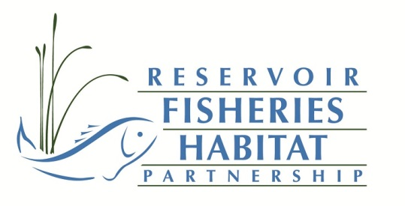
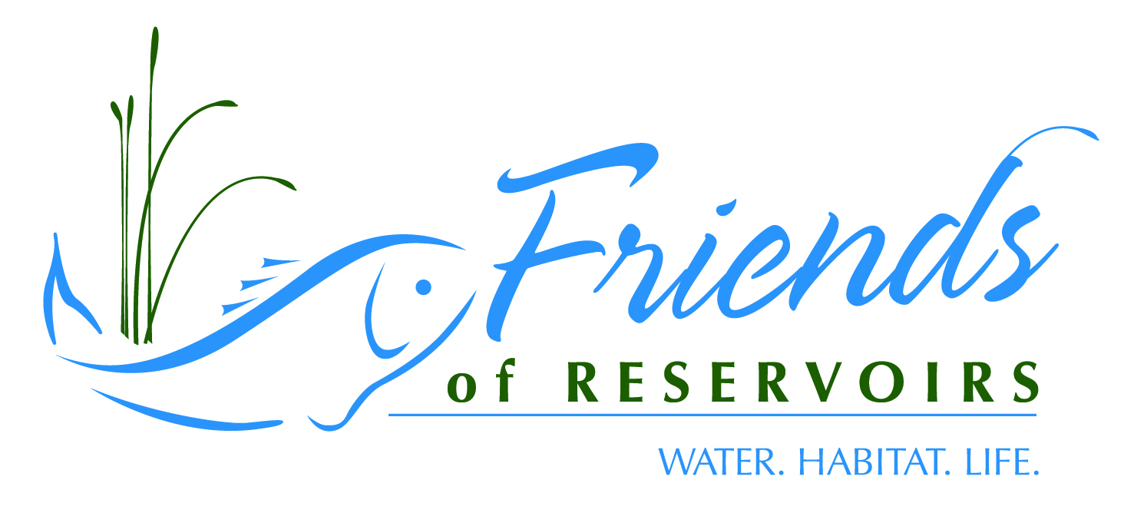
4-6 October 2019
Hollywood Casino
Kansas City, KS

Sponsored By:

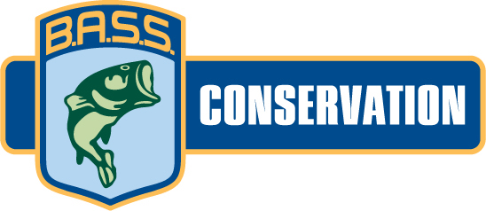
Reservoir Fisheries Habitat Partnership/Friends of Reservoirs Annual Meeting
4 October 2019
0900-1130 | Dredge Demonstration-Sam Minnich, Geoform
1130-1300 | Lunch
1300-1700 | RFHP/FOR Business Meeting

Reservoir Habitat Restoration Workshop
5 October 2018

Topics/Presenters
- Introduction/How to Select a Project-Jeff Boxrucker (RFHP) | 0800-0830
- Permitting-Greg Pitchford (Allstate Consultants) | 0830-0900
- Woody/artificial Structure-Ben Page (PFBC) | 0900-0930
- Nuisance/Invasive Aquatic Vegetation Control-Jeff Slipke-Midwest Lake Management | 0930-1000
- Restoring Native Aquatic Vegetation-Gene Gilliland (B.A.S.S.) | 1000-1030
BREAK | 1030-1050
- Sedimentation-Mark Porath (NGPC) | 1050-1120
- Nutrient Control-Reed Green (USGS) | 1120-1150
- Shoreline Stabilization-Lynde Dodd (USACE) & Jeremy Shiflet (KY Wildlife Resources) | 1150-1220
LUNCH | 1220-1300

TECHNICAL SESSIONS
1300-1320 | Welcome-Brad Loveless, Secretary KWPT, Introductions-Jeff Boxrucker
1320-1340 | Reservoir Fisheries Habitat Restoration is too Big a Job for Any one Agency to Tackle: Partnering and the Friends of Reservoirs Role in its Promotion-Jeff Boxrucker, RFHP
1340-1410 | Open Discussion on Microplastics-Dave Terre
1410-1440 | The value of sharing knowledge – Queensland’s experience with reservoir fisheries habitat management-Andrew Norris, Dept. of Agriculture & Fisheries, Queensland, Australia
1440-1500 | Water Injection Dredging (WID) Demonstration at Tuttle Creek Lake-Josh Olson, Kansas Water Office
1500-1630 | Break
1530-1550 | Conserving Water Quality in Kansas through the WRAPS Program-Travis Sieve, Kansas Department of Health and Environment
1550-1610 | Habitat Restoration at Harris Lake, North Carolina-Clinton Morgeson and Mark D. Fowlkes, NC Wildlife Resources Commission
1610-1630 | Friends of Lake Livingston: New Approaches to Restoring Aquatic Plants to a Turbid Reservoir-James Langley, Lee College
1630-1800 | Break
1800-2100 | Banquet

Sunday October 7
0900-0920 | Rockport Reservoir Habitat Augmentation-Kent Sorenson, Utah Division of Wildlife Resources
0920-0940 | Watershed Protection – How It Is Being Approached by the Beaver Watershed Alliance, Clell Ford, Beaver Watershed Alliance
0940-1000 | Status of the Watershed-Upper White River Basin-David Casaletto, Ozarks Water Watch
1000-1020 | Sediment Management in the Desert-Earl Conway, Sun Country Outdoors
1020-1040 | A Summary of Habitat Enhancement Efforts at Reservoirs Within the Lone Star State-Michael D. Homer Jr., Texas Parks & Wildlife Department
1040-1100 | Lessons in Establishing Aquatic Plants in Lakes and Reservoirs- Michael J. Mounce, IL DNR
1100-1120 | The Lake Shelbyville Fish Habitat Alliance: Year 2 update- Michael J. Mounce, IL DNR
1120-1140 | Indiana’s Reservoir Habitat Enhancement Program: Four Lake in Four Years-Sandy Clark-Kolaks, IN DNR
 | Lunch

ABSTRACTS
Reservoir Fisheries Habitat Restoration is too Big a Job for Any one Agency to Tackle: Partnering and the Friends of Reservoirs Role in its Promotion-Jeff Boxrucker, Reservoir Fisheries Habitat Partnership; jboxrucker@sbcglobal.net
The task of restoring habitat in the nation's reservoirs is a multijurisdictional challenge and cost prohibitive for a federal and/or state agency to accomplish without partnering with other public and private organizations or individuals. The Reservoir Fisheries Habitat Partnership (RFHP) recognizes that reservoir fisheries habitat impairments are often extensions of poor land-use practices in the respective watersheds. RFHP works to bring agencies and local organizations and individuals together to address habitat impairments at the local scale. RFHP and the Friends of Reservoirs Foundation have a membership and grant program that encourages local groups to work with state fisheries biologists to ensure that projects enhance fisheries management plans. RFHP has conducted a habitat impairment assessment of reservoirs nationwide to help prioritize activities. Funded projects have focused on native vegetation restoration, structure addition and shoreline stabilization. Future projects look to partner with organizations to address watershed impairments to improve water quality and habitat in downstream impoundments.

The value of sharing knowledge – Queensland’s experience with reservoir fisheries habitat management- Dr Andrew Norris, Senior Fisheries Biologist, Department of Agriculture and Fisheries, Queensland, Australia

Knowledge can be acquired in many ways. It can be gained through observation, trial and error, experimentation or mimicry. However, one of the most effective and efficient ways is through knowledge sharing. Learning what works and what does not work from others means past mistakes and learnings are not repeated, and instead the pool of knowledge is expanded. Organizations such as the Reservoir Fisheries Habitat Partnership and Friends of Reservoirs enable the willing exchange of knowledge and ideas, facilitating more rapid learning for individual partners as well as the collective group. Learning from these organizations and their partners has led to the commencement of impoundment fisheries habitat projects in Queensland, Australia. The value of managing aquatic habitats in impoundments to improve fisheries has typically been overlooked in Australia. In 2015 I visited the USA to investigate how reservoir habitats were managed to benefit recreational fisheries. Meeting with many members of the Reservoir Fisheries Habitat Partnership and Friends of Reservoirs allowed me to access data and knowledge which helped convince Australian fisheries and waterways managers that habitat enhancement was management tool worth exploring further. Habitat enhancement trials have been established in three impoundments in Queensland, Australia, with each waterbody addressing the response of a different suite of native fish to the introduction of structural habitat. Key goals for these projects include assessing fish response to various structure types, assessing angler attitudes and catch rates, determining the most cost effective and appropriate structure types for Australian conditions and demonstrating to waterway managers that the introduction of fish attraction structures do not have detrimental impacts to waterway operation or safety.
Water Injection Dredging (WID) Demonstration at Tuttle Creek Lake-Josh Olson, Kansas Water Office

Tuttle Creek Lake, like many of the other Kansas reservoirs, is losing storage capacity due to sedimentation at an accelerated rate. Recent estimates from the Kansas Water Office (KWO) indicate that approximately 48% of Tuttle Creek Lake’s original capacity has been lost due to sedimentation, causing a variety of negative impacts to the reservoir, including the reduction of fish habitat. In order to address this issue and promote sustainable long-term reservoir sediment management, the KWO, in partnership with the Corps of Engineers, plans to implement a Water Injection Dredging (WID) demonstration project at Tuttle Creek Lake. WID is a process in which large volumes of water are injected at low pressure into the sediment bed near the bottom of the reservoir through the use of pumps and a series of nozzles located on a horizontal pipe positioned above the sediment bed. The injected water effectively fluidizes the sediment creating a ‘density current’ that allows the sediment to flow by gravity to deeper areas. In the case of Tuttle Creek Lake, the proposed WID demonstration project would be aimed at moving the sediment toward the existing low-level outlet in the dam and monitoring the flow of the density current through the outlet during controlled discharges, restoring lost reservoir storage.

Conserving Water Quality in Kansas through the WRAPS Program-Travis Sieve, Kansas Department of Health and Environment; travis.sieve@ks.gov
The Kansas Department of Health & Environment (KDHE) implements the Watershed Restoration and Protection Strategy (WRAPS) program with the intent to repair and maintain water quality in Kansas water bodies. Through this holistic approach, Kansas citizens become involved in a framework to identify watershed restoration and protection needs, establish local goals, create action plans, and to ultimately implement the outlined strategies in the plans. Funded through Clean Water Act section 319 and Kansas State Water Plan funds, the WRAPS program continues to build partnerships with state/federal agencies, local governments, as well as industry. WRAPS strategies involved traditional cost-sharing, information and education, incentives, and equipment purchases. Each strategy implemented in the WRAPS program is dependent on the culture of the watershed, its unique individuals, and the water quality impairments needing mitigation.
Kansas reservoir protection is of great importance to the state and has become a high priority to the WRAPS program. KDHE supports WRAPS projects around each of the major reservoirs in Kansas to not only improve water quality, but to address future sustainability.

Habitat Restoration at Harris Lake, North Carolina-Clinton Morgeson and Mark D. Fowlkes, NC Wildlife Resources Commission

Harris Lake is a 1,680-ha impoundment of White Oak and Buckhorn creeks, tributaries of the Cape Fear River, and is located 35-km southwest of Raleigh, North Carolina. It is a productive eutrophic reservoir that supports a multi-species fishery consisting of Largemouth Bass Micropterus salmoides, Black Crappie Pomoxis nigromaculatus, sunfish species, Channel Catfish Ictalurus punctatus, White Catfish Ameiurus catus, Bullhead Catfishes Ameiurus spp., and White Perch Morone americana. Bassmaster Magazine ranked it 4th in the nation for best bass lakes in America and first in the southeast region in 2017. Hydrilla Hydrilla verticillata, a federally noxious weed, has been in the reservoir since the late 1980’s. It has been identified as a source population and Hydrilla has spread into other water bodies, including the Cape Fear River and Jordan Lake. To control Hydrilla, the North Carolina Division of Water Resources stocked 1,400 triploid Grass Carp Ctenopharyngodon idella in December 2018. The potential loss of habitat may result in changes in fish behavior and could decrease angler catch rates. Offering other natural and artificial structures, including native aquatic vegetation for fish to utilize could help maintain angler catch rates and satisfaction. The North Carolina Wildlife Resources Commission is leading efforts to improve aquatic habitat in the reservoir. The project objectives are to: 1) develop and implement a 5-year aquatic habitat enhancement project in Harris Lake with public input and assistance, and 2) establish and expand coverage of native aquatic macrophyte communities (0.4 hectare of founder colonies) and install at least 12 hectares of artificial and natural structure (≈700 fish attractors) to improve physical habitat by 2023. The Commission sought input from anglers and other partners to develop a 5-year Habitat Enhancement Plan for Harris Lake. Between 2018 and 2019, the Commission installed 63 additional artificial reef sites (323 structures) and planted aquatic vegetation at 33 locations.

Friends of Lake Livingston: New Approaches to Restoring Aquatic Plants to a Turbid Reservoir-James Langley, Lee College
FOLL has been working with six Independent School Districts in the Lake Livingston area to culture and plant water willow in suitable areas of Lake Livingston. success has not been optimal. With input from a variety of science advisors including TPWD, Texas A&M-AgriLife, Lee College Horticulture program, the Lewisville Aquatic Research Facility, the Texas Riparian Association, and the Meadows Center for Water & Environment, we have introduced an updated strategic plan to ensure better results. The new strategic plan incorporates very selective planting site selection, adding new plant species to eliminate mono-culture establishment, and establishing founder colonies for the first time. Our partners at TDC Ellis/Lee Horticultural have begun experimenting with six new aquatic plant species. Once they've perfected propagation techniques, plants will be distributed to the high schools in preparation for fall planting. The new plants include:
- Emergent Species: Bulrush: Giant (Schoenoplectus califoricus) & American Water-Willow (Justica Americana)
- Submerged Species:Water Stargrass& (Heteranthera dubia)
- Floating Leaved Species:&Yellow Water Lily, Spatterdock or Cow Lily (Nuphar luteum) and American Lotus (Nelumbo lutea)
Rockport Reservoir Habitat Augmentation-Kent Sorenson, Utah Division of Wildlife Resources
Yellow perch are a popular sport fish in Utah and creel surveys indicate those waters with strong populations typically rank as some of the most used waters in the state. Fishery managers in Utah have been looking to improve the consistency of yellow perch recruitment in their steep, canyon shaped reservoirs for a number of years as fisheries can often go five years or more without a strong year class of perch. It was thought this inconsistency was due to a lack of nursery cover in the littoral zone during the early life stages of fish as Utah’s reservoirs typically experience annual drawdowns of up to 55 vertical feet, rendering the shallow areas of the reservoir devoid of cover at all but full pool elevations. Now new research in North America and Europe is demonstrating that yellow perch and their closely related cousins, European Perch, are tolerant of moderately hypoxic water (4.5-2.0 mg/L) and may not need littoral cover to recruit fish and maintain populations. European perch (Perca fluviatilis) juveniles have been abundantly found in areas associated with deep moderately hypoxic waters, suggesting they are using these waters as refuge from predators and exclusive feeding areas. In 2018 and 2019, fishery managers in Utah observed similar activity by juvenile yellow perch, capturing them in gill nets in the deep, moderately hypoxic waters of the hypolimnion of Rockport Reservoir, Utah. This new research has led Utah to shift its focus from enhancement of littoral habitat to enhancing habitat in deep water areas where portions of the juvenile yellow perch population are now suggested to reside. Shortly after documenting fish using bathypelagic areas of the reservoir, proposals were then drafted to place artificial habitat in deep water areas of the reservoir as refuge for young perch to utilize during periods when the reservoir is mixed. Several structure types (all BOR/water district approved) were added over the deep basin portion of the reservoir. Bathymetric mapping pre- and post-placement of structure was completed and netting was done to substantiate sonar evidence. Subsequent sampling planned over the next few years will determine if consistency in recruitment has been achieved.
Summary of Habitat Enhancement Efforts at Reservoirs Within the Lone Star State-Michael D. Homer Jr., Texas Parks & Wildlife Department, Michael.Homer@tpwd.texas.gov
Reservoir ageing greatly diminishes quality of fisheries by impairments such as siltation, loss of littoral and aquatic vegetation as well as structural habitat, changes in water regimes, and eutrophication. Reservoir habitat impairments will worsen and further degrade quality of fisheries unless major steps are taken to remediate them. In Texas, the Largemouth Bass Conservation License Plate Program has funded numerous fish habitat restoration and enhancement projects in reservoirs. Since 2015, about $200,000 of CLP funding has been used to support nearly 60 habitat enhancement projects in Texas’ reservoirs. Partnerships such as the Reservoir Fish Habitat Partnership, the Brazos River Authority, and others have been crucial to the success of the fish habitat improvement projects by generating funding support, manpower support, and further communicating the need of habitat enhancement to communities. Strategies for fish habitat enhancement efforts have included the development of brush piles, deployment of fabricated artificial structures, pier enhancements, installation of aerators, and erosion control. Development of improved evaluation strategies is necessary to ensure habitat enhancement efforts are producing desired results and to assess changes in habitat and angling quality.

Watershed Protection – How It Is Being Approached by the Beaver Watershed Alliance, Clell Ford, Beaver Watershed Alliance
The Beaver Watershed Alliance, a 501(c)3 non-profit based in Springdale, Arkansas, was formed in 2011 to carry out the mission of proactively protecting, enhancing and sustain the water quality of Beaver Lake and maintaining the integrity of its watershed. Beaver Lake, a USACE reservoir completed in 1965, serves as the drinking water supply for nearly a half-million Arkansans, and is the engine that drives the continued growth of corporations such as JB Hunt Trucking, Tyson Foods, and of course Wal Mart. For an 1192 square mile watershed, with land uses dominated by pasture and poultry agriculture, and with Arkansas’ third largest city in its headwaters, there are a lot of challenges and opportunities that daily help us address meet our mission. The Alliance approaches the task armed with the Beaver Lake Watershed Protection Strategy, the first EPA approved nine-element watershed protection strategy in Arkansas. This talk will introduce the Beaver Lake Watershed, the Alliance, and the many activities that we are undertaking to help the development that is inevitable in a rapidly growing area, grow in concert with the needs to protect the Lake and its Watershed.
Status of the Watershed-Upper White River Basin-David Casaletto, Ozarks Water Watch
The Upper White River Basin Foundation, now doing business as Ozarks Water Watch (OWW), was formed as a 501(c) 3 charitable foundation in 2002 by a group of local businessmen with a vision to have the four lakes in the Upper White River watershed, Beaver, Table Rock, Taneycomo and Bull Shoals, the cleanest manmade lakes in North America. The mission of OWW is to promote water quality in the Ozarks area through bi-state collaboration and research, education, public policy and action projects basin-wide, in both Arkansas and Missouri. OWW provides water quality education and awareness to the business community, elected officials and the general public about the status of the water quality throughout the upper White River watershed through the publication and distribution of the annual Status of the Watershed report. This report compiles water quality monitoring samples collected by volunteers. This monitoring work is essential to providing an accurate assessment of where water pollution problems may exist in the watershed. OWW administers this volunteer water quality monitoring network throughout the Upper White River watershed in Arkansas and Missouri. OWW was also instrumental in bringing the governors of Arkansas and Missouri together to sign the Bi-State Shared Water Agreement on November 28, 2008 that allows the states to work on mutual water quality and quantity issues across state boundaries
Sediment Management in the Desert, Earl Conway, President, Sun Country Outdoors
Dams don’t last forever, but the sediments that move within the watersheds do. A vision of New Mexico without reservoirs is pretty dismal. Agriculture in the Lower Rio Grande and Pecos communities would be gone. Farmlands would revert to worthless weeded fields. Economic development in Las Cruces and El Paso would be curtailed due to domestic water shortages. Subsistence farming in Texas and Mexico would also be severely impacted. Any recreational or environmental use of the reservoir would also be lost and the dams would become a threat to anyone downstream of them, for fear of that inevitable day when it will breach and all of the trapped sediments will make their way down the river in uncontrollable floods. Picture a 200-foot wall of dirt piled up behind the dam as a flood tops the aging spillway. A new whitepaper, Reservoir Sediment Management: Building a Legacy of Sustainable Water Storage Reservoirs, was recently released that roadmaps a path to avert a national crisis.

Lessons in Establishing Aquatic Plants in Lakes and Reservoirs- Michael J. Mounce, IL DNR
Desirable species of aquatic vegetation can provide significant aquatic habitat, curb shoreline erosion, improve water quality, and can become self-establishing, resulting in enhanced aesthetics and improved angling quality. Illinois has many species of aquatic plants and some are very well suited to providing habitat in small impoundments as well as large. Methods of establishing aquatic plants are not well studied and long-term success can be difficult to achieve. Substrate and propagule treatments, like rooting hormone, soil sulfur, macro-nutrients, and aeration enhance planting survival and allow for increased area affected. Planting site variation is highly significant and successful plantings are expanded. Additionally, methods and timing of planting and maintenance practices that have been used, with some evaluated in central Illinois and elsewhere will be presented and discussed.

The Lake Shelbyville Fish Habitat Alliance: Year 2 update- Michael J. Mounce, IL DNR
The Lake Shelbyville Fish Habitat Alliance (LSFHA) was proposed and formed in spring 2017. Typical 48+ year old Midwestern flood-control reservoir, Lake Shelbyville was in desperate need for coarse-physical and aquatic-macrophyte habitat. Through chance encounters of invaluable information from underwater photographer, Eric Engbretson, the Lake Shelbyville cube developed, modeled after the original Georgia Cube design. Through additional chance meetings with local businessman, Chip Christensen, and long-time angler advocate, Bob Kerans, the LSFHA was formed. In addition, a long-desired aquatic plant nursery was developed by Dawson Boys, an Eagle Scout nominee. Individual anglers, fishing organizations and clubs, businesses, local communities, and additional non-governmental organizations came together in support of the LSFHA to apply, successfully, for a $47K Friends of Reservoirs’ habitat grant in fall 2017. Through donations by only angler and local business, 413 Shelbyville (66%) and/or Georgia Cubes and 70 artificial stumps were placed in the lake by December 2018, with many additional structures to be built in 2019 with FOR funds (300+). In February, 2018 the first Annual Fish Habitat Banquet was held, with an unexpected $20,900 dollars of profit realized. The recently developed “Adopt-a cube” program has raised over $3,000 since October, 2018. Anglers have reported and documented such outstanding fish use of the Lake Shelbyville cube, they have suggested discontinuing building the Georgia cube in the future. The benefits of these fish attractors have been documented through research collaboration with the Illinois Natural History Survey. Hundreds of pots of multi-species plants have been planted in protective-exclosures in the lake in the past three years, with some outstanding success. However, long-term summer flooding in 2019 devastated some of the most successful plantings but has not yet been fully evaluated. These activities are not only considered essential for the benefit of the fisheries, the angling community, and local businesses directly tied to angling, but the economic health of the local and state economy as well.

