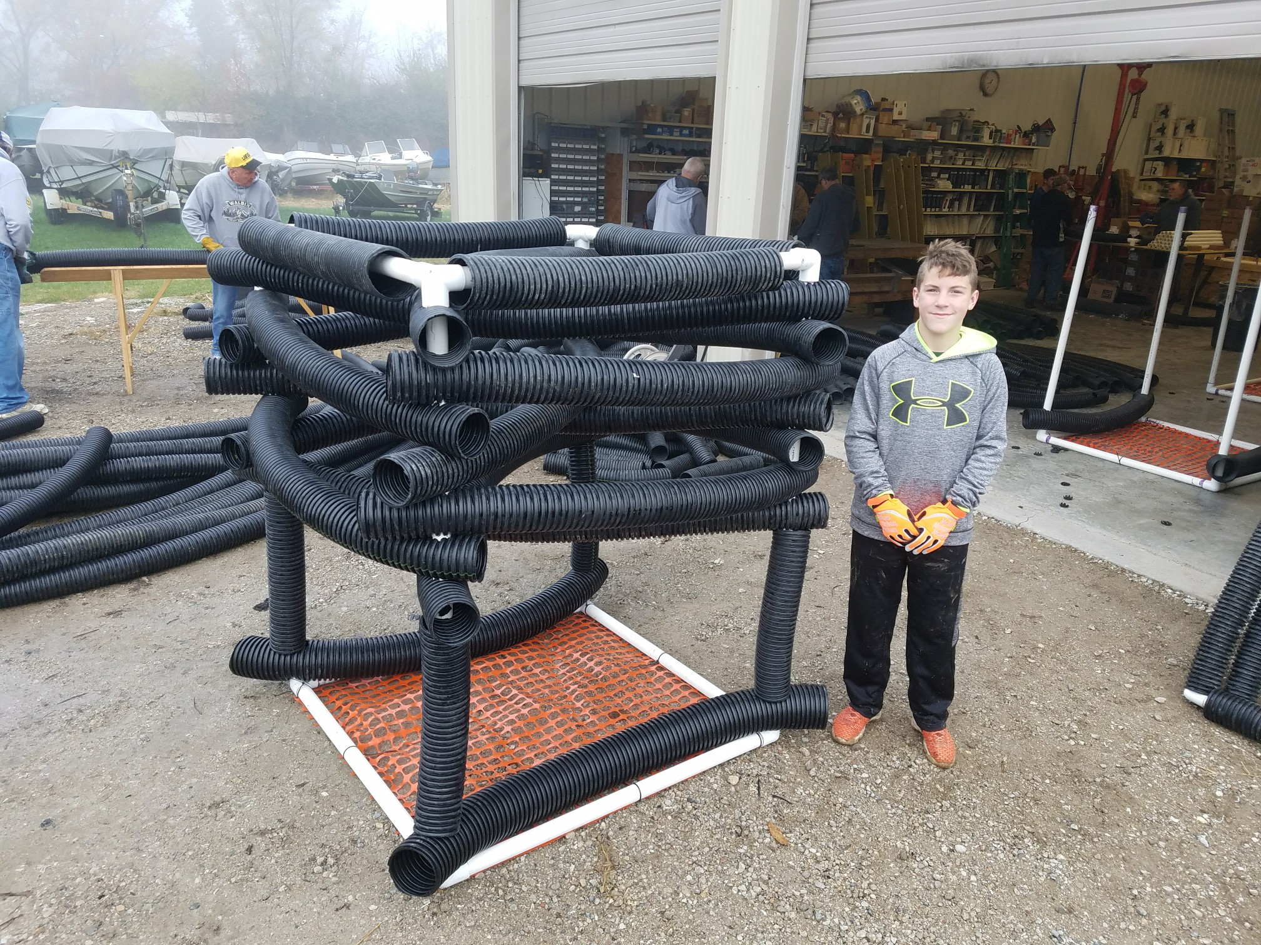
Use a 2-1/8 inch hole saw to drill holes in tiles.

Six - 78” diagonal tiles (that fit crossways) form the 1st, 3rd, & 5th layers.
4ft x 4ft heavy-duty snow fencing attached w/12 cable ties (>12” long, >40 lbs. & UV resistant)
Four - 18” tile spacers
½ inch (max) hole drilled into corner of each 90-degree side outlet to allow air to escape.
Construct the top and bottom halves initially as two separate “V”s, then attach together to form the square. Add tile to top “V”s before combining. Attach the two halves of the top with the open end of the corner joints facing down.
Eight - 56” side-to-side tiles, 2nd & 4th layers. Start each piece individually on a corner, before securing then secure the second tile end.
All PVC pipe is 1.5” Cell- or Cellular-core (UV-resistant). All drain tile is 4” (slotted works best) unless otherwise noted.
Four - 60” vertical PVC pipes form the corner uprights. Four - 45” PVC pipes form the top.
Four - 45” PVC pipes, filled with quartz pea-gravel & using Stockcap T-plugs (#250) at each end, to form bottom.
Shelbyville Cube
Four - 38” tile that cover top PVC, “6th layer”.
Two - 56” tiles/spacers made of 5 or 6-inch tile and filled with 4 standard construction bricks each
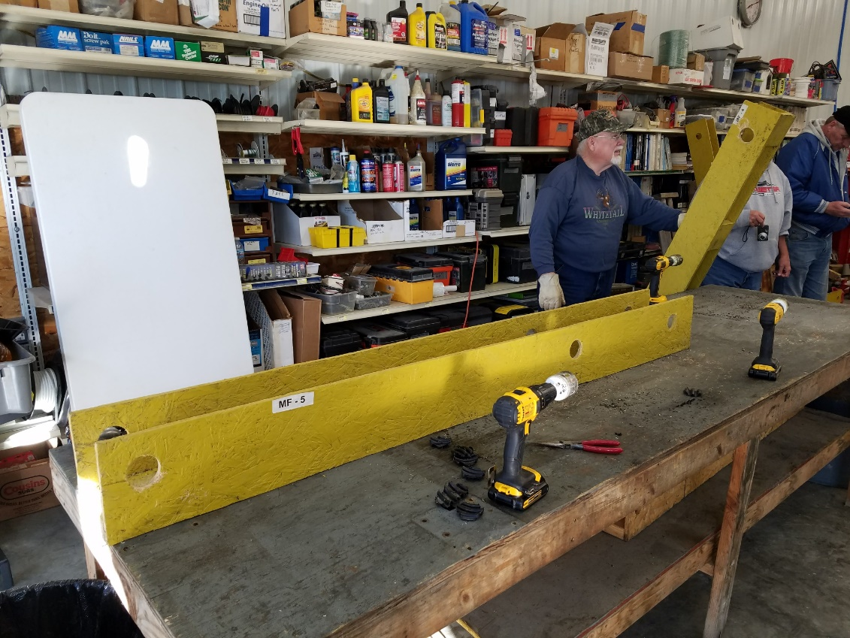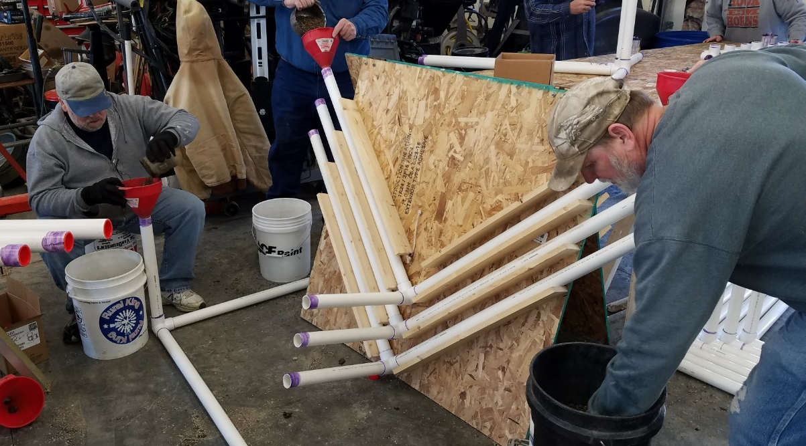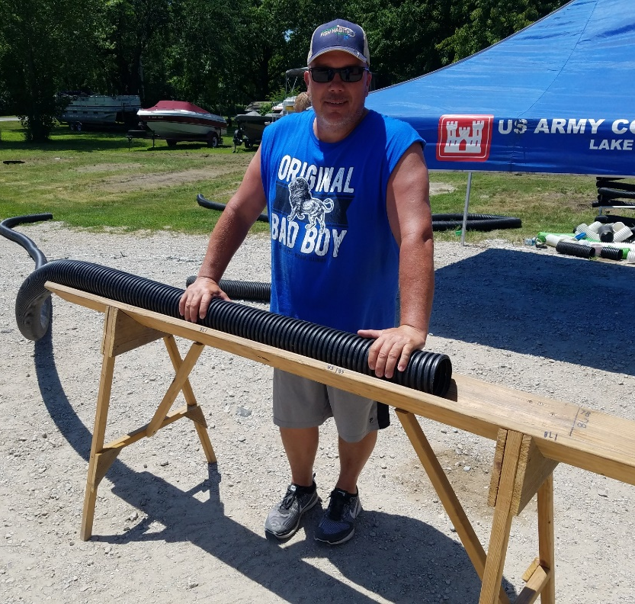
Jig for cutting holes in the tile. One for 5-inch diameter pipe and one for 4-ich diameter pipe. Jig length includes holes to drill holes for 78” or 56” pieces.
Jig for filling bottom-frame pipe with quartz gravel. Prior to this step, put end caps in pipe ends before gluing into the corner pieces. This is the old style and the short pipe is not used any longer.
Jig for cutting tile. Marks on the jig are used for each length of tile, 18”, 38”, 56”, 78”.

General Construction Procedure:

Note: When gluing PVC-pipe pieces together, twist the PVC-pipe pieces while assembling if possible, and hold them together for a few seconds, as the glued pieces tend to push apart on their own. Always use PVC primer. Ideally, allow glue to cure for 24+ hours before deployment, or use quick-set (“hot”) glue. Attention to details will result in a long-lived structure with a greater benefit return.
- Drill ½” holes in the corner of each PVC-pipe “corner” (90-degree side outlet) piece before assembly or priming (8 pieces required/cube).
- Cut snow fencing sections (~46” long), individual 1-1/2” PVC-pipe lengths (4 - 60” pieces & 8 - 45” pieces), individual 4-inch tile pieces (4 – 18”, 4 – 38”, 8 – 56”, and 6 – 78”), and two 5-inch tile pieces (56”). Some, if not all, of this can be done in bulk ahead and separated into bins.
- Prime all PVC-pipe pieces to be glued, including the inside of each corner pieces.
- Place tile pieces in jig and drill holes with 2-1/8-inch hole saw to allow the tile pieces to slide over the PVC-pipe uprights. Note: Have the natural curve of the tile either face up or down while drilling holes. The 18-inch and 38-inch pieces do not need holes drilled.
- Place “T-plugs” in one end of each 56”-inch PVC-pipe horizontal pieces (4) for the BOTTOM frame only. The second plug will be placed in the other end later.
- Glue two 56”-horizontal pieces into each corner joint (keep tops and bottoms sections separate) creating a “V” shape. Creating two “V”s in this step will help keep the construction square. Twist the PVC-pipe pieces while assembling and hold them together for a few seconds.
- Put bottom section(s) into the gravel-filling jig and fill with quartz gravel using large funnels. Use quartz because it is denser than limestone.
- Add “T-plugs” to the second end of bottom pieces (4) that have been filled with gravel and then glue two sections together into the another corner piece to form the bottom frame, remembering to hold glued pieces together for a few seconds.
- Turn the frame with corner-joint holes facing down and add snow fencing to the bottom of the bottom frame, using 3 to 4 UV-resistant medium- to heavy-duty plastic cable ties to each side to hold the fencing to the frame. Try to keep the snow fencing as flat as possible. This will ensure that the maximum surface area of the fencing will be in contact with the substrate, accumulate sediment, and hold the cube in place after final placement. The fencing prevents the cube from sinking into soft sediment and the accumulation of sediment on the fencing acts like an anchor in a short amount of time.
- Top frame: Turn the two TOP-frame “V” sections with the opening of the corner joints facing down. Add two 38-inch tile sections to each PVC-pipe piece of the two TOP-frame sections. Glue two sections together, remembering to hold glued pieces together for a few seconds.
- Glue the four 60” pieces into the bottom frame. Twist while assembling and hold each piece for a few seconds after assembly.
- Add four bricks to each of the two 5-inch tile sections. Place the 5-inch tile over the opposite sides of the uprights and secure over the PCV-pipe corner ends by “stomping” firmly on the “inside” edge of the pipe. Stomping on the ends of the tile can crack the tile.
- Add the four 18-inch tile spacers.
- Place two 78-inch horizontal tile cross pieces on the 60-inch uprights of the frame.
- Place one 56-inch horizontal tile side piece on each corner, then in a clockwise, or counter-clockwise method, place the second end of the tile piece over the adjacent tile end on the adjacent corner. It helps to not push them all the way down to the spacer or previous layer during early assembly.
- Repeat steps 14 and 15. Alternate the way the curve of each horizontal-cross piece is facing from the one below to maximize complexity of the structure on each layer.
- Repeat step 14, again alternating the curve of each cross piece from the one below.
- Glue the corner joints and upright ends and add the top frame. Use a rubber mallet to secure each corner of the top frame and hold for a few seconds if needed.
Considerations for Placement:

- Cubes that may be partially or entirely exposed to air during the winter could form ice inside the pipe which could crack the PVC pipe. If fully exposed to air, drill holes in the bottom horizontal pieces to facilitate drainage. We make sure cubes are placed at least 3-feet below winter pool level to avoid ice and boat motor damage.
- Cubes in lakes that are drawn down in the winter could be subject to damage from boat motor contact. Place them in deep-enough water to avoid this. The original Georgia cube style can be used in slightly-shallower water (~2 feet less) if needed.
- Anglers at Lake Shelbyville say that the Shelbyville cube design is much more effective at attracting desirable-size fish than the Georgia cube design. We use a 75%:25% ratio of Shelbyville cubes to Georgia cubes in construction and placement.
- In deeper and clear reservoirs, “double-decker” or “triple-decker” cubes can be built as tall as desired. Keep adding 18-inch spacers in-between levels. Small amounts of water-proof expandable foam can be used in the top frame construction to ensure that they do not tip over. Use a slightly wider (~6”) base.
- Anglers prefer cubes arranged and placed in clusters of approximately five individual cubes, over arranged in pairs or placed singly. This arrangement may be dictated by the number of cubes built and/or the size of the water body.

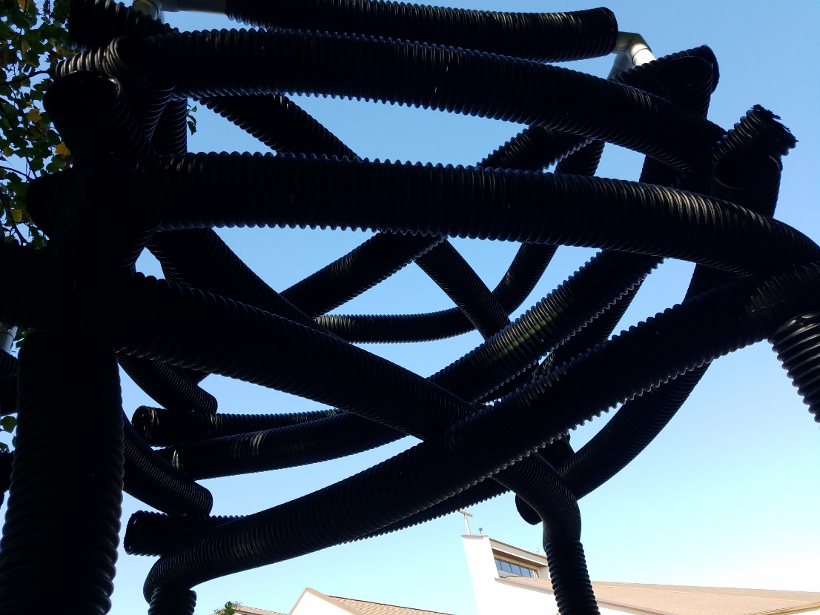
Fish-eye view of the Shelbyville cube.

