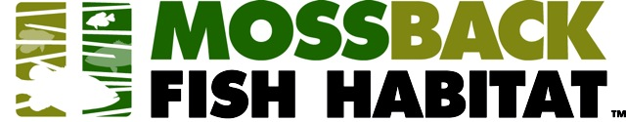
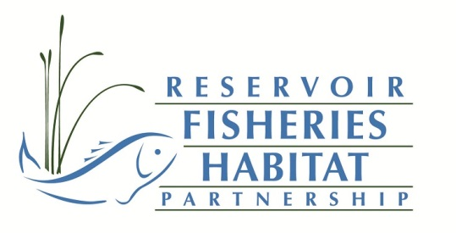
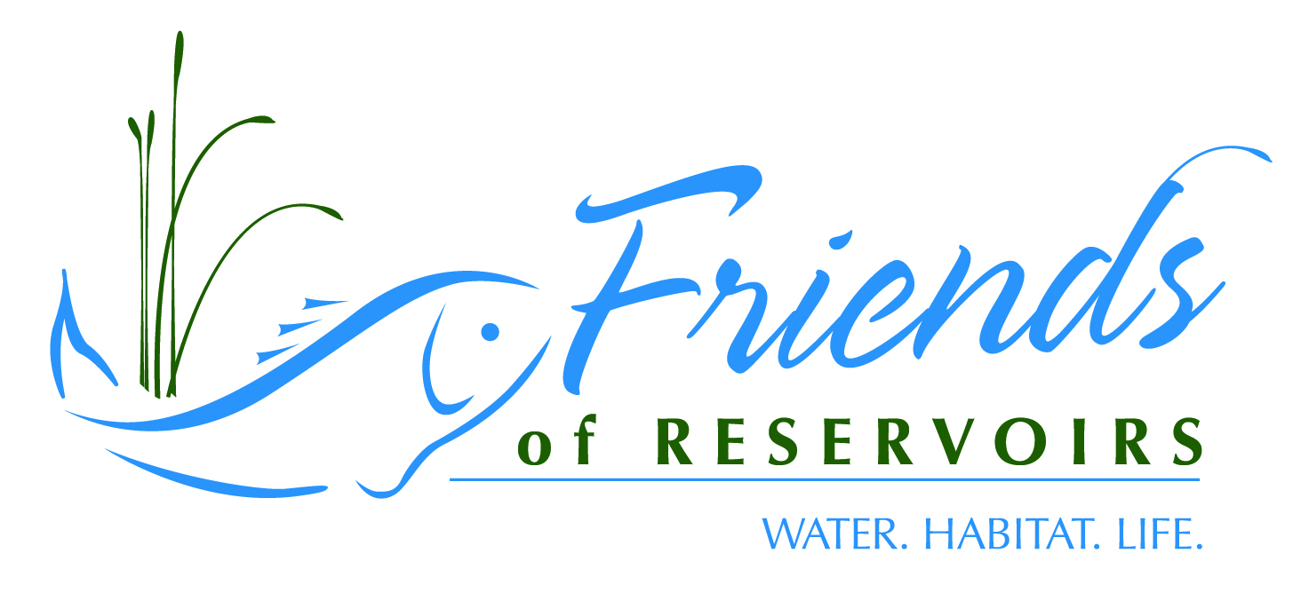

REQUEST FOR PROPOSALS
Mossback/Friends of Reservoirs Small Projects Grant Program

The Reservoir Fisheries Habitat Partnership (RFHP) and the Friends of Reservoirs Foundation (FOR) and King Enterprises (www.mossbackfishhabitat.com) makers of Mossback artificial fish habitat products are pleased to announce their small grants program available exclusively to Friends of Reservoirs member organizations. Membership applications can be downloaded off of the Friends of Reservoirs webpage (www.friendsofreservoirs.com/members).
Mossback has been a corporate sponsor of Friends of Reservoirs for several years and wants to work with FOR members in restoring structural habitat in public waters. Mossback is offering 3-$1000 grants of Mossback products exclusively to FOR members. The retail value of the grants is approximately $1500 if purchased directly from Mossback. The grant is for Mossback Fish Habitat products only and recipients will be responsible for associated freight costs.
Proposals must be submitted on-line at : https://www.friendsofreservoirs.com/grants/submit-a-project/mossback-grant/
- Name of the Friends of Reservoirs Member Sponsoring the Project
- Project Leader Contact Information
  - Name, address, phone, email
- Location of Project
  - Reservoir name *reservoir must be open to public access to be eligible
  - Location (GPS coordinates of dam, if available)
- List the Project Objectives
- Methods
  - Will the product be used in conjunction with existing habitat restoration efforts on the reservoir?
    - Will the product supplement natural brush, rock, etc. being added to the reservoir?
  - A letter of support from a representative of the state fish and wildlife management agency must be included in the proposal;
    - If available, include a copy of or link to a lake management plan that states the need for structural habitat enhancement (proposals which complement an existing plan for the lake will receive extra consideration).
  - Will state fish and wildlife agency staff be directly involved in the project?
      - Planning
      - Site selection
      - Participate in installation
- List the Species that the Project is Expected to Benefit
- Partners
  - Provide a list of partners involved in the project
    - To be considered a partner, the group/company/agency has to provide either direct monetary or in-kind (supplies, equipment, labor) to the project
- Budget (the budget should be presented in the table format below; you can cut and paste this table directly into your proposal and fill in as appropriate

Partner | Cash Contributions | In-kind Contributions (type: labor, supplies, equipment) | In-kind Contributions (cash value)
Mossback |  | $1000.00
Grant Recipient | Shipping Costs
Partner A | 500.00
Partner B |  | Concrete Blocks | $400.00
Partner C |  | Labor | $1000.00
Partner D |  | Rock | $500.00
State Management Agency |  | Labor/boats | $1000.00
*text in red is meant as examples of in-kind contributions (volunteer labor should be calculated at $10/hr for age 16 and under; 18/hr other volunteers; agency staff labor rates @ $24/hr

- Outreach
  - Include an outreach plan
    - How do you propose to advertise the project (on-site signage, press releases, websites, message boards, etc.)

Friends of Reservoirs will publicize the project on its website (www.friendsofreservoirs.com) and on its Facebook page.
Grant recipients will be asked to provide pictures of putting the structures together and placement from boats or docks along with a short completion report that Friends of Reservoirs and Mossback can use in press releases, newsletters, etc.
Proposals are due 15 August 2022 and must be submitted on-line at: https://www.friendsofreservoirs.com/grants/submit-a-project/mossback-grant/ Contact Jeff Boxrucker; jboxrucker@sbcglobal.net. I will be happy to answer any questions or provide guidance at the above e-mail or call (405) 659-1797.

Proposals will be scored by Reservoir Partnership staff and projects selected at the Friends of Reservoirs annual meeting in early October. Winners of the grants will be notified shortly thereafter. Winners will need to make arrangements directly with Mossback for shipping.

