REQUEST FOR PROPOSALS
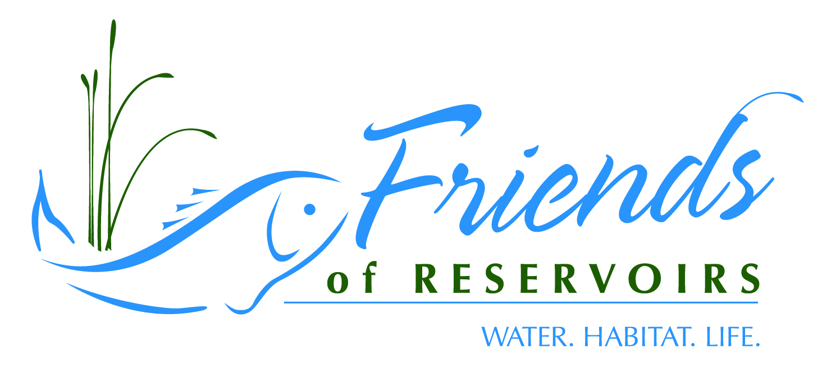
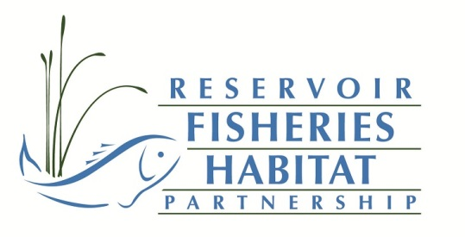
Reservoir Fisheries Habitat Partnership-Small Projects Grant Program

The Reservoir Fisheries Habitat Partnership (RFHP) and the Friends of Reservoirs foundation (FOR) is pleased to announce its small grants program available exclusively to Friends of Reservoirs member organizations. FOR membership dues are used solely to fund this program. As membership in FOR expands, we will increase the number of projects funded and/or increase the dollar value of the grants. FOR will be awarding 7-8-$2000 grants for FY2022.
Proposals should be no more than 3 pages in length and must include the following:
- Name of Friends of Reservoirs Member Sponsoring Project
- Project Leader Contact Information
  - Name, address, phone, email
- Location of project (reservoir name, location (GPS coordinates of dam, if available) *reservoir must be open to public access to be eligible;
- Describe the Project Objectives
- Describe the Methods being used to Address this Need
  - State the type and amount of habitat that the project proposes to add/restore;
  - Describe the methods used to accomplish the project;
  - What are the expected outcomes? (decrease shoreline erosion, provide cover for sport fishes, etc.)
- A letter of support from a representative of the state fish and wildlife management agency must be included in the proposal
    - If available, include a copy of or link to a lake management plan that states this need (proposals which complement an existing plan for the lake will receive extra consideration).
- What species will the project affect?
- Outreach
  - Include an outreach plan
    - How do you propose to advertise the project (on-site signage, press releases, websites, message boards, etc.)
- Partners
  - Provide a list of partners involved in the project
    - To be considered a partner, the group/company/agency has to provide either direct monetary or in-kind (supplies, equipment, labor) to the project
    - Preference is given to projects with a “youth group” actively involved (volunteer labor, fundraising, etc.)

- Budget (the budget should be presented in the table format below; you can cut and paste this table directly into your proposal and fill in as appropriate

Partner | Cash Contributions | In-kind Contributions (type: labor, supplies, equipment) | In-kind Contributions (cash value)
Friends of Reservoirs | $1000.00
Partner A | 500.00
Partner B |  | Concrete Blocks | $400.00
Partner C |  | Labor | $1000.00
Partner D |  | Backhoe | $2500.00
Partner E |  | Rock | $500.00
State Management Agency |  | Labor/boats | $1000.00
*text in red is meant as examples of in-kind contributions (volunteer labor should be calculated at $10/hr for age 16 and under; 18/hr other volunteers; agency staff labor rates @ $24/hr

Grant recipients will be asked to provide before and after pictures of their projects along with a short completion report that Friends of Reservoirs can use in press releases, newsletters, etc.

Proposals are due 15 August 2022 and must be submitted on-line at: https://www.friendsofreservoirs.com/grants/submit-a-project/small-grant/ Contact Jeff Boxrucker at jboxrucker@sbcglobal.net with any questions or call (405) 659-1797.

