FY2022 REQUEST FOR PROPOSALS
Reservoir Fisheries Habitat Partnership

- Applicant Information
Lake Shelbyville Fish Habitat Alliance, 1068 CR 1025N Sullivan, Illinois 61951
Phone: 217-728-2610

- Active Friends of Reservoirs Groups Involved in Project
Lake Shelbyville Fish Habitat Alliance, Friends of Lake Shelbyville, Heartland Hookers Bass Club, Lake Shelbyville Muskie Club, Central Illinois Sportsmen for Outdoors Accessibility, Central Illinois Crappie Club, Martin "Chip" Christensen (individual), Illinois Muskie Tournament Trail, Mike Mounce (individual), Jim Garavaglia (individual).

- Project Information
Title: Lake Shelbyville Fish Habitat Development and Restoration Project
Location - LAKE SHELBYVILLE, Temperate Plains.
    - 39°24'30.62"N, 88°46'39.86"W, Shelby and Moultrie Counties, Illinois.
    - See Appendix for site map
U.S. Congressional District: 15
Target Species (priority order): Largemouth bass (all life stages), white crappie, black crappie, bluegill, muskellunge, walleye, sauger, channel catfish, flathead catfish, white bass, striped bass, smallmouth bass, yellow bass, freshwater drum, gizzard shad, epiphytic insect larvae, invertebrates, zooplankton, and phytoplankton. Secondary benefits of aquatic plants are expected for Unionid mussels, waterfowl, shorebirds, wading birds, and a variety of aquatic and terrestrial mammals, reptiles, amphibians, crustaceans, grazing and pollinator insects, and a multitude of invertebrates. Stabilization of sediment and shorelines will also benefit a wider diversity of emergent and terrestrial vegetation, than simply those introduced.
Project objective(s): The objectives of this project are to continue the introduction of long-lasting structural and biological habitat to Lake Shelbyville. This will be accomplished through a combination of habitat editions (PVC cube/ artificial stump structures) and plantings of aquatic/semi-aquatic vegetation, both directly on shorelines as well as on artificial floating islands designed to be planted with a high density of vegetation. The artificial floating islands will not only provide a small area of vegetation with various habitat and water quality benefits, but will also provide a long-lasting source of seed to the surrounding area that will germinate when conditions are conducive. The benefits of these additions include; increased complexity and diversity of habitat for fish and wildlife, decreased turbidity, siltation, and nutrient loading for improved water quality, and improve deep water refuge availability during summer stratification. This will provide increased density of priority game fishes and other desirable organisms for greater quality of experiences for anglers, hunters, ecotourists, and increase local business revenue for increased quality of life for all residents within the influence of the reservoir. The project will provide deliverables that include (depending on material donations): at least 180 Shelbyville cubes (14,400 ft³), at least 20 Georgia cubes (800 ft³), 120 artificial stumps (2,400 ft³), 450 ft² of high density artificial floating islands, and 5,625 ft² of shoreline planted in willow with exclosures. Success of the project will be gauged primarily by improved quality of the fishery, fish use of habitat structures, and secondarily by water quality improvements, bank stabilization, and reduced sedimentation.

Start and End Dates
    - Anticipated RFHP Funding Use: May 2022 through December 2022.
    - Habitat introductions have occurred for many decades and are expected to continue indefinitely. Lake Shelbyville Cubes and aquatic plant production in the USACE nursery were initiated in November 2016 and April, 2017, respectively. The Illinois Natural History Survey is conducting a habitat evaluation separate from this project, but will be working in conjunction with the Lake Shelbyville Fish Habitat Alliance to evaluate fish use of artificial attractors and felled trees. The USACE will be using rip-rap to armor banks from erosion.

Habitat Type | Time Frame | Current  Years of Effort | Units already introduced
Christmas tree | <1985 - 2017 | 35+ | 10,000+ trees
Aquatic Plants | 1997 - Present | 20+ | 10,000+ plants
Large tree felling | 2001 - Present | 20+ | 50 trees
Rip-rap | <2007 - Present | 10+ | 63,700+ tons
Porcupine Balls | 2012 - 2017 | 5 | 420 structures
Shelbyville Cubes | 2016 - Present | 5+ | 807 structures
Georgia Cubes | 2016 - Present | 5+ | 346 structures
Artificial Stumps | 2018 - Present | 3+ | 270 Structures
Plumber’s Union testing structures | 2017 | <1 | 55 structures
Rock Reefs | 2020-Present | 1+ | 18 reefs, 380 tons

Amount of Grant and Estimated Total Cost of Project
  - Grant Request (FY22) - $40,000
  - Project Total Cost (FY22) – $124,315

List of Partners (All have donated time/materials/cash through the LSFHA)
- Businesses:
Chip’s Marine (Martin “Chip” Christensen (executive committee), April Stephens), Lithia Springs Marina, East Side Marine - Springfield, Leprechaun Landing Bait Shop, Coon Creek RV Park and Resort, Cargill - Tuscola Plant, ADM, Mt. Auburn Facility, Sullivan and Shelbyville Ace Hardware (Kurt VanDeursen), J.P. Construction, R. D. Cox Masonry, Mark Witt - GCI, Druby's Restaurant, Bruce Sanders (guide), Brian Cleland (guide), John Carr (guide), Phil Wood (guide), Marvin Keller Trucking, Winskill Autobody, and Moultrie County Redi-Mix.
- Governmental Agencies:
U.S. Army Corps of Engineers (Lee Mitchell, Jon Summers (both executive committee), Illinois Department of Natural Resources, Division of Fisheries (Jim Garavaglia), City of Shelbyville, City of Sullivan.
- Non-Governmental Organizations:
Lake Shelbyville Fish Habitat Alliance (Executive Committee members noted and Placement Committee members listed below), Living Lands & Waters (Chad Pregracke, et.al.), Friends of Lake Shelbyville, Lake Shelbyville Development Association, VFW Post 6410.
- Lake Shelbyville Fish Habitat Alliance Placement Committee:
John Wright (tournament angler), Andy Roberts (tournament angler), Brian Cleland (guide), Bruce Sanders (guide), Bob Foran (accomplished angler), Matt England (guide), Greg Harkins (tournament angler), Bud York (tournament angler, John Carr (tournament angler), expanding.
- Angling Organizations
Illinois Muskie Tournament Trail (Robert Kerans (executive committee), Central Illinois Crappie Club, Springfield Crappie Club, Lake Shelbyville Muskie Club, Heartland Hookers Bass Club, Champaign County Bassmasters, Crappie Camp, Central Illinois Crappie Club, Illini Muskies Alliance, Shawnee Muskie Hunters, Chicagoland Muskie Club, Angler’s Choice Tournament Trail.
- Individuals:
Robert Petti, Richard Glazebrook, Don Rathje, Bob Long, Mark Whitt, Cory Crowder, Matt Shields, many others who donate time.

- Project Description
Regional and Lake  Impairments | Solutions Proposed in Plan | Products/Usables  Proposed in Plan
Excessive Nutrients | Biological absorption and use by aquatic plants, mechanical inhibition of erosion | Artificial floating islands, Willow Plantings
Siltation/Turbidity | Mechanical inhibition of erosion, biological stabilization of substrates | Artificial floating islands, Willow Plantings
Limited littoral structure (lack of woody structure and vegetation, shoreline erosion) | Introduce long-lasting physical habitat, aquatic plants, introduce large woody structure, armor areas inhospitable to plants | Shelbyville & Georgia cubes, Artificial Stumps, Artificial floating islands, Willow Plantings, Tree Felling
Excessive mudflats/shallowness (little deep water refuge) | Improve water clarity to increase O² availability in deep water refuges in summer, reduce erosion to slow successional filling | Artificial floating islands, Willow Plantings
Water Regime (extreme and/or mistimed fluctuations, low retention) | Introduce pioneering species of aquatic plants that can survive or reseed themselves after extreme summer flood events | Artificial floating islands, Willow Plantings
Connectivity | Reduce erosion and the subsequent movement of sand to stop deposition at the mouth of coves that is impacting connectivity of littoral areas to limnetic areas | Artificial floating islands, Willow Plantings

Project Overview
Excerpt from the USACE 2017 Master Plan:
“Lake Shelbyville is located in Shelby and Moultrie Counties of east-central Illinois. The dam site is located on the Kaskaskia River about one-half mile east of Shelbyville, Illinois. Much of the land in the Lake Shelbyville watershed is flat or gently sloping. However, the many small tributaries entering the river above the dam site have created ravines and valleys to form a very irregular shoreline. Many coves, both large and small, can be found as a result.
The lake is confined by relatively abrupt slopes and has many timbered arms with 172 miles of shoreline. The abrupt slopes and the erodible soils have resulted in shoreline erosion impacting project facilities. The topography changes from a streambed elevation of about 535 feet NGVD to an elevation of 650 to 660 feet NGVD at the bordering uplands. Most of the valley slopes are covered with some virgin timber, but primarily second growth forest. The lake has a water surface area of 11,100 acres at joint-use pool elevation 599.7 feet NGVD. The pool at this elevation extends upstream from the dam approximately 20 miles and varies in width at this elevation from 0.25 to 1.0 mile. The depth of water from the valley floor at the dam to joint-use pool elevation is about 53 feet.
Shoreline erosion at Lake Shelbyville is caused by a combination of factors: fluctuating lake level, waves created by wind and boat actions, and the soil surrounding Lake Shelbyville being predominately glacial sandy clay with little resistance to erosion. Erosion was considered during project design to have minimal impact on pool storage in early years. However, because the last full sedimentation survey was conducted in 1984, there is no way of knowing exactly what that impact is today. The 1984 survey concluded that although the lake was estimated to lose 6.8% of its storage capacity in 50 years (by 2034), that rate of deposition was 2.5 times higher than original estimates. A sedimentation survey coupled with a revised shoreline erosion plan are needed to get a clearer picture of future needs.”
Due to the standard aging process, Lake Shelbyville (which has been impounded for 50+ years) has lost a significant portion of its’ woody habitat to natural forces. “Very little dead standing timber remains in coves as most have decayed over the last 40 years.” Long-duration floods, on occasion in excess of 12’, have further stranded woody habitat in uplands resulting in addition habitat loss.
These floods have made conditions difficult for aquatic macrophytes to establish without help. This lack of habitat and associate erosion and reduced water quality are affecting the quality of the fishery significantly and efforts to replenish and develop habitat have not kept up with losses. Standard management practices help maintain the quality of the fishery, but the standard reduction in quality with reservoir age continues with rippling economic effects throughout the community and region.
Dr. Gary Owen Dick, Research Ecologist, from the U.S. Army Corps of Engineers Research and Development Center (ERDC), Lewisville Aquatic Ecosystem Research Facility (LAERF) visited Lake Shelbyville in May 2013. He completed an evaluation of the aquatic plant community and general habitat and water quality of the lake and stated in his report: “The failure of native vegetation to establish naturally in the lake thus far is due to an absence of propagules needed for colonization and abiotic (flood management, etc.) and biotic (herbivory, etc.) factors that limit establishment of the few propagules that may be introduced into the lake. This has resulted in a poorly developed natural resource.”
He further went on to state: “Lake Shelbyville qualifies as a Corps resource in need of an improved ecosystem to maximize its natural resource benefit potentials. Establishing substantial native aquatic vegetation in the lake will meet this need by providing habitat necessary to sustain fisheries, in particular as cover for young-of-the-year centrarchids and other aquatic fauna dependent upon vegetation for habitat. In addition to cover for fish, aquatic and riparian vegetation would serve as substrate for aquatic invertebrate reproduction, foraging, and predation protection. This will expand the existing food web and increase its energy flow potential, which will in turn develop and support healthy fisheries. Other aquatic and semi-aquatic wildlife, including migratory waterfowl and wading birds, would also benefit from these trophic improvements. Additional benefits include reductions in shoreline erosion and turbidity.” These comments and the actions proposed by this grant parallel and support the goals of the RFHP (report included).
As mentioned in the narrative and table above, the goals of this project are to introduce long-lasting structural and biological habitat, inhibit shoreline erosion on highly eroded areas, inhibit mobilization of sediment and nutrients, and maintain connectivity of coves to the main lake. The benefits expected include; increased complexity and diversity of habitat for fish and other wildlife, decreased turbidity, siltation, and nutrient loading for improved water quality, improve deep water refuge availability during summer stratification, to provide increased density of priority game fishes and other desirable organisms for greater quality of experiences for anglers, hunters, ecotourists, and increase local business revenue for increased quality of life for all residents within the influence of the reservoir.

Monitoring Plan Overview
Success of the project will be gauged primarily by improvements in the quality of the fishery, fish use of habitat structures, and secondarily by water quality improvements, bank stabilization, and reduced sedimentation.
Incidentally, the Illinois Natural History Survey’s Kaskaskia Biological Station, located immediately on Lake Shelbyville, is conducting a study on the use of the artificial habitat structures we have placed in the lake by various fish species. They are evaluating structures using standard electrofishing, deep-water electrofishing, and sonar (side-scan and Livescope sonar)Their evaluations will provide a wealth of information about best management practices (BMPs) in designing and placing fish habitat structures for maximum results. They will also provide additional data to support changes in the fish population, invertebrate communities, and basic water chemistry parameters through their various projects on the lake.
IDNR will annually conduct standardized fish population surveys and stocking success surveys each fall to evaluate changes in fish populations. Parameters easily measured during the time frame of this project include changes in density, size structure indices, and body condition. Species readily evaluated would include primarily largemouth bass, crappie, and muskellunge due to their relative ease of sampling and reliance on the physical and biological habitat being introduced. Goals of CPUE, size structure indices, and body condition are listed in the management plan for the lake. Anecdotal evidence will also be collected from the numerous fishing guides, tournament directors, and anglers who fish around these various habitat additions.
Plantings will be monitored on a regular basis (monthly at minimum, more during the growing season). The artificial floating islands will be closely monitored (every 2 weeks minimum) to evaluate success and monitor for depredation. Willow plantings will be monitored the spring following their planting, and on a monthly basis during the growing season to monitor for survival, growth, and to monitor for depredation.
Measurements of water quality changes will be difficult to obtain on such a large and highly fluctuating reservoir. USACE monitors water quality parameters and those will be followed and evaluated. INHS will likely obtain water quality measurements in treatment versus “control” coves.

Outreach Plan
  - The Lake Shelbyville Fish Habitat Alliance has an established Facebook page with frequent updates. The USACE has an established Facebook page and webpage in which we will post updates. The IDNR has two Facebook pages that will post updates. Local businesses, Chip’s Marine, Friends of Lake Shelbyville, and fishing clubs post updates on their Facebook pages and/or websites. We continue to provide information and encourage them to continue to publicize our activities, include grant awards from the organizations mentioned above and others.
  - We will arrange news conferences to announce major grants, and already utilize press releases distributed to a wide ranging list through the USACE to make announcements about this project and hold an annual “State of the Lake” in April, highlighting habitat projects and partnerships. We have and will continue to make radio show appearances to promote and update these efforts and contributors.
  - Banners were placed at all major boat launches around the lake in 2021 to publicize the habitat project and to thank our partners, including FOR and RFHP.
  - We have encouraged participation by anglers in habitat events by delaying the availability of new habitat maps online and only providing maps of new attractor locations to anglers who help with a build.
  - The utilization of a fish attractor “Placement Committee” made up of local anglers and guides promotes “buy-in” as input from some the most knowledgeable anglers on the lake help dictate the locations where habitat structures are placed. This committee is still being added to as opportunity permits.
  - The LSFHA has held an Annual Fish Habitat Banquet with overwhelming success, raising over $20,000 at each event with 100% of profits going towards habitat improvement projects.
  - The LSFHA works with several area schools to promote participation by youth, including providing materials for students to build cubes themselves, and then participate in the subsequent placement of those cubes.
  - LSFHA plans to continue discussions with Shelbyville High School to have their agriculture program (with a greenhouse) raise aquatic plants for shoreline and artificial vegetated island plantings. Plans were made to begin this program in 2020 but were derailed by the Covid-19 pandemic. We hope to get plan ironed out to possibly begin this program in Fall of 2021.
Project Deliverables
The project will provide deliverables that include (depending on material donations, which have historically been high): a minimum of 180 Shelbyville cubes (14,400 ft³), at least 20 Georgia cubes (800 ft³), 120 artificial stumps (2,400 ft³), 450 ft² of high density artificial floating islands, and 5,625 ft² of shoreline planted in willow with exclosures.
These structures will be added to the already deployed: 807 Shelbyville cubes (64,560 ft³), 346 Georgia cubes (13,840 ft³), 270 artificial stumps (5400 ft³), 4,000ft² of planted area, 18 rock reefs (98,000 ft³), and approximately 5,000 feet of severely eroding lake shoreline that has been stabilized with riprap.
These products are anticipated to primarily benefit the following species, but will in effect benefit a much wider diversity of organisms: Largemouth bass (all life-stages), white crappie, black crappie, muskellunge, walleye, channel catfish, flathead catfish, white bass, sauger, bluegill, smallmouth bass, yellow bass, freshwater drum, and gizzard shad, epiphytic insect larvae, and epiphytic invertebrates, zooplankton, and phytoplankton. Secondary benefits of aquatic plants and greater fish and invertebrate density are expected for Unionid mussels, waterfowl, shorebirds, passerine and wading birds, a variety of aquatic and terrestrial mammals, reptiles, amphibians, crustaceans, grazing and pollinator insects, and a multitude of invertebrates. Stabilization of sediment and shorelines will also benefit a wider diversity of emergent and terrestrial vegetation, than simply those introduced.
Anglers are the most frequent user group on Lake Shelbyville. They and their families also comprise a high percentage of other user groups such as campers, boaters, hunters, ecotourists, and beach patrons for example. This makes preservation and enhancement of the quality of the lake’s fishery, water quality, and aesthetics even more important to stabilize and increase all area activities. The USACE already has very active programs highlighting environmental amenities, nature experiences, and wildlife-based activities and opportunities on lands adjacent to reservoir systems to engage and inform local communities and visiting public on the values and benefits of healthy reservoir systems which helps meet RFHP objectives.
Meeting the goals listed above will not only benefit the organisms and constituents that directly utilize the lake, but the entire community surrounding the lake. Greater user group participation on the lake due to improved angling quality, hunting opportunities, ecotourism, water quality, vegetation stabilization, and overall aesthetics, will restore Lake Shelbyville to a prime quality destination location. Although visitation is somewhat improved due to the improving economy, improvements to outdoor experiences will bring additional tourism and revenue to businesses in the area such as bait shops, marinas, gas stations, grocery stores, motels/hotels, resorts, camp grounds, federal, state, and municipal parks, and others, improving and stabilizing incomes. Increased incomes and stimulation of the local economy from additional outside users will benefit the entire community through increased tax base revenue. This provides a greater quality of life for all residents within the influence of the reservoir, as well as the direct and indirect user groups.
Improvements in the quality of experiences surrounding natural resource enjoyment gives these places greater value to primary users and secondary benefactors alike. Success of projects, like those proposed in this application, promotes greater participation in these activities providing even greater results, not only for Lake Shelbyville, but other reservoirs and impoundments as well. Success also shines a positive light on participating organizations, including RFHP and FOR. This allows for further opportunities to gain additional support and meet organization goals in this and on other reservoirs. Success also provides value to not only preserve but enhance facilities that provide even greater opportunity for participation in quality outdoor experiences. This reservoir already has 14 high quality boat ramps with numerous high-water ramps. Added value to, and use of, the reservoir will only provide impetus to maintain and enhance the facilities.

List of Required Permits
- A USACE Nationwide Permit will be required for placement of habitat structures.
- Provisions to protect the restoration project site after project completion:
  - It is expected that the Shelbyville and Georgia cubes will need little maintenance. None have tipped over or have moved from the placement location once settled. Fish use will be monitored via INHS study and volunteer angler monitoring via fishing and sonar. Funded by USACE/IDNR.
  - Artificial stumps will be monitored to make sure that they stay in place and re-secured if necessary. Again, none have fallen or moved after deployment. They will be monitored by IDNR fisheries biologists and USACE staff. Funded by USACE/IDNR.
  - Aquatic plant exclosures will be monitored and maintained. Winter freezing and thawing often causes exclosures to heave and requires “reseating” of rebar and wire exclosure material. Failed plantings will result in exclosure materials being recovered and moved to new locations. Funded by USACE/IDNR.
  - Artificial floating islands will be monitored by LSFHA volunteers and seasonally moved when necessary to accommodate water level fluctuations.

Project Timeline (subject to contract signing date).
  - May-June 2022: Purchasing of material for cubes, stumps, and floating islands will begin when funding becomes available.
  - July 2022: Construction of Shelbyville cubes, Georgia cubes, and artificial stumps will be planned for two dates in June/July. Placement of structures will occur within a month of the build
  - July-August 2022: Floating island structures will be placed, anchored, and planted. Protective fencing will be placed to protect the islands from depredation while becoming established. Islands will be monitored every two weeks at minimum to monitor for growth and depredation.
  - September 2022: Two additional builds of cube structures and artificial stumps will be planned for late September and October, with placement scheduled for November.
  - November 2022: Floating Islands will be moved to overwintering locations (due to winter drawdown). Islands will be moved in spring and fall yearly by volunteers from the LSFHA.
  - November-December 2022: Willow cuttings will be planted and fenced with exclosures.
  - If any of the above is delayed due to water level fluctuations, a pandemic, etc., it would be made up during the spring of 2023 at the latest.
  - Monitoring of benefits achieved by these projects will continue well into the future by the IDNR surveys and INHS research projects.

- Budget
Item | Cost/Unit |  | # Units | Total Cost
Shelbyville Cube | $100 |  | 180 | $18,000
Georgia Cube | $100 |  | 20 | $2,000
Artificial Stump | $50 |  | 120 | $6,000
Floating Plant Island | $2,000 |  | 6 | $12,000
Willow | $600 |  | 12 | $7,200
Plant Rearing Materials | - |  | - | $4,800
 |  |  | Total | $50,000
Budget Narrative
  - Each Shelbyville Cube is 3.8'X3.8'X5' with most of the plastic field tile raised 20" above the substrate (see photo), constructed with 62’ - 1-1/2” PVC Pipe, 8 - 90º Side Outlet Elbows, 77’ - 4" Drain Tile, 9’ - 5" Drain Tile, 54” - 4' Snow fencing, 8 - Bricks, 16 lbs. - Gravel, 12 - 14", 120 lbs., Cable Ties. Cost per unit averages $100, depending on materials donated.
  - Each Georgia Cube is 3.8’X3.8'X2.5' constructed with 40’ - 1-1/2” PVC Pipe, 8 - 90º Side Outlet Elbows, 77’ - 4" Drain Tile, 9’ - 5" Drain Tile, 8 - Bricks, 16 lbs. – Gravel. Cost per unit averages $100, depending on materials donated.
  - Each artificial stump will consist of a 3’ section of 24” diameter culvert with concrete weight and held in place by filling the bottom with concrete. Simulated roots will be comprised of 3” agricultural tile. 24” culvert is donated by a company that would otherwise be disposing of it, saving it from being tossed in a landfill. Cost of cement and 3” tile for stumps is $50.
  - Each artificial floating island will consist of 30 ft² of planting space. Each Floating Island costs approximately $2,000, which includes the island, materials for the anchoring system, exclosure fencing to reduce depredation, and plugs to plant the island with.
  - Willow exclosures will consist of 100’ lengths of 14 gauge wire mesh - 4”X2” mesh arranged in an oval shape. Exclosure will be held in place with 6.5’ pieces of 5/8” rebar driven into the substrate. Wire mesh will be attached with plastic cable ties. Wire mesh costs $180-$200 per 100’ roll. Rebar and cable ties are provided at no cost. Heavier gauge wire mesh is required on this lake due to fluctuating ice conditions. Willows will likely be purchased from a nursery, with potted trees costing approximately $50 per potted plant. We are also looking into the possibility of collecting our own willow cuttings to plant, which would decrease the cost of plants and increase the area that could be planted.
  - Plant Rearing Materials would help cover the cost for local schools to raise plants for our artificial floating islands, willow plantings, and other aquatic vegetation plantings. Materials might include containers (pots and large tanks for aquatic plantings), soil, fertilizer, plant starts (for species that cannot be collected locally) and various tools that are needed to raise plants and plant them in Lake Shelbyville.

Categories | Partner  Contribution Amount | Cash or In-Kind | Federal | Non-Federal | Timeline
Reservoir Fisheries Habitat Partnership
Administrative /Technical Services
Construction Costs/Materials | $40,000 | Cash | x |  | 5/2022 to 10/2022
Labor (paid)
Labor (volunteer)
Miscellaneous (outreach materials)
LSFHA
Administrative/  Technical Services | $2,283 | In-Kind |  | x | 5/2022 to 12/2022
Construction Costs/Materials | $10,000  $11,700 | Cash  In-Kind |  | x  x | 5/2022 to 10/2022
Labor (paid)
Labor (volunteer) | $39,956 | In-Kind |  | x | 5/2022 to 12/2022
Miscellaneous (outreach materials)
USACE
Administrative/
Technical Services
Construction Costs/Materials
Labor (paid) | $16,776 | In-Kind | x |  | 5/2022 to 12/2022
Labor (volunteer)
Miscellaneous (outreach materials)
IDNR
Administrative/
Technical Services
Construction Costs/Materials
Labor (paid) | $3,600 | In-Kind | x |  | 5/2022 to 12/2022
Labor (volunteer)
Miscellaneous (outreach materials)
Total Direct Costs | $124,315

Budget Line Justification
- LSFHA – Admin/Technical Services: $2,283
Volunteer time (80 hr * $28.54) by executive board members and volunteers planning and scheduling meetings and structure builds, purchasing supplies, updating social media and outreach material, etc.
- LSFHA – Construction Materials: $11,700
Donated construction materials solicited by LSFHA, including 24” culvert pipe (if purchased would cost $90 per piece/stump * 120 stumps) and bricks donated by various sources (if purchased would cost $0.75 per brick * 1,200 bricks).
- LSFHA – Labor (volunteer): $39,956
Estimated volunteer hours for events such as habitat structure builds, structure placement days, placement committee meetings, executive committee meetings, outdoor expos and other outreach events, school events, and the annual banquet. (Adults 1,000 hr * $28.54; Youth 400 hr * $28.54).
- USACE – Labor (Paid): $16,776
Estimated value (699 hr * $24) of in-kind time spent by USACE staff on various projects related to Lake Shelbyville Habitat Restoration efforts including executive meetings, placement meetings, habitat structure builds and placements, annual banquet, vegetation collection and planting, monitoring efforts, etc.
- IDNR – Labor (Paid): $3,600
Estimated value (150 hr * $24) of in-kind time spent by IDNR biologists on various projects related to Lake Shelbyville Habitat Restoration efforts including executive meetings, placement meetings, habitat structure builds and placements, annual banquet, vegetation collection and planting, monitoring efforts, etc.

Optional supporting materials (do not count toward page limits):
- Aerial or on-the-ground photos of the proposed project site. Though not required, these visual aids will help to support the proposal. Photos taken from the ground should show the current condition of the site. All photos should be identified with date of photo and location.
- Map(s) of the proposed project location and site in addition to the described location under B above.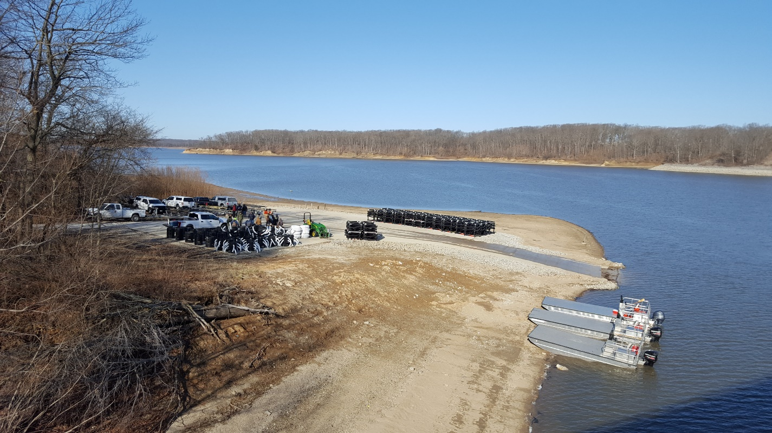
Early morning photo of the Coal Shaft Boat Ramp shortly before a habitat placement day on March 20th, 2021.

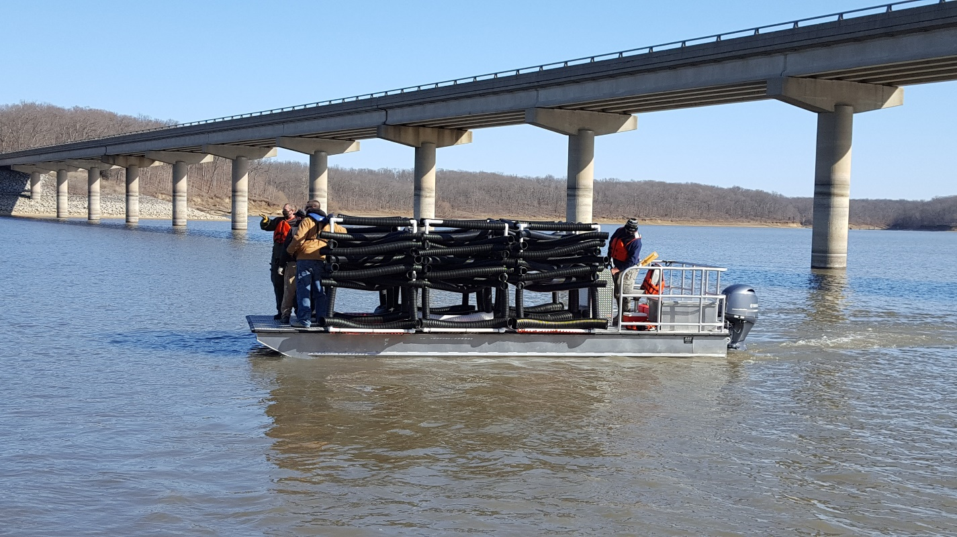
Shelbyville Cubes on their way to being placed on March 20th, 2021.

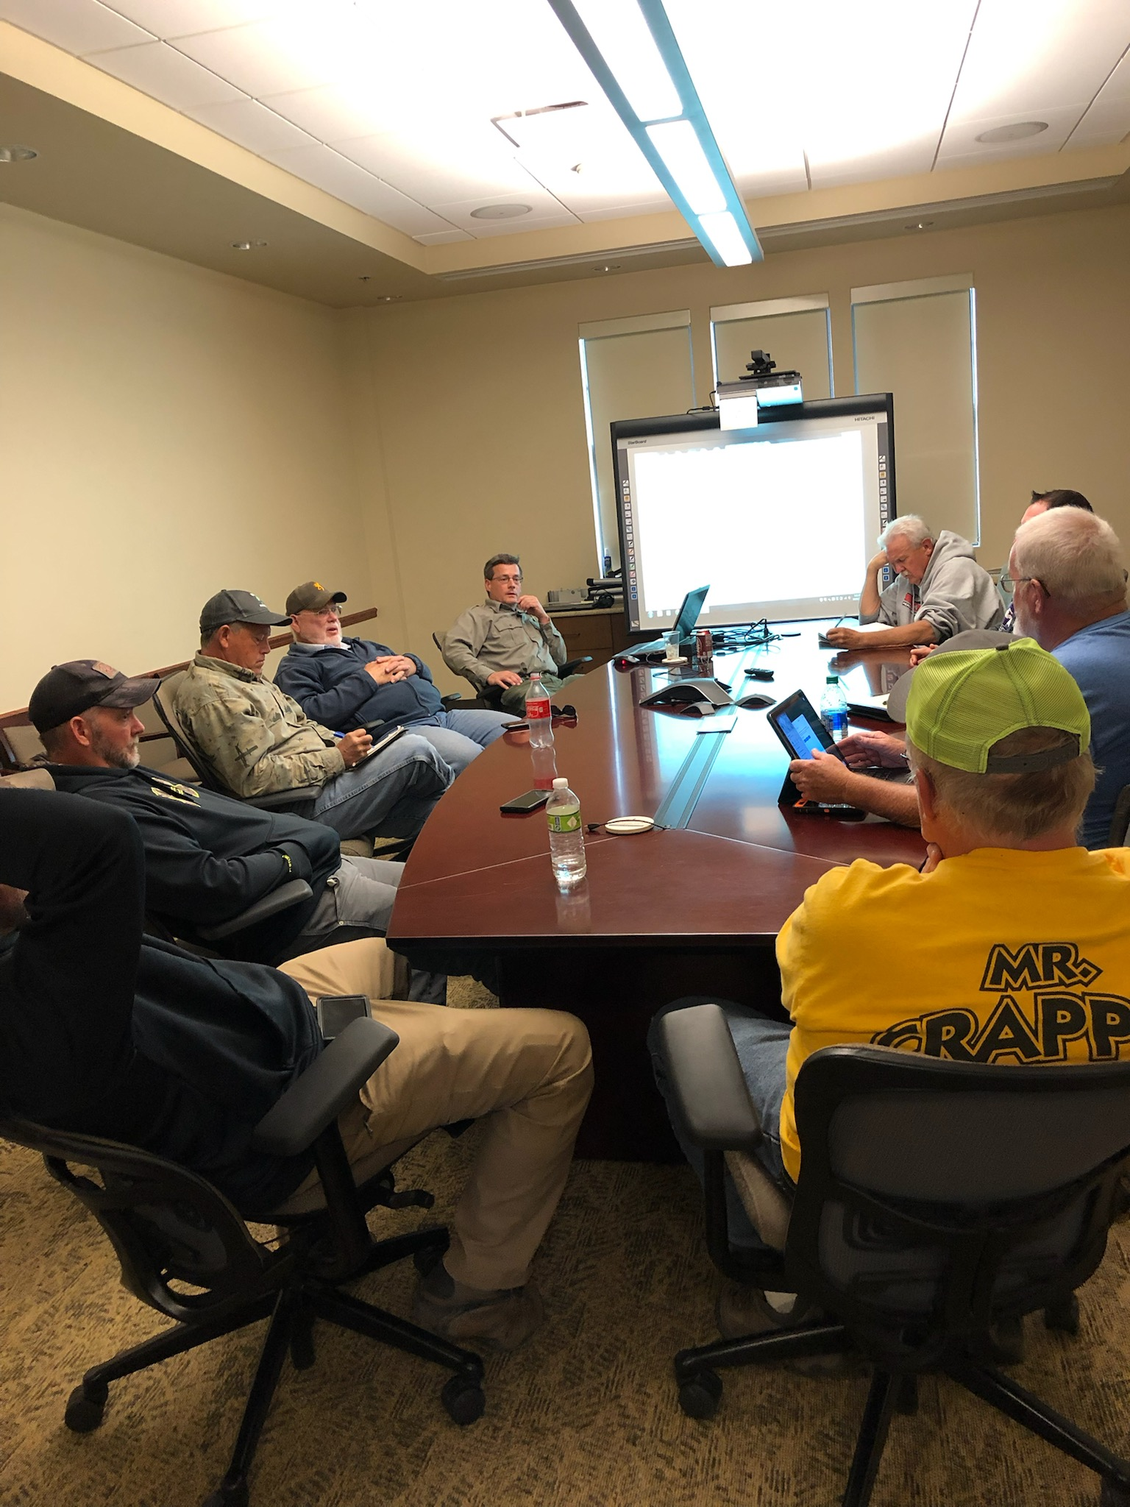
The Lake Shelbyville Fish Habitat Alliance Placement Committee discussing locations for a habitat structure drop.

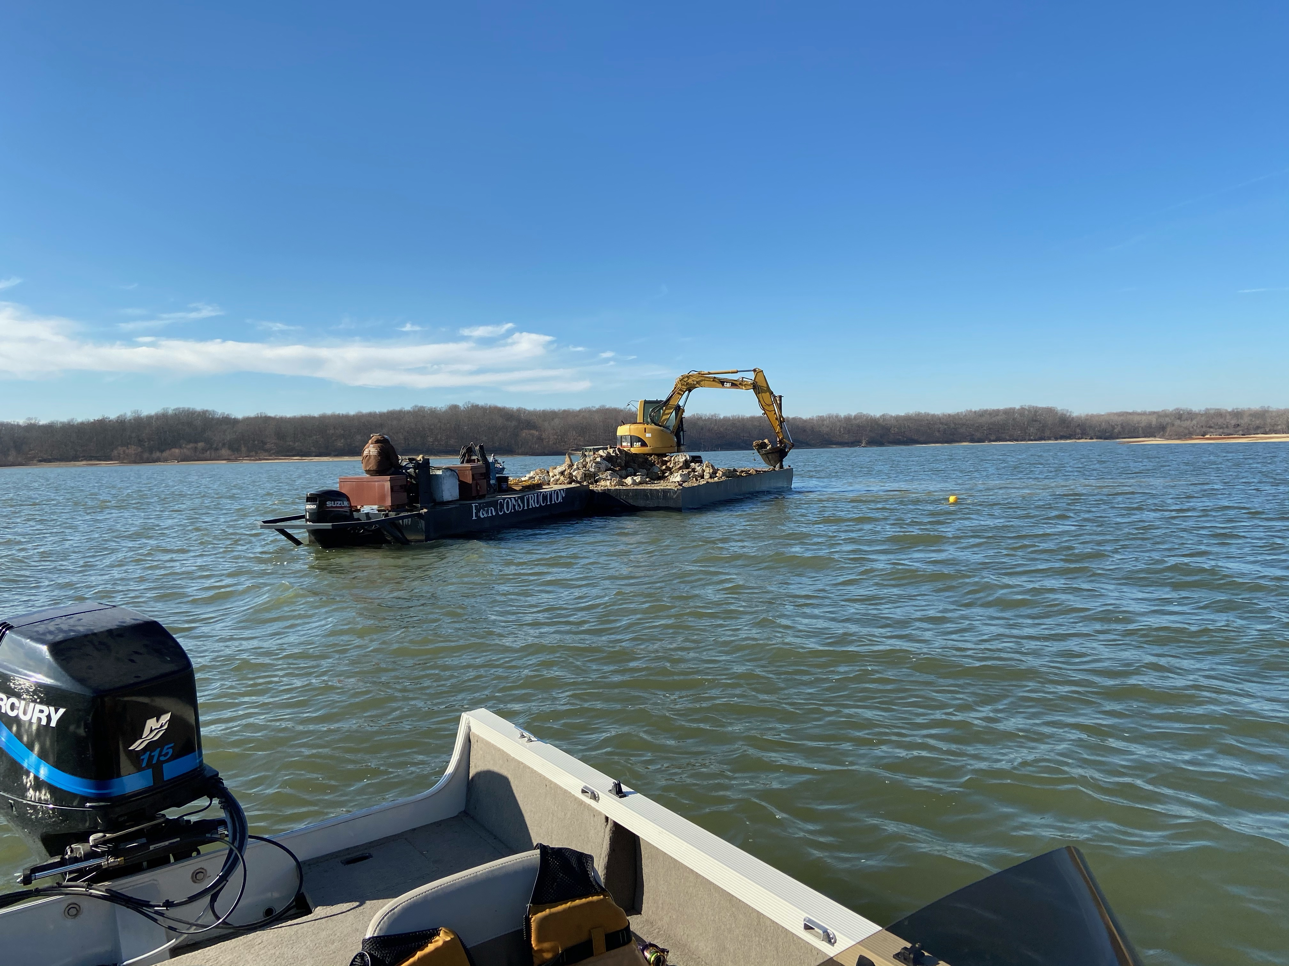
Rock reef placement in December of 2020.

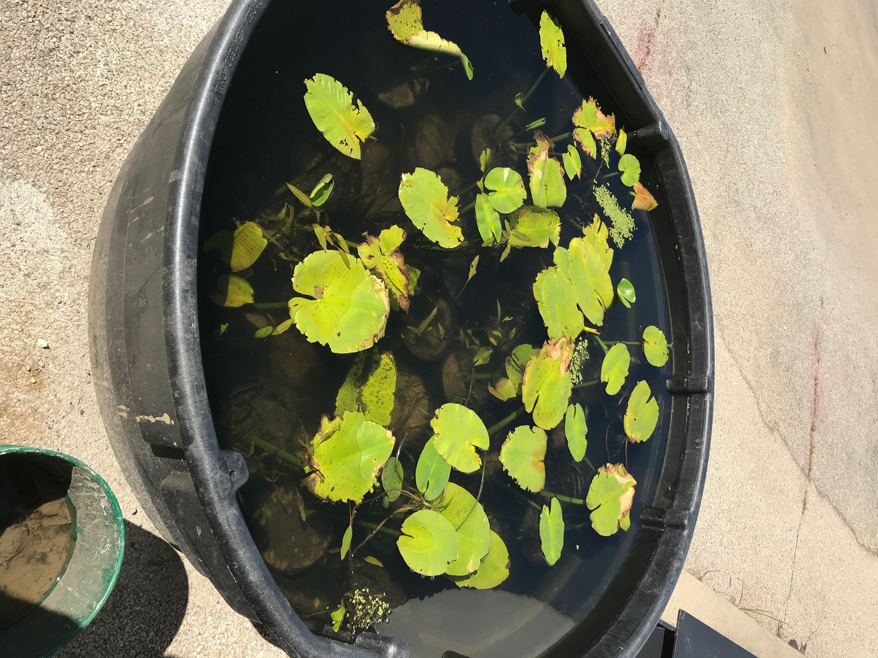
Plants reared in nursery tanks at the USACE Project office.

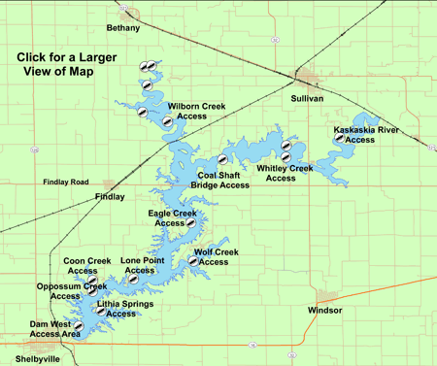
Map of Lake Shelbyville with boat access locations and nearby towns.
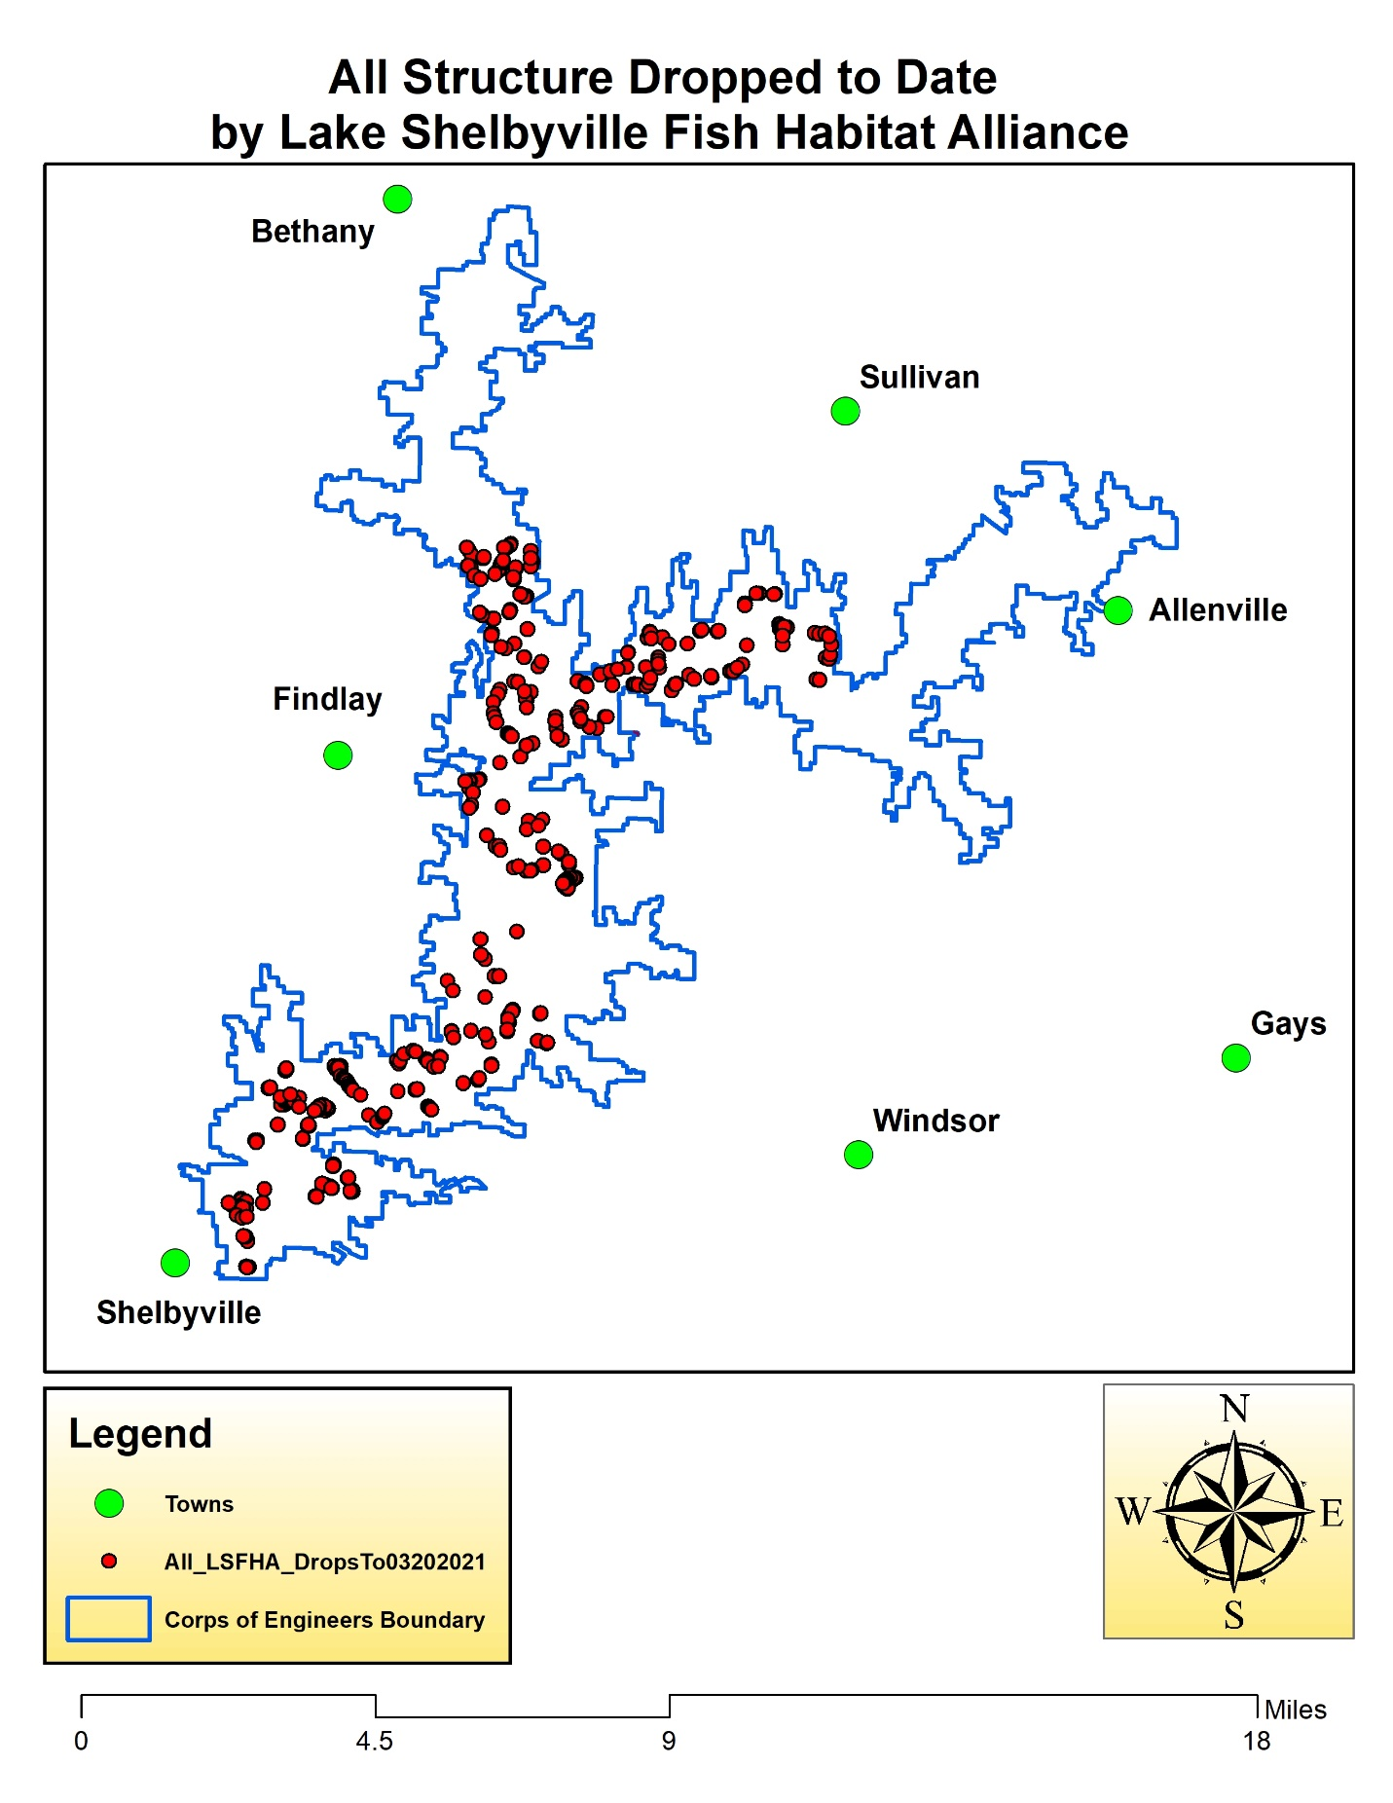
Map of Lake Shelbyville, red dots represent locations of habitat structures added to lake and green dots represent locations of nearby towns.

