**PROJECT MAP—Noxon Rapids and Cabinet Gorge Reservoirs, Sanders County, Montana**

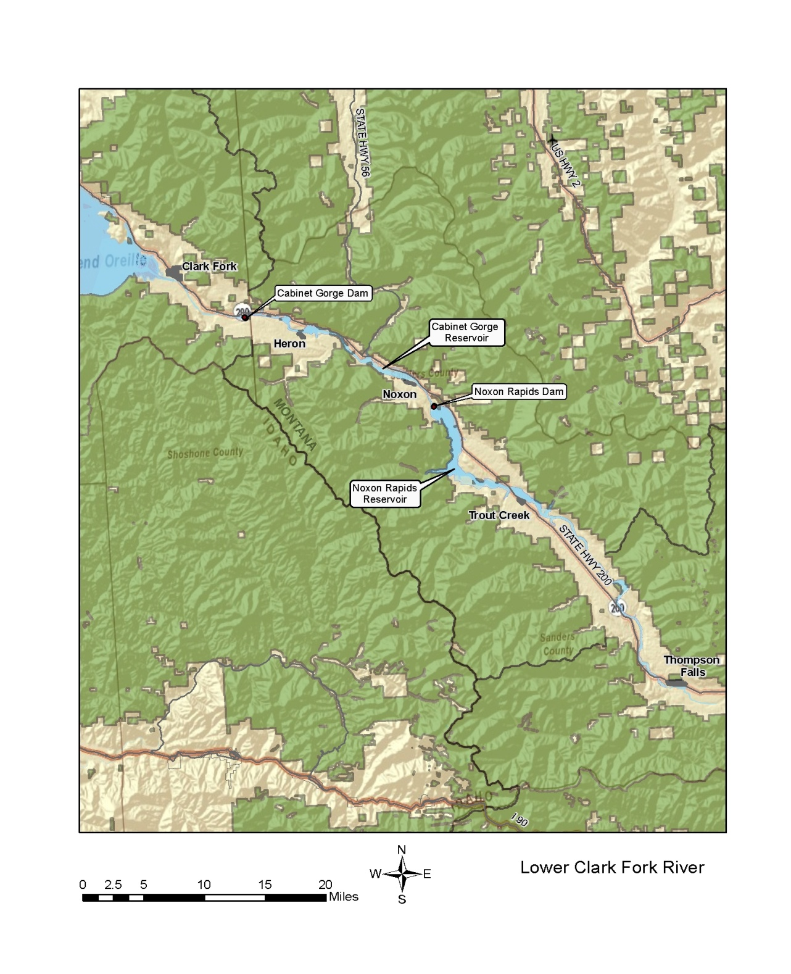

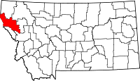

*Sanders County, Montana*