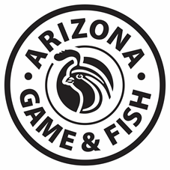 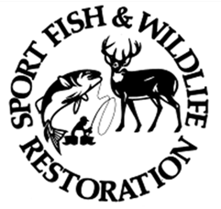

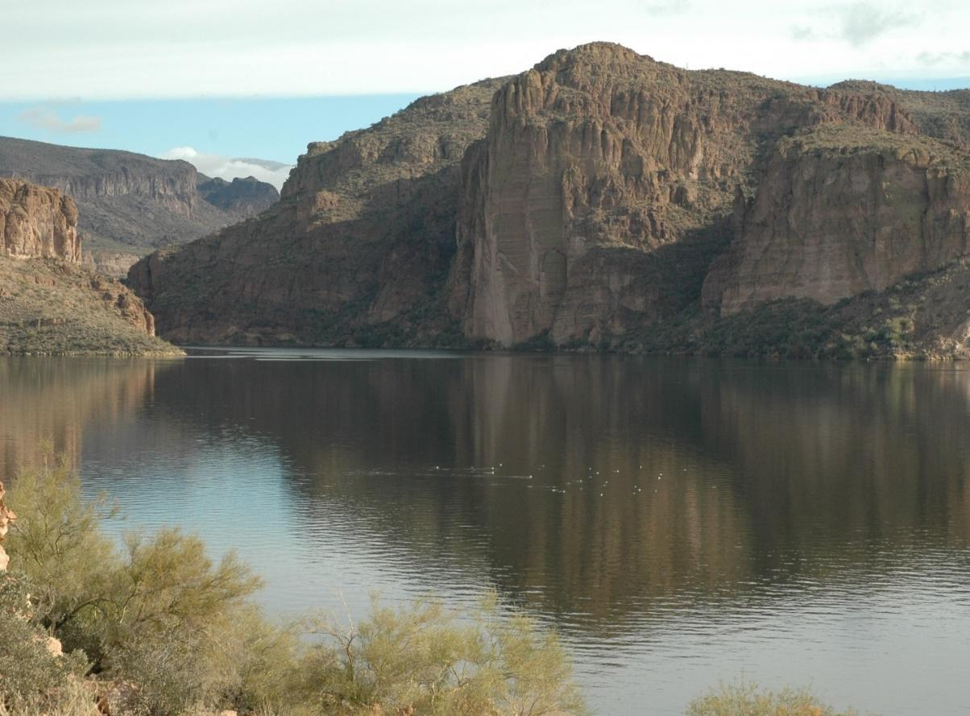

**Canyon Lake**

**Fisheries Management Plan**

**2020-2030**

**Curt Gill, Aquatic Wildlife Program Manager, Region VI**

**The Arizona Game and Fish Department (AGFD) prohibits discrimination on the basis of race, color, sex, national origin, age, or disability in its programs and activities. If anyone believes that they have been discriminated against in any of the AGFD's programs or activities, including its employment practices, the individual may file a complaint alleging discrimination directly with the Directors Office, 5000 W. Carefree Hwy, Phoenix, AZ 85086-5000, (602) 942-3000 or U.S. Fish and Wildlife Service, Attn: Civil Rights Coordinator for Public Access, 5275 Leesburg Pike, MS:WSFR, Falls Church, VA 22041-3803.**

Persons with a disability may request a reasonable accommodation or this document in an alternative format by contacting the Director’s Office as listed above.

**Location**

Canyon Lake is located 82 kilometers east of Phoenix along the Apache Trail in the Tonto National Forest (Figure 1). Canyon Lake is the third lake in the Salt River chain located below Apache Lake and above Saguaro Lake. Canyon lake is located is game management units 22 and 24b.

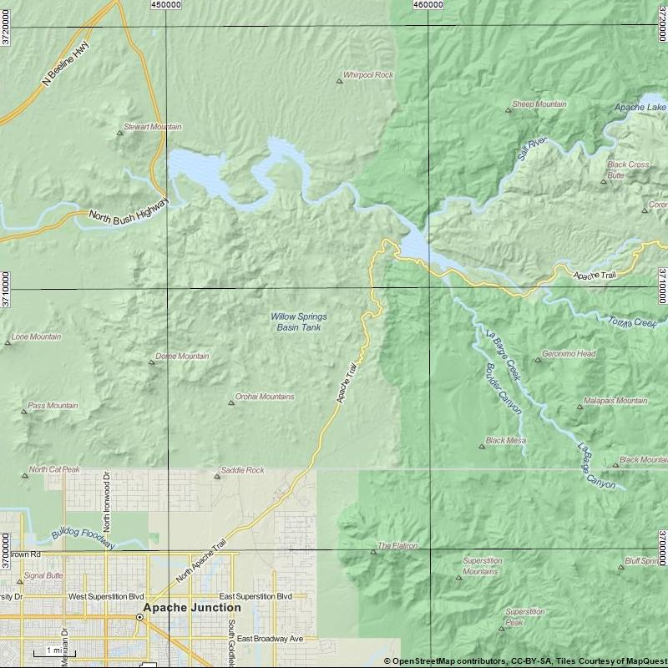

**Figure 1.** Location map for Canyon Lake in central Arizona.

## Management Prescription

The Arizona Game and Fish Department (Department) has developed approaches under a Warmwater Strategic Vision Document (AGFD 2019a) to help guide warmwater fisheries management in Arizona. Using these approaches, fisheries management at Canyon Lake will focus primarily on an AZ Hawg Bass Largemouth Bass *Micropterus salmoides* fishery, secondarily to manage for a Featured Species opportunity fishery for Yellow Bass *Morone mississippiensis*. Additionally, the lake will be managed for a seasonal Intensive Use Rainbow Trout fishery as described in the Department’s Coldwater Sportfisheries Strategic Vision Document (AGFD 2019b).

Objective 1: Maintain the Largemouth Bass population to meet or exceed Hawg standards.

Objective 2:Maintain the Yellow Bass population to meet or exceed the Featured Species standards.

Objective 3: Maintain a seasonally (November to March) stocked Rainbow Trout fishery to meet or exceed the Intensive Use standards.

Objective 4: Maintain angler satisfaction at 80%.

Monitoring activities, including community-wide or species-specific electrofishing surveys and angler creel surveys will be used to determine if aforementioned management objectives are being met. Objective guidelines to meet objectives are listed in Table 1 below.

**Table 1**. Canyon Lake Objectives and Adaptive Management Strategies.

|  |  |  |  |
| --- | --- | --- | --- |
| ***Objective 1: Maintain the Largemouth Bass population to meet or exceed Hawg standards as listed in the Warmwater Sportfisheries Strategic Vision Document.*** | | | |
| **Parameters** | **Objective Guideline** | **Trigger point to address unmet Objectives** | **Strategies if Objectives are not met** |
| Electrofishing Catch Rates | Spring electrofishing CPUE1 ≥ 50 fish per hour. | Mean CPUE drop below 50 fish/hour for three consecutive surveys.  Mean CPUE drops below 10 fish /hour for a single sampling event. | * Re-evaluate survey methods and equipment * Stocking * Regulation Changes |
| Size Structure | PSD2 between 50-80, PSD-P3 between 30-60, and PSD-M4 between 10-25 | Three consecutive sampling events showing population below management guideline. | * Re-evaluate survey methods and equipment * Stocking * Regulation Changes |
| Angler Catch Rates | Angler CPUE of no less than 0.25 fish per hour for anglers targeting Largemouth Bass. | Angler CPUE drops below 0.25 Largemouth Bass per hour for two consecutive creel surveys. | * Stocking * Regulation Changes * Outreach/Education |
| ***Objective 2: Maintain the Yellow Bass population to meet Featured Species standards as listed in the Warmwater Sportfisheries Strategic Vision Document.*** | | | |
| Size Structure | Multiple Age Classes  PSD between 40-70, PSD-P > 10 - 40 | Three consecutive sampling events showing population below management guideline. | * Re-evaluate survey methods and equipment * Regulation Changes |

|  |  |  |  |
| --- | --- | --- | --- |
| ***Objective 3: Maintain a seasonally (November to March) stocked Rainbow Trout fishery to meet or exceed the Intensive Use standards******as listed in the Coldwater Sportfisheries Strategic Vision Document.*** | | | |
| Angler Catch Rates | Angler CPUEno less than 0.5 fish per hour for anglers targeting Rainbow Trout. | Angler catch rate drop below 0.5 fish per hour for two consecutive creel surveys. | * Adjust stocking rates * Regulation changes * Re-evaluate Objective |

|  |  |  |  |
| --- | --- | --- | --- |
| ***Objective 4: Maintain angler satisfaction at 80%.*** | | | |
| Angler Satisfaction | Angler satisfaction in creel surveys >80%. | Angler satisfaction drops below 80% for two consecutive creel surveys. | * Stocking * Outreach/education |

1CPUE=Catch Per Unit Effort (fish per hour), 2 PSD=Proportional Size Distribution, 3 PSD-P = Proportional Size Distribution – Preferred, 4 PSD-M = Proportional Size Distribution –Memorable

**Background**

Canyon Lake has a surface area of 384 hectares at maximum level, an average depth of 39 meters (128 feet) and is 550 meters (1,800 feet) in elevation (Figure 1). It is located 82 kilometers (51 miles) east of Phoenix along the Apache Trail in the Tonto National Forest. Canyon Lake was formed in 1925 as a result of the construction of Mormon Flat Dam on the Salt River. The reservoir is third in a chain of four hydropower/irrigation storage reservoirs which are impounded on the Salt River. Water level fluctuations rarely exceed an average of 2.4 (7-8 feet) vertical meters annually and 1-1.2 meters (4 feet) daily depending on hydro pump-back storage operations. At maximum, the impoundment is 16 kilometers long and the shoreline extends 45 kilometers (28 miles).

The land around Canyon Lake is managed by the U.S. Forest Service, more specifically the Tonto National Forest. The aquatic species within the lake are managed under the authority of the Arizona Game and Fish Department (Department). The Department’s sportfish management objectives are to provide a diversity of sportfish to anglers.

**Productivity/Water Quality**

In 2006, a lake profile was completed for Canyon Lake. Four locations were sampled measuring temperature, conductivity, pH, dissolved oxygen and total dissolved solids every meter in depth until reaching the lake floor. At the dam site temperatures ranged from 22.63 Celsius at the surface to 18.82 Celsius at 29 meters (95 feet) in depth. Conductivity showed very little change from 1,155 ohms at the surface to 1,143 ohms at the lake floor. The pH at the surface was recorded at 8.34 and steadily dropped to 7.45. Dissolved oxygen was 7.30 mg/l at the surface, increasing to 7.44 mg/l at 2 meters (6.5 feet) before dropping to 4.37 mg/l at 6 meters (20 feet) and 2.07 mg/l at 7 meters (23 feet) . Dissolved oxygen fell slowly to 1.06 mg/l on the lake floor. Total dissolved solids ranged from 0.7394 g/l at the surface to 0.7315 g/l at 29 meters (95 feet), showing very little change in TDS at different lake depths. All four sites show similar lake parameters. Depths deeper than 15 meters (50 feet) become very anoxic at all four sampling locations.

Fox et al. (2013) initiated another water quality study of Canyon Lake under a grant by the Department in April of 2017 to provide detailed dissolved oxygen and temperature profiles through Canyon Lake for one complete period of stratification. Sampling was continued until November of 2017 and stratification dissipated in mid-October of 2017. A total of 19 field sampling trips were made during the course of the study. Fox et al. (2013) were to identify regions in Canyon Lake where quagga mussels *Dreissena bugensis* might be capable of surviving and reproducing. Their report suggested temperatures at the surface did exceed 28oC at all sampling locations, however, the time periods that surface temperatures were potentially stressful to quagga mussels was one month or less. Temperature data revealed that thermal stratification occurred from May until October and dissolved oxygen became depleted in the hypolimnion (lower layer of water in a stratified lake) which was present at a depth of 5 m (16 feet) or deeper in Canyon Lake (Fox et al. 2018). The majority of Canyon Lake had dissolved oxygen concentrations lower than 2 mg/l in the hypolimnion and the time periods that would be stressful to quagga mussels increased with depth in Canyon Lake (Fox et al. 2018).

Depths of 15 m (50 feet) or greater could experience dissolved oxygen concentrations lower than 2 mg/l for over 90 days. At depth of 5 m, dissolved oxygen concentrations can be lower than 2 mg/l for over 30 days. Most locations near the shore had similar oxygen and temperature depth profiles. Locations in the river channel had less stratification and did not have as much reduction in dissolved oxygen as compared to other locations (Fox et al. 2018).

Future water quality measurements should be collected at a quarterly basis to gather much needed lake profile data in our heavily recreated reservoirs. The Regional Aquatic Wildlife Program will work with the Water Quality Program at Phoenix Headquarters to develop a plan to begin gathering productivity data where feasible and appropriate.

Currently there is very little data for the zooplankton population in Canyon Lake. It is recommended that a study of the zooplankton population be completed to update knowledge and understanding of conditions at the lake.

Phytoplankton

Phytoplankton resources in Canyon Lake have been poorly documented over the years. However, golden alga *Prymnisium parvum* was first discovered in Arizona in 2005 and has since been identified in all four reservoirs along the Salt River on the Tonto National Forest. Golden alga has been documented to be the cause of several fish kills that have occurred in these reservoirs, which includes Canyon Lake. Under certain environmental stresses, golden algae produce a toxin that negatively affects gill-breathing species such as fish, mollusks, arthropods, and the gill-breathing stage of amphibians (Stewart et al. 2013). Additionally, golden alga has been found in more than 30 small municipal or private waters and several urban fishing lakes in central Arizona. Golden alga was likely present as early as 2001 following a substantial die-off of Asian clam *Corbicula fluminea* in Saguaro Lake. Canyon Lake has had minor and major kills since 2005 with the most recent kill occurring in 2018.

**Forage/Prey**

The prey base in Canyon Lake is predominately made up of sunfish and Threadfin Shad *Dorosoma petenense*. Monitoring of the sunfish populations as a constituent of the prey base occurs as part of the electrofishing survey conducted every 2 years in the fall.

Bluegill

Bluegill *Lepomis macrochirus* provide recreational angling opportunities and are an important forage fish for littoral predators at Roosevelt Lake. Catch rates and length ranges for Bluegill are included in the species discussion later in the document.

Shad

Canyon Lake contains both Gizzard *Dorosoma cepedianum* and Threadfin Shad *Dorosoma petenense*. Adult Gizzard Shad are able to reach large sizes and can outgrow gape limits of many predators. Threadfin Shad adults are considerably smaller, rarely exceeding 6 inches in length. Threadfin are temperature sensitive and stress at temperatures below 45°F. Few Gizzard Shad have been captured at the lake with eight being captured in 2014 and 41 in 2018.

**Habitat**

Habitat was placed into Canyon Lake in 2008 during a planned 50 foot drawdown of the reservoir. The habitat plan was to place man made structure and natural debris into the dry lakebed before it was refilled in January of 2008. Three sites were chosen at Canyon Lake due to their topography, e.g. ledges close to deep water, humps off outside points, or sloping boulder shorelines that offered the best enhancement opportunities. Habitat structures were made up of three pallets to form a tee-pee, ten cement blocks inside the triangle and then lashing three trees to the outside of the triangle (Robb 2008). Habitat was also placed into Canyon Lake at LaBarge Cove in 1988. Three different man made habitat types were used including “Crappie Condos”, “Fish ‘N Trees”, and “Catfish Condos”. Roughly 75% of the habitat was placed within casting distance of the shore or fishing pier. (Warnecke and McMahon 1988) Over time reservoir habitat degrades leaving very little structure for predatory and prey fish species. Since Canyon Lake does not fluctuate as much as other reservoirs it will be a great candidate for installing more habitat on a regular basis. The Department recently received clearance through the Tonto National Forest to install natural and artificial habitat in all the Region VI lakes on the Tonto. Canyon Lake is scheduled to have habitat structure installed beginning with Georgia Cubes as early as the fall of 2020 and then Christmas trees in winter 2021/2022. Other habitat structure may be installed in the lake in a later phase and will be incorporated into the Canyon Lake Habitat Implementation Plan.

**Species**

The major sportfish in Canyon Lake include Largemouth Bass, Bluegill*,* Yellow Bass,and Channel Catfish. The primary forage species include Threadfin Shad, Gizzard Shad, and several species of sunfish *Lepomis* spp. Other species found in the lake include Walleye *Stizostedion vitreum*, Flathead Catfish *Pylodictis olivaris*, Black Crappie *Pomoxis nigromaculatus*, Common Carp *Cyprinus carpio*, and Yellow Bullhead *Ameiurus natalis.*

There are no special fishing regulations which apply to Canyon Lake. All species are managed under statewide general daily bag limits.

Black Bass and Temperate Bass

Canyon Lake contains Largemouth Bass and Smallmouth Bass is known as one of the best black bass lakes in the Southwest. The lake also contains a high density population of Yellow Bass which are known to attain trophy size. In 2014, Canyon Lake ranked as the #9 fishing lake in Arizona by angler use day according to results from a Department commissioned angler opinion survey (Fisheries Branch 2015).

*Largemouth Bass:*

The Largemouth Bass population at Canyon Lake continues to produce trophy size class fish. The current state record Largemouth Bass came from Canyon Lake which is almost 16.5 pounds and was caught in 1997. The Department’s Warmwater Strategic Vision document (AGFD 2019a) set targets for Largemouth Bass populations that are managed under a Hawg Bass approach with proportional size distribution (PSD) values in the range of 50-80%, RSD-Preferred values in the range of 30-60% and RSD-Memorable values in the range of 10% - 25. The 2007 through 2009 fall surveys had PSD’s of 93, 24 and 49 respectively. For the 2014 fall survey the PSD value was 58. PSD-P values for 2007, 2008, 2009 and 2014 were 61, 22, 12 and 23. PSD-M values for 2007, 2008, 2009 and 2014 were 6, 2, 3 and 2 respectively (Table 3). Future survey efforts will need to take place more consistently to get a better understanding of the Largemouth Bass population at Canyon Lake. While the population is within guidelines in the PSD and PSD-Preferred categories for a balanced Largemouth Bass population; the population does fall short in being considered for a trophy population. While the population is within guidelines periodically it appears that the population cannot maintain itself within these guidelines. It might be possible to increase and maintain the population within these guidelines by reducing or eliminating harvest on Largemouth Bass over 18 or 20 inches in an effort to protect the larger individuals. However this is not likely to be popular with the many tournament anglers that participate in the numerous tournaments at the lake as it will restrict their ability to weigh multiple fish bags.

The Department’s Warmwater Strategic Vision document (AGFD 2019a) recommended that Largemouth Bass managed under a Hawg Bass approach should have a relative weight that falls within a range of 95 to 105. Largemouth Bass require a prey source that is roughly 15 percent of the bass's total length to express a relative weight around 100. Largemouth Bass with a relative weight less than 95 are feeding on prey that are less than 15 percent of the bass's total length while bass with a relative weight greater than 105 are feeding on a prey source that is greater than 15 percent of that fishes total length. Mean relative weights in 2007, 2008, 2009 and 2014 were 108, 96, 95 and 94 (Table 4). The data shows that the relative weights of the bass population have remained fairly stable and within or near the 95 to 105 range suggesting that there is adequate prey of the appropriate size in the lake to support the Largemouth Bass population. No surveys were conducted in the fall of 2012 due to a lack of staffing.

Catch per unit effort (CPUE) was highest in the most recent survey in fall 2014 with 27.29 fish per hour. Fall 2008 had the lowest CPUE with 16.1 fish per hour. This low CPUE was most likely due to the recent Golden Algae die off in the reservoir. (Table 2)

In looking at the length frequency data for this period the data shows a good distribution of fish throughout the entire population (Figure 2 and 3). Length frequency data does not suggest problems in the population and in fact suggest that the population is very healthy with both reproduction and recruitment occurring at levels that are adequate for maintaining the bass population in spite of what is thought to be a large amount of angling pressure.

The Department collected DNA samples from Largemouth Bass in 2014 that indicated that 13% of the bass were pure Florida strain, 0 % were F1, 87 % were Fx, and 0% were northern strain bass. Additionally, it was determined that 83% of the alleles were from Florida strain and 17% were from northern strain Largemouth Bass. The percentage of Florida strain alleles is the highest of any among the Department’s Region VI lakes and may be why both lakes produce more trophy size bass than the other Region VI lakes.

*Yellow Bass:*

The Yellow Bass population in Canyon Lake is thriving and underutilized by anglers. Proportional size distribution values from 2007, 2008, 2009 and 2014 were 93, 57, 47 and 92 respectively. PSD-P values from 2007, 2008, 2009 and 2014 were 54, 26, 40, and 83 respectively. PSD-M values from 2007, 2008, 2009 and 2014 were 13, 9, 8 and 24 respectively. These values indicate distribution in multiple size classes including decent numbers in memorable size class. Mean relative weights for the fall 2007, 2008, 2009 and 2014 surveys were 98, 93, 93, and 98 respectively. These values fall near or in the recommended range of 95-105. Yellow Bass mean relative weights indicate the population is healthy and utilizing the prey base. The AZGFD should continue to promote the fishing opportunities for Yellow Bass in Canyon Lake. High catch rates are possible once knowledge of the Yellow Bass fishery is obtained by the angler.

*Bluegill/Sunfish:*

The Bluegill population appears stable however the PSD values show that the population is dominated by smaller fish, evidenced by the lack of individuals in the PSD-Preferred category. For Bluegill populations to be able to support a trophy bass population Willis et al. (1993) recommended that PSD values should be in the range of 10% to 50% and PSD-Preferred values should fall in the range of 0% to 10%. The 2009 fall electrofishing survey had a PSD of 54.05 and a PSD-P of 0.44. The 2014 fall electrofishing survey had the PSD for Bluegill at 36.78 and the PSD-P at 1.36. Proportional stock density in every size category fall into Willis et al. (1993) preferred ranges for a trophy population of Largemouth Bass and Bluegill fishery. This could be because lack of habitat or large number of predatory species not allowing them to get to larger size classes. Relative weight values are consistently just at or below the management guidelines of 95 to 105. Relative weights for the 2009 fall survey fell into the accepted range for a balanced population of Bluegill. The Wr-stock was 99.36, the Wr-quality was 95.17 and the Wr-preferred was 95.83. The 2014 fall survey the relative weights fell below the acceptable range for a balanced population. The Wr-stock was 90.34, the Wr-quality was 91.81 and the Wr-preferred was 86.03. Length frequency data mirrors the PSD data and it appears that the population is well distributed in the various smaller size classes, but lack larger size classes (Table 3). Bluegill as a species typically average between 120-mm and 200-mm in length. The majority of the Bluegill fall under 140 mm for the last 4 surveys, although the most recent 2015 survey does show some recruitment to larger size classes. We will continue to monitor the Bluegill population during each fall electrofishing survey. Catch per unit effort (CPUE) was highest in the most recent survey in fall 2014 with 100.95 fish per hour. Spring 2010 had the lowest CPUE with 53.99 fish per hour. This low CPUE was most likely due to the recent Golden Algae die off in the reservoir.

*Rainbow Trout:*

Rainbow Trout are stocked between November and March at Canyon Lake to create a seasonal fishery for this popular species. Canyon Lake is typically stocked every two weeks during this period and receives 1,500 catchable Rainbow Trout per month. Although they are only stocked seasonally, they account for 39.6% of the sportfish harvest between June 2007 and May 2010 (Stewart et al. 2013). The demand for Rainbow Trout continues to increase annually throughout

the state however and Department hatcheries have been producing at their capacity for many years now. As funding and trout supplies allow, the Department will continue seasonal stocking of Rainbow Trout under an Intensive Use approach with an objective of achieving angler catch rates of 0.5 fish per hour.

*Undesirable or Invasive Species:*

Gizzard Shad were recently introduced into the lake with a total of eight adult Gizzard Shad sampled in 2014 and 41 in 2018. Future surveys will continue to include gill netting to follow the population trends of Gizzard Shad.

Quagga mussels were collected in late 2015 on a boat near the marina. Quagga mussel veligers also were collected. A quagga mussel dive was conducted in March 2016 to determine population size of quagga mussels. During the dive a total of two adult quagga mussels were found. Monitoring should continue to determine population trends over time. AIS technician efforts should be focused on Canyon Lake to inform the public about the recent findings and to prevent future spread.

**Access**

Canyon Lake currently has two boat ramps, Palo Verde and Laguna. Boulder cove is a recreation site on Canyon Lake that has a fishing pier. The pier is closed for repair until further notice. Information can be found on the Tonto National Forest website. Fishing access can be found from multiple parking lots along the south side of the lake. The Department will continue close coordination with the Tonto National Forest for boat ramp, fishing pier and parking area maintenance and improvements.

**Catch**

Creel surveys had not been conducted at Canyon Lake since 2010 until the Region VI Aquatics program started one in summer 2019. Unfortunately, the survey was recently cut short due to the lake being closed because of Covid-19. However, results of that survey are currently in progress. Catch rate goals for Canyon Lake should be at minimum 0.25 fish per hour for Largemouth Bass when anglers are specifically targeting those species. Canyon Lake will continue being managed as a Hawg Bass Largemouth Bass fishery therefore, catch rates will be lower than other lakes managed as High Quality or General Opportunity fisheries, but size should be larger. Catch rates for Rainbow Trout should be 0.5 fish per hour when anglers are specifically targeting them and it is during the stocking season. Having necessary catch rate, harvest and angler satisfaction data is important in making management decisions, especially with a Hawg Bass fishery.

**Satisfaction**

According to the Golden Alga project from 2007-2010 angler satisfaction at Canyon Lake was 67.4 % (Stewart et al. 2013). The Department’s goal for angler satisfaction is 80% of anglers having a good or excellent experience. A creel studies was recently conducted at Canyon Lake and results are in progress. This survey will be used to determine current angler satisfaction at the lake.

**Literature Cited**

Arizona Game and Fish Department (AGFD). 2019a. Warmwater Sportfisheries Strategic Vision Document. 2015-2025. Arizona Game and Fish Department, Statewide Fisheries Program.

Arizona Game and Fish Department (AGFD). 2019b. Coldwater Sportfisheries Strategic Vision Document, 2015-2025. Arizona Game and Fish Department, Statewide Fisheries Program.

Fisheries Branch. 2015. 2013 Arizona Angler User Days, Fishing Economics and Angler Demographics, Federal Aid Project FW-100-P-23. Arizona Game and Fish Department, Phoenix Arizona.

Fox, P., T. Lau, A. Buell. 2018. The Potential for Quagga Mussel Survival and Reproduction in Canyon Lake, Deliverable 4 – Final Report. School of Sustainable Engineering and the Built Environment. Arizona State University

Robb, N. 2008. Canyon Lake Fish Habitat Improvement Project Completion Report, Arizona Game and Fish Department, Mesa, AZ.

Stewart, W.T., A.S. Makinster, A. K. Vasey, and L.D. Avenetii. 2013. Salt River reservoir

golden alga project. Arizona Game and Fish Department, Research Branch, Technical Guidance Bulletin No. 13. Phoenix. 148 pp.

Warnecke, J., McMahon, T. 1988. Canyon Lake – LaBarge Cove Fish Habitat Project. Arizona Game and Fish Department. Mesa, AZ.

Willis, D.W., B.R. Murphy, and C.S. Guy. 1993. Stock density indices: development, use, and limitations. Review in Fisheries Sciences 1:203-222.

**Tables and Figures**

**Table 2.** Mean catch-per-unit-effort (CPUE) of fish captured during electrofishing surveys in Canyon Lake.

|  |  |  |  |  |  |  |  |
| --- | --- | --- | --- | --- | --- | --- | --- |
| Species | Fall 2007 | Spr. 2008 | Fall 2008 | Spr. 2009 | Fall 2009 | Spr. 2010 | Fall 2014 |
| Largemouth Bass | 23.18 | 23.08 | 16.10 | 17.24 | 19.34 | 24.46 | 27.29 |
| Bluegill | 60.59 | 60.25 | 63.35 | 65.58 | 64.55 | 53.99 | 100.95 |

**Table 3.** Proportional stock density (PSD), proportional stock density of preferred-sized fish (PSD-P), proportional stock density of memorable-sized fish (PSD-M), and proportional stock density of trophy-sized fish (PSD-T) captured during fall surveys in Canyon Lake.

|  |  |  |  |  |  |  |  |  |  |  |  |  |  |  |  |  |  |  |  |
| --- | --- | --- | --- | --- | --- | --- | --- | --- | --- | --- | --- | --- | --- | --- | --- | --- | --- | --- | --- |
|  | PSD | | | | PSD-P | | | | | PSD-M | | | | | PSD-T | | | | |
| Species | F07 | F08 | F09 | F14 | | F07 | F08 | F09 | F14 | | F07 | F08 | F09 | F14 | | F07 | F08 | F09 | F14 |
| Largemouth Bass | 93 | 24 | 49 | 58 | | 61 | 22 | 12 | 24 | | 6 | 2 | 3 | 2 | | 0 | 0 | 0 | 0 |
| Bluegill | 22 | 13 | 49 | 36 | | 1 | 0 | 0 | 1 | | 0 | 0 | 0 | 0 | | 0 | 0 | 0 | 0 |

**Table 4.** Mean relative weight of fish captured during fall electrofishing surveys in Canyon Lake 2007 to 2014.

|  |  |  |  |  |
| --- | --- | --- | --- | --- |
| Species | Fall 2007 | Fall 2008 | Fall 2009 | Fall 2014 |
| Largemouth Bass | 101 | 92 | 95 | 94 |
| Bluegill | 109 | 92 | 97 | 89 |

**Figure 2**. Length Frequency of Largemouth Bass at Canyon Lake sampled fall 2007, 2008, and 2009 during electrofishing surveys.

**Figure 3.** Length Frequency of Largemouth Bass at Canyon Lake sampled 2014 during electrofishing and gill netting surveys.