A. Applicant Information:

Sun Country Outdoors, 12913 Blackstone Rd NE, Albuquerque, NM 87111

President and NMBN Conservation Director Earl Conway 12913 Blackstone Rd NE, Albuquerque NM 8711, (505) 610-5156. Way2busy2fish@aol.com

USACE counterpart Wesley C. Myers, U.S. Army Corps of Engineers, 82 Dam Crest Road, Pena Blanca, NM 87041, (505) 465-0307, Wesley.C.Myers@usace.army.mil

Project Manager: Savanah Rampy, Sun Country Outdoors intern, sarampy@gmail.com

B. Friends of Reservoirs (FOR) Group that is active in the project.

New Mexico Bass Nation and Sun Country Outdoors

C. Project Information

Title: Cochiti Lake Aquatic Habitat Enhancement Project

Location: Cochiti Reservoir, Pena Blanca, NM; Sandoval county, Xeric Region
35°37’37.64” N
106°18’56.02 W

U.S. Congressional District: NM-3

Target Species (priority order): Largemouth bass, Smallmouth bass, Crappie spp., Catfish spp., Sunfish spp., Walleye, Northern Pike, White bass

The project overview is a critical part of the application that should provide reviewers with sufficient detail to fully understand the proposed project. Please review the Evaluation Criteria to ensure that all relevant information has been included.
Please include the reservoir history, when impounded, on which river/creek the dam is located, status of the existing fishery (include the latest creel information, economic value, etc.), the existing relevant habitat conditions and the desired or targeted conditions. Is this a component of a larger, existing habitat restoration project? If so, describe. Does the overall project include amenities such as increased access, natural trails, etc. that would lead to an improved outdoor experience for reservoir users? Is the project expected to improve water quality? Are there components of the project that might mitigate climate change effects on the fishery? Project outcomes expected, e.g., size of the area to be restored, number of habitat structures to be installed, species that will benefit from the restoration activity, and the specific restoration methods and techniques that will be used).

Project Objective(s):
This project addresses several impairments: sedimentation, aquatic invasive species and initial vegetation removal and earth scouring during dam construction. The lake has also been subject to hazardous algae blooms. This grant will be directed towards the propagation of native aquatic and shoreline vegetation and fish habitat placement with an emphasis on spawning enhancement for both game and forage fish species.
Severe wildfires in the adjacent Jemez mountains have exacerbated and accelerated the rate of sediment deposition and cove siltation in Cochiti Lake. Over 8 miles of prime spawning shoreline has been destroyed and an additional one to two miles of spawning habitat is lost each year. The additional sedimentation and local erosion has also led to aggressive invasion of Eurasian watermilfoil, choking out native aquatic plant species. Also an unresolved impairment is the clearcutting and leveling of the entire area near the earthen dam. The barren coves have almost no structure nor vegetation except the Eurasian watermilfoil. Therefore, the major objectives of the project are: 1) To improve and revitalize degraded aquatic habitat and enhance local aquatic communities through aquatic invasive species removal, 2) improve aquatic habitat by stabilizing eroded shorelines and improving bank shading through native vegetation establishment and management, 3) create spawning and production fish habitat by deploying fish habitat structures adjacent to restoration sites, channels, and barren construction scars, 4) enhance spawning sites for prey-base species including gizzard shad and yellow perch. 5) increase angler use of fish habitat sites (boat and shoreline anglers) to increase awareness and support, and 6) increase angler/user and public knowledge about the value and benefit of a healthy reservoir ecosystem through project outreach events and media coverage. While it is not explicitly an objective of this project, there is reason to believe that success with the project will also reduce the excess nutrients that lead to hazardous algae blooms.

This project grant will support continuation of a project that has begun with a thorough evaluation of the reservoir, documentation of sedimentation and Eurasian watermilfoil impairments, options for water manipulation, and reviews of multiple fish electroshocking surveys. The project is currently constructing an on-site greenhouse for propagation of native aquatic plants to be used as part of an extensive AIS eradication and replacement strategy funded by the Corps, partners and an AFTCO grant.

This grant will be directed towards the following methods:
- construction and placement of specifically designed or selected fish habitat with an emphasis on spawning enhancement for both game and prey-base species,
- continue efforts to eradicate the Eurasian watermilfoil and replace it with native vegetation, and
- increase public user interest and satisfaction through education, participation and enhanced angling opportunities with an emphasis on youth involvement.

Examples of comprehensive methods include the application of aquacide to approximately 130 surface acres of the reservoir over the time span of 3 years (additional applications may be needed for thorough control of invasive species) by the USACE. Using best practices from other RFHP projects and the recommendations from the WOTS assessment, approximately 3.37 miles of shoreline will be revegetated with aquatic natives grown on site and pole plantings of shoreline plants. Artificial fish habitat will be placed by design including 14 concrete culvert pipe fish habitat structures, 150 American Fish Tree 4 ft tree plastic fish habitat structures (or equivalent), 40, 3.5 ft tall concrete reef ball modules, and 100 fish cribs with integrated spawning mats for gizzard shad and yellow perch. Other custom designed artificial habitats will also be used to fill in niches and experiment with sediment and siltation control. Sun Country Outdoors has extensive knowledge and experience with habitat selection and design based on a decade of adaptive innovation.

Project success will be measured primarily by the reduction in the invasive aquatic species Eurasian watermilfoil acreage, the survival and growth of native vegetation plantings and live stakes, and the number of fish habitat structures deployed. Secondary data will be collected related to the how fish use of habitat structures at restoration sites (e.g., increased large mouth bass catch rate in NMDGF samples and by anglers), and the measured reproductive success of prey-base species. However, it has been problematic doing reliable electroshocking or gill-netting at this reservoir due to the turbidity, depth and snags.

Estimated on-the-ground start and end dates: June, 2022 – June, 2024

Amount of grant and estimated total cost of project: RFHP Grant request of $50,000; estimated total project materials cost: $80,000. Budget details included in Partnership Budget Table

List of partners: U.S. Army Corps of Engineers, New Mexico Bass Nation, Sun Country Outdoors/Friends of Reservoirs, Rinker Materials, New Mexico Wildlife Federation, New Mexico Department of Game and Fish, Jaynes Construction, New Mexico State Tourism Department, Duke City Bass Bums, Bureau of Land Management (AIS). Likely grantees to be coordinated through New Mexico Bass Nation include: Bass Pro Shops, AFTCO, AERF, Shimano, Blues Baits, Zia Kayaks, The Turner Foundation, Shady Lakes and others.

D. Project Description

The proposed project will address several regional reservoir habitat impairments. Control of the aquatic invasive species Eurasian watermilfoil will have a positive impact on biodiversity and aid in restoring a healthy aquatic ecosystem, as well as, preventing the contribution of nutrients aiding in harmful algal blooms. Native aquatic vegetation plantings grown in onsite nursery will have higher success rates and will help keep limnetic zones intact, reduce shoreline loss and turbidity, contribute to juvenile fish habitat, and aid in excess nutrient uptake. Revegetation with native aquatic and shoreline plant species, based on several prior RFHP project best practices, will contribute to bank shading of the littoral zone improving fish habitat. Examples of native species are smartweed, coyote willows, Goodding’s willows, Rio Grande and Fremont cottonwoods and native pondweed. Submerged artificial fish habitat structures (concrete culvert pipes, concrete reef balls and plastic fish habitat structures) will provide long-lasting fish and macroinvertebrate habitat in areas that have none. The stabilized shoreline resulting from vegetation plantings will reduce nearshore turbidity and slow siltation in proximity to the restoration sites, thus preserving connectivity between littoral and limnetic zones. Some prototype eelgrass structures will be evaluated for erosion control and periphyton production. The propagation of gizzard shad and yellow perch will bolster the ecological food web contributing to a larger food base within the reservoir and improve overall biodiversity. The results of this project along with the guidance received from the USACE WOTS will guide future habitat plans at Cochiti Lake and similar reservoirs nationwide.

Project overview:

The Cochiti Dam site lies just downstream of the mouth of White Rock Canyon, which marks the beginning of the Middle Valley of the Rio Grande. Downstream from the project area, the Rio Grande flows into a fertile river valley characterized by a narrow riparian woodland of cottonwood trees, cultivated farms, Indian Pueblos, small towns, and expanding metropolises.

Cochiti reservoir is an important fishery in New Mexico due to its proximity to the largest population centers in the state. It is located on the picturesque eastern base of the Jemez Mountains, where a series of wooded mesas, foothills, potreros, and narrow canyons descend to meet the Rio Grande. Our reservoir is located in Sandoval County, New Mexico, upstream from the Pueblo de Cochiti, about 50 miles north of Albuquerque and 20 miles southwest of Santa Fe, New Mexico. It is the closest thing New Mexico has to an urban fishery in the most highly populated area of the state.

Construction and operation of Cochiti Dam was authorized under the Flood Control Act of 1960 and PL 86-645, PL 534 as amended, Senate Document No. 97, and PL 88-293. Cochiti Dam is authorized to regulate Rio Grande flows for flood and sediment control. The facility is constructed on Pueblo de Cochiti Land and was designed, built, and is operated by the U.S. Army Corps of Engineers to reduce flooding downstream from the dam. Construction of the dam began in 1965 and impoundment of water in Cochiti Lake began in 1973.

Total construction cost was $94.4 million, but it is estimated that the dam saved over $113 million in flood damages in 2013 alone. In addition, economic benefits from the lake are between $1 and $7 million each year. Visitation averages about 200 thousand annually.

In addition to flood damage reduction, sediment control, and recreation, the lake also serves as a drinking water supply for the city of Albuquerque as well as fish and wildlife habitat. The lake has two public recreation areas both with shoreline access for fishing and swimming and picnic shelters The Cochiti Recreation Area is located on the west side of the lake hosts a maintained hiking trail, a regulated swim beach, an overlook, a picnic area, a boat ramp, and a USACE managed campground. The Tetilla Peak Recreation Area is located on the east side of the lake and contains seven recreation areas with shoreline access, a boat ramp, and a USACE managed campground.

The 11,147-acre lake is considered eutrophic and is about 20 miles long at maximum flood control pool. The permanent pool extends about 7 miles upstream of the dam and has an approximate surface area of 1,240 acres. In recent years, harmful algal blooms (HABs) have been documented in Cochiti Lake. Work is currently underway developing nutrient monitoring plans to evaluate upstream and downstream environments of the reservoir and within active HABs areas. It is unclear at this time how the presence of native or invasive aquatic plants may effect nutrient cycling within the reservoir or how this influences HABs outside of other autochthonous (legacy nutrients in lake sediments) or allochthonous (disturbance within the watershed – e.g. post-fire erosion and subsequent sedimentation within the reservoir, or operational releases for flood control) sources of nutrients that may be contributors in the system.

The Rio Grande in the project area is normally turbid and the bottom very unstable and flows at the dam site typically range from 7,000 second-feet in the spring to about 200 second-feet in the fall. Runoff from the steep mountains and foothills of the watershed is rapid until it reaches the relatively flat areas in the river valleys. There is approximately 21 miles of shoreline at the permanent pool elevation; however, a substantial portion of the shoreline is not accessible because of the rugged terrain and steep canyon walls.

The Cochiti Lake Aquatic Habitat Enhancement Project addresses several habitat needs of Cochiti Lake. The project aligns with USACE policy, which states, “It is the policy of the Chief of Engineers to protect and manage shorelines of all civil works water resource development projects under the Corps of Engineers jurisdiction in a manner which will promote the safe and healthful use of these shorelines, while maintaining environmental safeguards to ensure a quality resource for use by the public. The objectives of all management actions are to achieve a balance between permitted uses and resource protection for general public use”.

An initial survey of Cochiti Reservoir in early July 2020 showed that Eurasian water milfoil (EWM) has developed an almost continuous submerged presence from approximately 10 feet to 2 feet in depth around the perimeter of the reservoir. In some cases, the beds are over 100 feet wide and exist as monotypic, thick stands. Thick patches exist near the swimming area and the popular east side coves where they could become a swimming hazard. The encroachment has negatively impacting biodiversity in the reservoir. While Cochiti Lake supports a number of native aquatic and wetland species, these desirable plants are eclipsed in abundance and distribution by the EWM.

To control EWM, application of the systemic herbicide ProcellaCOR EC will be used. Application will occur in either the spring or fall season (March – May, October – December). It is estimated that treatment shall be targeted for the fall season i.e., late mid-October 2022 to mid-December 2022 or the spring season i.e., early mid-March 2023 to late mid May 2023. Treatment timing will be based on numerous social, logistical, and technical factors and will be conducted early in the week to avoid any potential use restrictions over a weekend period. A total of 129.6 acres of the reservoir will be treated with a volume of ProcellaCOR EC to achieve an overall target concentration between 4 – 5 prescription dosage units (PDUs) per treatment area, equating to a total of 3,294 PDU’s. This will require the application of an estimated 81.58 gallons of ProcellaCOR EC. The overall objective is to remove EWM biomass to reduce potential for further spread.

Ensuring that a robust seed/propagule bank is available for recovery following disturbance is key to sustainable vegetation community composition. Culturing of aquatic plants for use in Cochiti Lake will require a suitable facility. A greenhouse with dimensions 32x36x12 will be constructed at SPA’s Cochiti Lake Project Office to provide adequate culturing facilities and mature transplants for founder colonies which will then be transplanted into selected founder colony sites. Tanks and tubs as well as constructed wooden boxes lined with pond liner will be built with depths that are conducive to aquatic/wetland plant growth.

A combination of outplantings of containerized plants and seeding (using a founder colony approach) will be implemented on multiple shorelines covering approximately 3.37 miles in length. Founder colonies will be installed at depths suitable for establishment (<3-ft) and will serve to provide immediate habitat and propagules for spread and recruitment in other suitable areas of the lake. The founder colony approach consists of moderately small plantings made at strategic locations within the water body with intention of overcoming impediments to aquatic vegetation establishment, i.e., availability of propagules. Production of propagules for dispersal at select sites in Cochiti Lake will be grown for establishment in deep water (10 to 20-ft at conservation pool) in areas of concern where EWM management is necessary. It is important to note that concurrent management of EWM and revegetation activities will depend on the seasonal timing, herbicides, application methodology, and concentration exposure times used so that non-target (native, desirable species) injury is avoided.

Selection of suitable species for restoration of native and desirable submersed aquatic vegetation include those able to withstand expected obstacles such as variable hydrology and herbivory. Many submersed species can tolerate short periods of desiccation and others produce vegetative structures (tubers or turions) that can reestablish once water levels return to normal. A number of species can survive in deeper water or low light conditions, whereas others are less palatable or more tolerant to herbivory (depending on the herbivore). Typically, these species tend to be perennial rather than annual in duration. Several species possess all or some of these traits, and as many of these species as can be sourced will be included in the restoration efforts. In an effort to increase submersed aquatic vegetation, species abundance, and biodiversity in Cochiti Lake, an effort will be made to procure the following submersed species: Illinois pondweed (Potamogeton illinoensis), longleaf pondweed, sago pondweed, Canada waterweed (Elodea canadensis), American eelgrass (Vallisneria americana) and coon's tail (Ceratophyllum demersum). The mentioned species are all native to New Mexico, will be grown in containers to maturity, and transplanted at appropriate depths at restoration sites.

To support shoreline stability and improve emergent habitat, bulrushes and spikerushes will be cultured from parent stock found on Cochiti Lake. Propagules for nursery production will be collected regionally (generally within the same watershed, i.e., the Rio Grande River Watershed, or within 200 miles of Cochiti Lake, brought to maturity and then transplanted at selected restoration sites along with 500 live stakes planted of the native varieties of Rio Grande cottonwood (Populus deltoides) and coyote willow (Salix exigua).

Some species of fish which are prominent to Cochiti Lake are Channel Catfish (Ictalurus punctatus), Common Carp (Cyprinus carpio), Largemouth Bass (Micropterus salmoides), Crappie (Pomoxis annularis), Smallmouth Bass (Micropterus dolomieu), White Bass (Morone chrysops), Walleye (Sander vitreus), Northern Pike (Esox lucius), Bluegill (Lepomis macrochirus), and Sunfish (Lepomis microlophus). Fishing in Cochiti Lake is open year-round in accordance with regulations and licensing requirements of the New Mexico Department of Game and Fish.

Spawning habitat for largemouth and smallmouth bass has been negatively impacted by massive wildfires and subsequent infiltration of sediments and debris from the nearby Rio Grande river drainage. It is also likely that low and fluctuating water levels have reduced the amount of required habitat. Several miles of the reservoir inlet have silted in over the last five years, eliminating most of the prime largemouth bass spawning areas. These impairments will be addressed by constructing and installing 150 American Fishtree plastic fish habitat structures, 40 concrete reef ball structures, and 14 concrete culvert pipes at selected restoration sites. These structures will increase refuge opportunities for juvenile and forage fish, surface area for macroinvertebrate production, and variability within the lake basin. Largemouth bass, bluegill, crappie spp., catfish spp., sunfish spp., walleye, white bass, and gizzard shad will all utilize these structures to some extent. Crappie spp. and sunfish will be attracted to the structures for cover and forage (macroinvertebrates) and catfish are expected to utilize the interior space of the culverts and reef balls.

The small numbers of small-bodied forage fish, and complete lack of pelagic forage fish within Cochiti reservoir, have limited the growth and survival of game fish species. Recent drought conditions have negatively impacted the habitat and fish populations. Most of the sport fish species, and their prey, are self-sustaining and reliant on spawning, nursery, and cover habitat. Being that there are little to no pelagic forage fish species in Cochiti Lake, the propagation of gizzard shad and yellow perch as a primary plankton consumer will improve the ecological food web and contribute to a larger food base within the lake, thus, improving biodiversity and game fish species success.

State Agency Involvement:

New Mexico Wildlife Federation (NMWF) staff will be active participants in the majority of the Cochiti Lake Aquatic Habitat Enhancement Project. NMWF contributions will assist with technical consultation on permitting, planning, and proper execution of fish habitat installation as well as aquatic invasive species management. The New Mexico Department of Game and Fish (NMDGF) monitors and manages the fish populations at Cochiti Reservoir. Although not funded by this grant, NMDGF’s involvement with this project will be crucial to the process of transferring gizzard shad from downstream in the Rio Grande as well as quantifying the success of aquatic habitat implementations on fish populations. NMDGF staff have thus far been involved in providing technical assistance with planning and construction of fish habitat structures.

Monitoring Plan Overview:

Goals of the Cochiti Lake Aquatic Habitat Enhancement Project are as follows: 1) To improve and revitalize degraded aquatic habitat and enhance local aquatic communities through aquatic invasive species removal, 2) to improve aquatic habitat by stabilizing eroded shorelines and improving bank shading through planting live stakes, and native vegetation establishment and management, 3) to create spawning and viable fish habitat by deploying fish habitat structures adjacent to restoration sites, 4) increasing the availability of prey-base fish , 5) to increase angler use of fish habitat sites (boat and shoreline anglers), and 6) to increase angler/user knowledge about the value and benefit of a healthy reservoir ecosystem.

Project success will be measured primarily by the reduction in the invasive aquatic species Eurasian water milfoil, the survival and growth of native vegetation plantings and live stakes, fish use of habitat structures at restoration sites (e.g., increased large mouth bass catch rate in NMDGF samples and by anglers), and the measured reproductive success of prey-base fish.

Survival and growth of native aquatic vegetation and woody vegetation plantings will be monitored through biannual and post flood photo point surveys of the restoration sites. Species-specific survival/mortality will be documented so that future plantings can be adapted for success. Species specificity of live stakes will be maintained through the use of colored survey tape.

Fish use of submerged habitat structures (reef balls, plastic structures, concrete culvert pipe structures) will be monitored by NMDGF using standard electrofishing sampling protocols pre- and post-installation. Largemouth bass will be targeted for data analysis during these samples but crappie spp., catfish spp., and sunfish spp. usage will be documented as well. Samples will be conducted fall 2021, spring and fall 2022 prior to installation of structures. Samples then will be conducted spring and fall 2023 and 2024 to document changes in use post installation. Structures placed at depths greater than 10 feet that cannot be sampled effectively via electrofishing will be monitored with sonar imaging and angling surveys, as needed. Angler use of submerged fish habitat structures will be monitored with trail cameras located on shore and aimed at fish habitat locations. Cameras will be placed prior to installation of fish habitat structures to document present angler use of the area. Total use will be calculated pre- and post-installation.

Outreach Plan Overview:

Sun Country Outdoors and the larger New Mexico Bass Nation has led in warm water fisheries and angling education and public involvement through habitat projects, workshop participation, trade-show exhibits and youth angling opportunities including tribal school fishing days at Cochiti Lake. USACE has also developed and implements a national strategic campaign for water safety through interpretive services and outreach, public education, media/public affairs technology and employee professional development through training, safety campaign management, visitors assistance, recreation facility management and partnership coordination. In addition to daily interactions with constituents, USACE and NMDGF will be on-site and discuss the Cochiti Lake Aquatic Habitat Enhancement Project with visitors at local public events, such as the Friends of Reservoirs, Lake Cleanup days, plastic structure build days, vegetation planting days, etc.

The New Mexico Department of Game and Fish (NMDGF) will distribute a press release to regional and local media outlets highlighting the project and its partners/contributors. NMDGF will also establish a page on its website designated to the Cochiti Lake Aquatic Habitat Enhancement Project. Updates, pictures and partners will be highlighted on this page. NMDGF plans to collect GPS coordinates for each fish attractor structure and make them available to the public online via the “Aquatic Habitat Enhancement Project” page. This is also being done for past RFHP projects in the state.
New Mexico Bass Nation, Sun Country Outdoors, USACE Cochiti Lake Project Office, NMDGF, NMWF and several other partners have active Facebook pages that will make posts listing active partners and contributors, scheduled work days, and project updates.
Sun Country Outdoors and NMWF staff will highlight the Cochiti Lake Aquatic Habitat Enhancement Project using media outlets at their disposal: television, magazine, Facebook, Twitter, YouTube. A video highlighting the Project will be developed and provided to the Reservoir Fish Habitat Partnership/Friends of Reservoirs.

Youth education and involvement has already begun and will increase as COVID restrictions are lifted. A partnership with the New Mexico Wildlife Federation and their Los Ninos program will guarantee continued science-based education and hands-on support with plant production at the Shady Lakes and Cochiti greenhouses as well as frequent student work days during the project. The Rio Rancho 4-H program also has an aquatic resources program and certification that will assist with the project. Shady Lakes has already begun ell grass propagation.
Provisions to Protect the Restoration Project Site After Project Completion:

The reef balls, plastic structures, and concrete culvert pipes are expected to require limited maintenance. Any necessary maintenance will be completed during annual winter drawdowns. Structures will be re-anchored and adjusted as necessary during this time. An emphasis will again be placed on incorporating natural juniper driftwood materials that collect along the dam when constructing spawning benches and other structures.

Vegetation plantings will be augmented annually, as necessary, to ensure good vegetative coverage of restoration sites. Staff can access the sites over land or via water depending on the time best suited for planting each species. The establishment of founder colonies will consist of a combination of protected plants and unprotected plants. The use of unprotected transplants will gauge herbivore pressure (i.e. when plants are evaluated for growth, missing unprotected but robust protected plants indicates heavy predation). Those species that are not impacted by herbivores can later be planted without protection. A wide array of protective exclosures will be used to protect newly establishing plants from common herbivores such as crayfish (Astacidae, Cambaridae, etc.), semi-aquatic turtles (mostly Emydidae) and common carp (Cyprinus carpio). For founder colonies, in water depths of less than 3-ft a mix of different protective exclosures will be employed including, but not limited to: cylindrical exclosures (herein referred to as ring cages) measuring 2-ft to 3-ft tall x 3-ft in diameter constructed from 1.5-in x 1.5-inch or 2-inch x 2-inch PVC-coated, galvanized wire mesh; and larger pens constructed of 2-inch x 2-inch PVC-coated, galvanized wire mesh 4-ft to 5ft tall x 50-ft wide supported by 6-ft tall t-posts fastened with aluminum ties. Ring cages will be anchored with three 3-ft to 4-ft rebar (depending on cage height), and attached to cage via cable ties. For pens, a 1-ft flange of wire will be included at the bottom of the pen to deter borrowing herbivores. Also Turtle ramps and carp exclusion devices will be included to allow for trapped animals escape after periods of high water. One-way funnels attached at the bottom of pens facing outward will allow for fish to escape pens. Ramps fashioned from 1-ft wide cage wire positioned and fastened at the end of the pen from the bottom of the pen to the top will allow for turtles to escape.

List of Required Permits:

Youth involvement has always been a core component of the USACE operations at Cochiti Lake. UASACE has and will continue to partner with NMGF, Sun Country Outdoors, New Mexico Bass Nation, Trout Unlimited and the New Mexico Wildlife Federation to provide angler education clinics at the lake, one CVOID restrictions allow. A new addition to the program will be the education and involvement of the Rio Rancho 4-H group, Boy Scout troop 283, The NMWF Los Ninos outdoor study program and an educational partnership with several local organizations including friends of the New Mexico Nature Center.
One unique aspect of the project is the effort to reconnect the indigenous populations of the Cochiti, Santa Clara, San Felipe and Santo Domingo Pueblos with the Rio Grande river ecosystem. There is a very high probability that the Pueblo youth will be allowed to contribute significantly to the replanting activities once COVID restrictions are lifted.

Project Timeline:

Start date for funded activities is June 2022. Due to changes in the program, the project will be flexible in start and end dates depending on the official funding date. If necessary, in kind cash grants and donations will be held until the grant is officially funded. The project is expected to take two years to fully execute all funded activities. Monitoring will continue for at least one year after completion.

D. Budget

Amount requested: $50,000

Amount of in-kind contributions: $110,000 (minimum in-kind with a goal of $50,00 minimum cash grants and donations)
Clarification: Non-federal cash contributions are expected to exceed $50,000 collectively from grants and donations to meet the 1:1 cash match requirement as it is stipulated for FY 2022. An additional $110,000 is expected in non-cash, in-kind material, equipment and labor donations.

(Federal funds cannot be used as in-kind contributions)

Categories | Partner  Contribution Amount | Cash or In-Kind | Federal | Non-federal | Timeline  (anticipated date  of expenditures)
Reservoir Fisheries Habitat Partnership |  | Cash | x
Administrative /Technical Services
Construction Costs/Materials | 50,000 |  | x |  | 06/2022 – 05/2024
Labor (paid)
Labor (volunteer)
Miscellaneous (outreach materials)
U.S. Army Corps of Engineers
Administrative/  Technical Services | 2,000 |  | x |  | 06/2022 – 05/2024
Construction Costs/Materials | 30,000 | Cash | x |  | 06/2022 – 05/2024
Labor (paid) | 6,000 | In-kind | x |  | 06/2022 – 05/2024
Labor (volunteer)
Miscellaneous (outreach materials)
 | ($88,000 Federal maximum total) |  | x |  | 06/2022 – 05/2024
New Mexico Bass Nation |  |  |  | x | 06/2022 – 05/2024
Administrative/  Technical Services | 1,000 | In-kind |  | x | 06/2022 – 05/2024
Construction Costs/Materials | 1,000 | Cash |  | x | 06/2022 – 05/2023
Labor (paid) | 4,000 | In-kind |  | x
Labor (volunteer) | 6,000 | In-kind |  | x
Miscellaneous (outreach materials) | 2,000 | In-kind
Sun Country Outdoors |  |  |  | x
Administrative/ Technical services | 8,000 | In-kind |  | x | 06/2022 – 05/2024
Construction Costs/Materials | 2,000 | Cash |  | x | 06/2022 – 05/2024
Labor (paid)/contracts | 4,000 | In-kind |  |  | 06/2022 – 05/2024
Labor (volunteer)
Miscellaneous (outreach materials) | 2,000 | In-kind |  | x | 02/2020-06/2024
Miscellaneous (website/social media) | 2,000 | In-kind |  | x | throughout
Rinker Materials |  |  |  | x | 06/2022 – 05/2024
Administrative/ Technical services
Construction Costs/Materials | 5,000 | In-kind |  | x | 06/2022 – 05/2024
Labor (paid)
Labor (volunteer)
Miscellaneous (outreach materials)
Jaynes Construction/NM Carpenters Union |  |  |  | x | 06/2022 – 05/2024
Administrative/ Technical services
Construction Costs/Materials | 15,000 | In-kind |  | x | 06/2022 – 05/2024
Labor (paid)
Labor (volunteer) | 6000 | In-kind |  | x | 06/2022 – 05/2024
Miscellaneous (meals/water/safety) | 1000 | In-kind |  | x | 02/2020-06/2024
New Mexico Wildlife Federation |  |  |  | x | 06/2022 – 05/2024
Administrative/ Technical services
Construction Costs/Materials
Labor (paid)
Labor (volunteer) | 3000 | In-kind |  | x | 06/2022 – 05/2024
Miscellaneous (outreach materials) | 2000 | In-kind |  | x | 06/2022 – 05/2024
Total Direct Costs | $160,000 |  |  |  | 06/2022 – 05/2024
*Volunteer labor calculated at $10/hr for age 16 and under; $18/hr for other volunteers; agency staff labor rates @ $24/hr

Budget Narrative:
All RFHP grant funds for the Cochiti Lake Aquatic Habitat Enhancement Project will be used for artificial fish habitat project DIY construction materials, commercially available fish habitats, seed, nursery production equipment, plant enclosures, and equipment necessary to place or monitor fish habitat from the lake habitat boat. No RFHP grant monies will be used for any administrative services.

Direct RFHP grant funding ($50,000) will be used for:

- $15,000 A variety of construction materials will be purchased to build custom fish habitat structures using volunteer labor for assembly to the maximum extent possible.
- $6,000 Plant enclosures will be constructed to prevent herbivore predation following the guidance in the WOTS assessment performed by Lynde Dodd, USACE.
- $5,000 Plant propagation materials, seeds and plant enclosure materials will be purchased as needed at the beginning of the grant period up to $5000. A greenhouse ($10,000) has already been purchased by Cochiti Project USACE with fans and supplies purchased using a 2020 AFTCO grant ($5,000) and Sun Country Outdoors in-kind support. The greenhouse will be used to culture both aquatic natives and containerized plants suitable for revegetation at restoration and revegetation sites.
- $12,000 Commercial artificial fish habitat and fish attractors for specific applications to increase angler support and catch per unit effort.
- $2,000 Anchor materials and hardware will be purchased to ensure that fish habitat structures constructed from juniper driftwood timbers do not drift into the dam structure as advised by dam operations.
- $5,000 Floating plant propagation mat construction materials and/or locally constructed floating “chinampas” will be purchased to facilitate stake (pole planting) production. Best practices from the New Mexico Elephant Butte and Carlsbad Lake projects will be used to determine the best route for collection and propagation of willows and cottonwoods. This will also bolster the educational hands-on participation of the youth groups with similar fixtures at the Shady Lakes education center.
- $5,000 Pond liner and other materials used to eradicate Eurasian watermilfoil and to clear and enhance spawning areas in the “Galisteo channel”.
Non federal RFHP grant budget components include:
- $11,000 Concrete culvert pipes not suitable for construction purposes, known as “seconds”, will be donated by Rinker Materials at a cost of $5000 plus a shipping charge of $300/load. These pipes will be transported into the lake and installed using a habitat pontoon supplied by Sun Country Outdoors. $500 cash for fuel and $2500 in-kind services
- $1000 Five trail cameras (Browning Dark Ops Pro) and accessories will be purchased by Sun Country Outdoors for monitoring the bank fishing site and nearshore fish habitat structures. Each camera and associated accessories is estimated to cost $200.
- $6000 Technical services from Sun Country Outdoors and New Mexico Wildlife Federation to develop fisheries restoration plans, educational materials, plant propagation guides, and grant writing support/services, and partnership development.
- $50,000 cash raised through grants and partner donation/fundraisers will be needed to pay for material transportation, work-day safety supplies, disposable supplies, habitat barges, rental equipment, prototype materials, baseline monitoring services, and field collection/propagation of native plants such as collection of Gooding’s willows from Santa Rosa Lake (USACE) or Conoco Pond (BLM).
- $2000 Habitat Pontoon deployment and operation. Includes the transport and operation of the Elephant Butte Adapt-a-Cove Pontoon to the site and temporary installation of two additional pontoons to accommodate the heavier fish habitat loads like the concrete culvert pipe. The pontoon boat must be transported approximately 500 miles round trip per use.
- $6000 Volunteer labor will be needed to construct fish habitat, deploy habitat, collect plants, construct plant enclosures, plant plants, etc. This will be a major component of the in-kind contributions of all partners.

Supporting Materials

- Site Photographs
Figure 1. Cochiti Lake, Pena Blanca, NM, Xeric Region.
Figure 2. Locations of Eurasian watermilfoil treatment areas.
Figure 3. Specific restoration site locations.
Figure 4. Specific revegetation site locations.

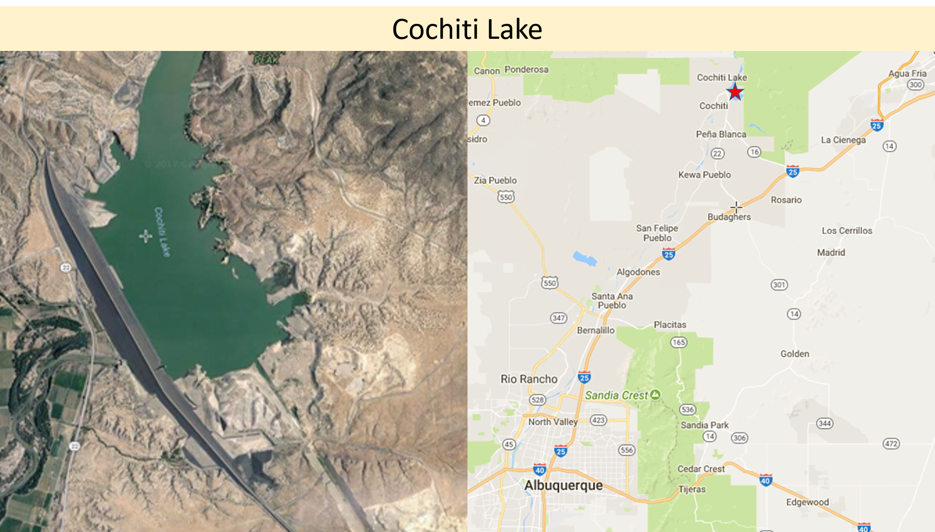
Figure 1. Cochiti Lake, Pena Blanca, NM, Xeric Region

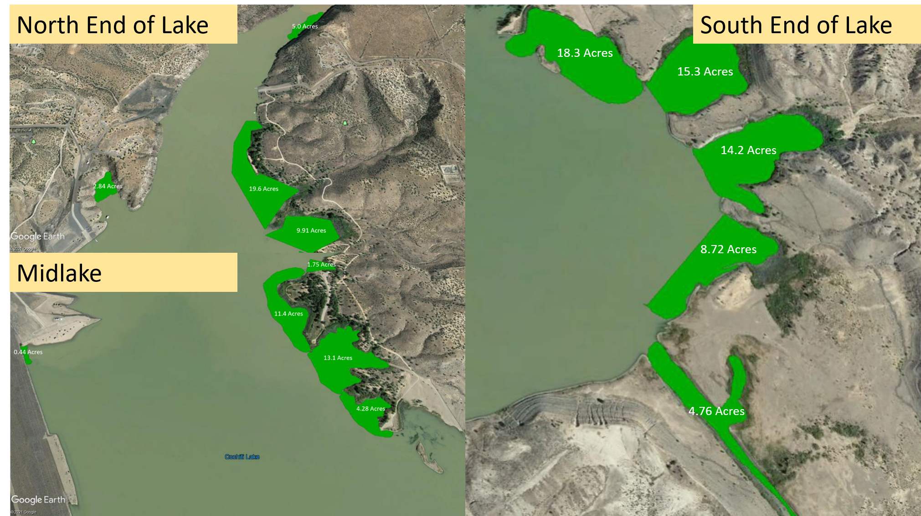
Figure 2. Locations of Eurasian watermilfoil treatment areas.

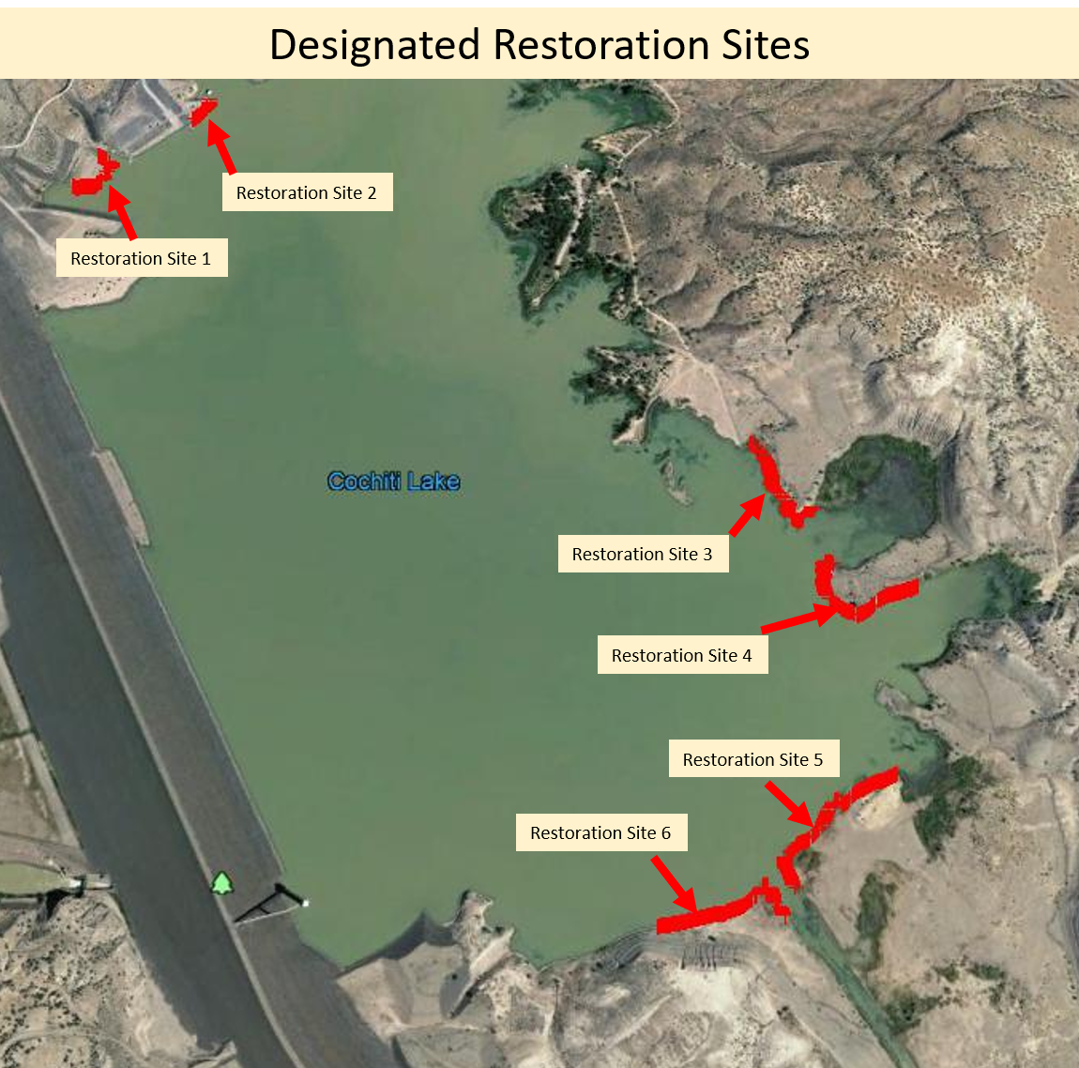
Figure 3. Specific restoration site locations.

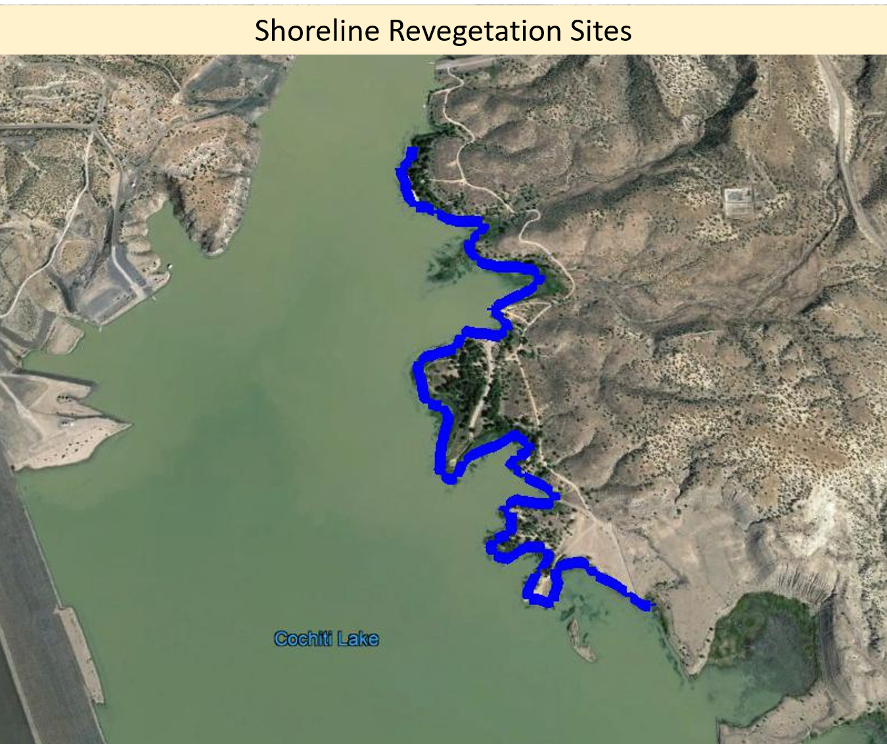
Figure 4. Locations where revegetation efforts will be concentrated post-herbicide treatment.

- Support Letters
A letter of support sign by Kevin Gardner, New Mexico Game and Fish is on file for the Cochiti Lake project. A verbal agreement is in place with Shawn Denny, supervisor of the warm-water biologists to provide technical support and physical assistance on an as-available basis. 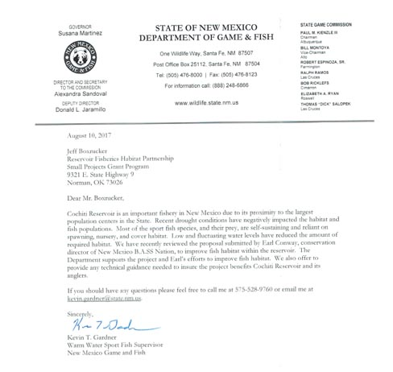

- Other Documents

WOTS Technical Report: Submersed Aquatic Vegetation Restoration and Invasive Aquatic Plant Species Management for Improvements to Aquatic Habitat: Albuquerque District, Cochiti Lake, NM 2020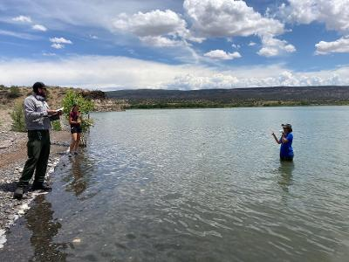

Figure 10. A WOTS assessment was performed and documented by Lynde Dodd, USACE and details the process and methodologies to restore native aquatic vegetation.

Reservoir Sedimentation Management: Building a Legacy of Sustainable Water Storage Reservoirs https://www.friendsofreservoirs.com/wp-content/uploads/2019/05/National-Res-Sed-White-Paper-2019-06-21.pdf
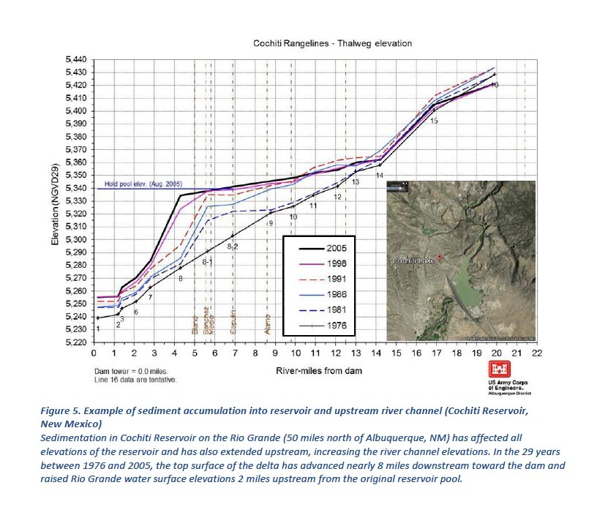
Figure 5. Cochiti Lake’s sedimentation thalweg progression was documented in a national white paper. Over eight miles of prime spawning shoreline has been lost since the Jemez wildfires.

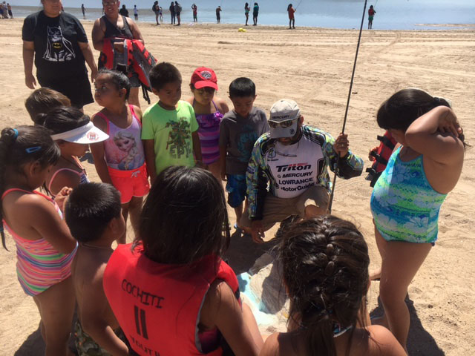

Figure 6. Nearby Pueblo schools lake day has provided Sun Country Outdoors and others an opportunity to reconnect youth to the lake.

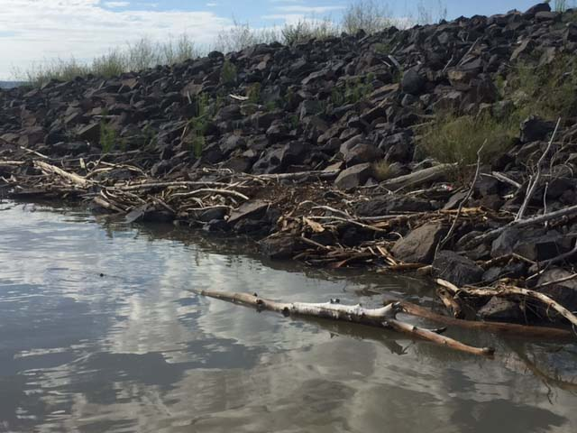

Figure 7. Cochiti Lake dam collects large amounts of pine and juniper driftwood from the burn scars. This is raw material for spawning benches when properly anchored.

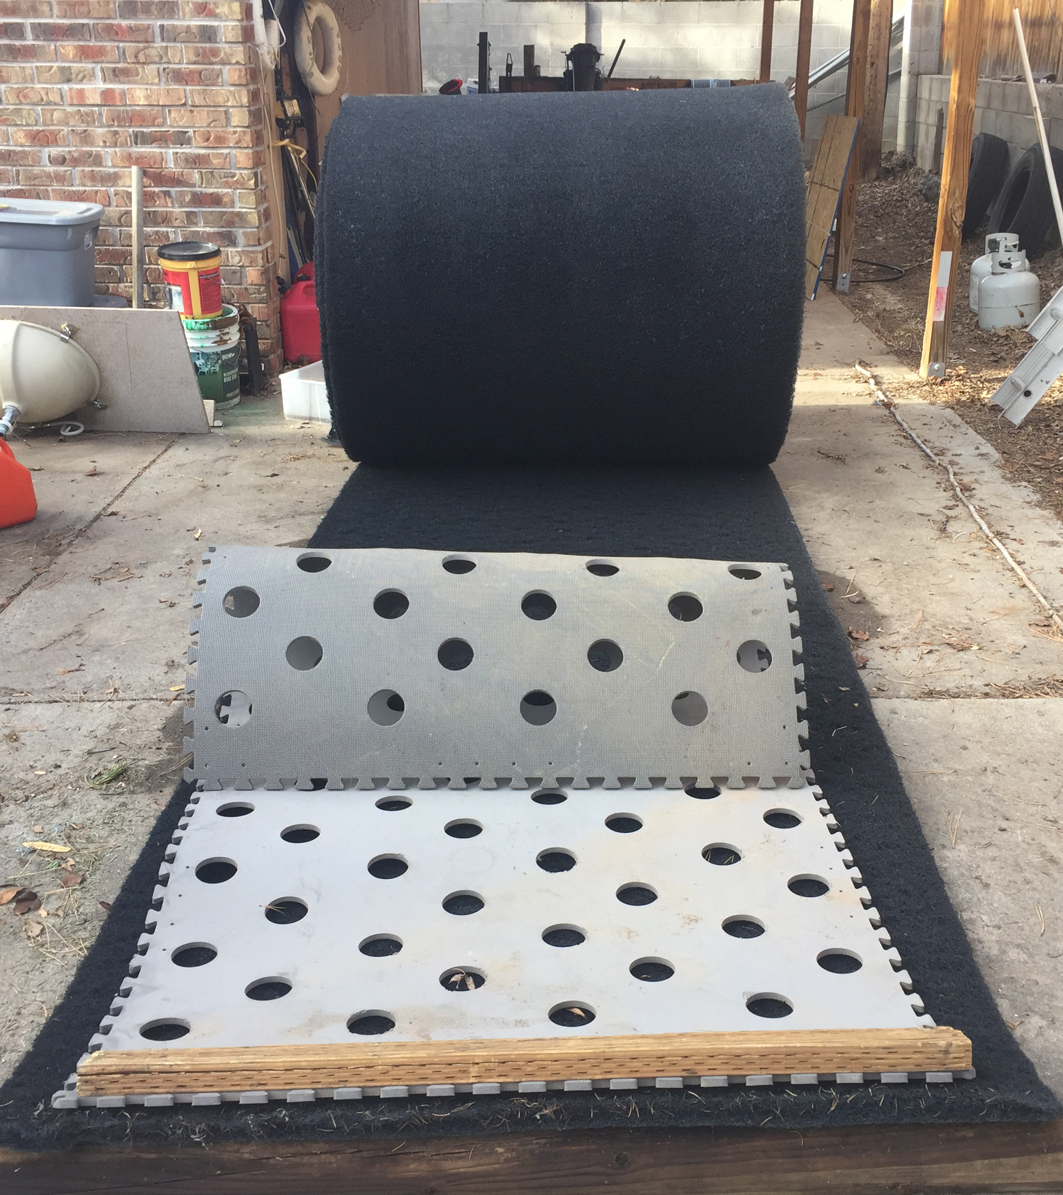

Figure 8. Floating islands and willow propagation mats have been developed and used for several New Mexico RFHP projects since 2010. They will be used to expand propagation areas. The material will also be used to provide spawning mats for prey base species.

