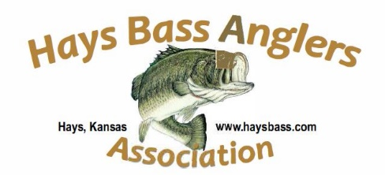

May 28, 2021

Reservoir Fish Habitat Partnership (RFHP)

Friends of Reservoirs

Dear Grant Application Committee Members,

The Hays Bass Anglers Association (HBAA) is excited to support the grant request being submitted by the Kansas Department of Wildlife Parks & Tourism (KDWP&T) for the purchase of artificial fish habitat structures to be placed in public bodies of water across the state of Kansas.

HBAA, along with a half-dozen clubs like ours from across Kansas, have agreed to donate man hours to assist KDWP&T in the placement of habitat structures purchased with this grant money. There are several Kansas clubs who are just now hearing about this grant application and I am confident those clubs will follow our lead in the support of this habitat improvement project by volunteering their time in the spirit of fisheries habitat improvement.

HBAA’s mission supports conservation measures in our region of the state and is excited to support this effort by KDWP&T to obtain additional structures that will have a positive impact on Kansas fisheries.

Sincerely,

Steven Hausler

Steven Hausler

HBAA Conservation Director