E. Supporting Materials
Figure 1. Three-Mile Lake (Union County, Iowa) contour map.

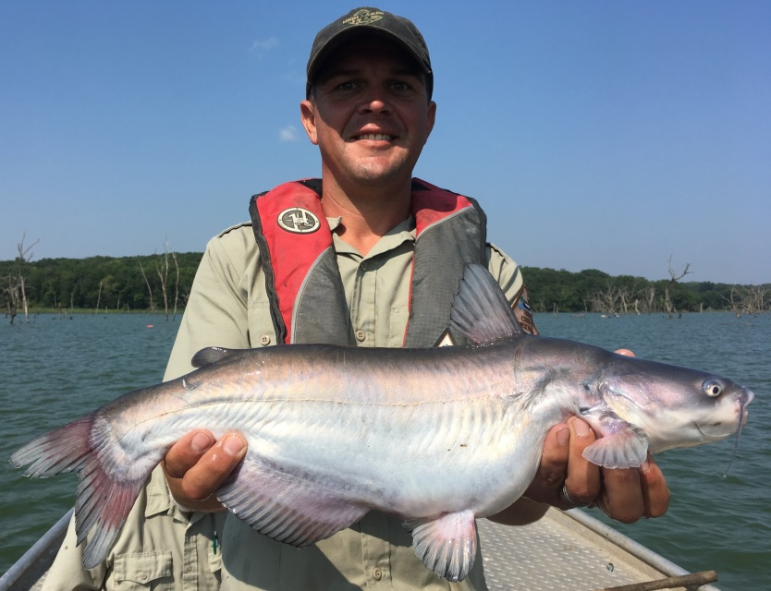
Figure 2. Blue Catfish captured at Three-Mile Lake (Union County, Iowa) in 2018.

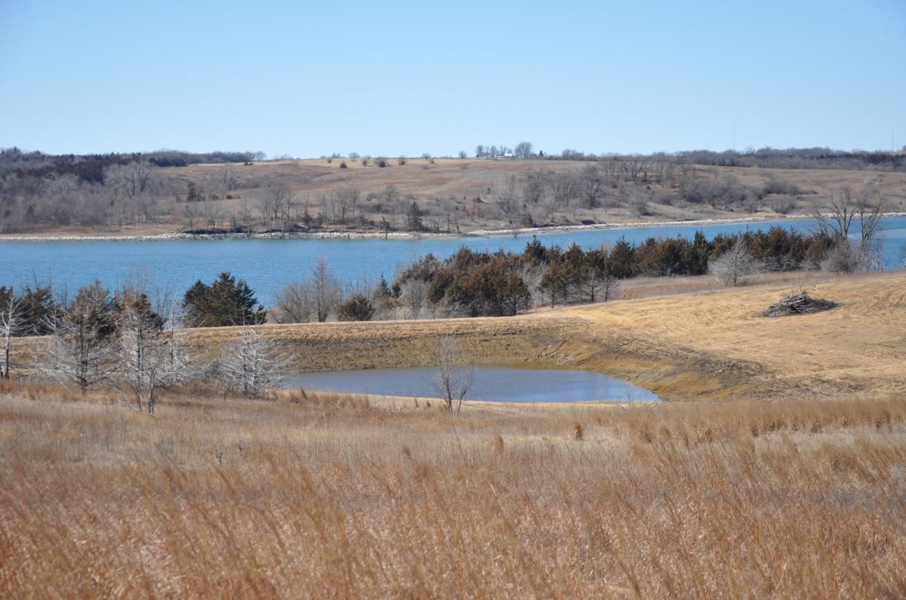
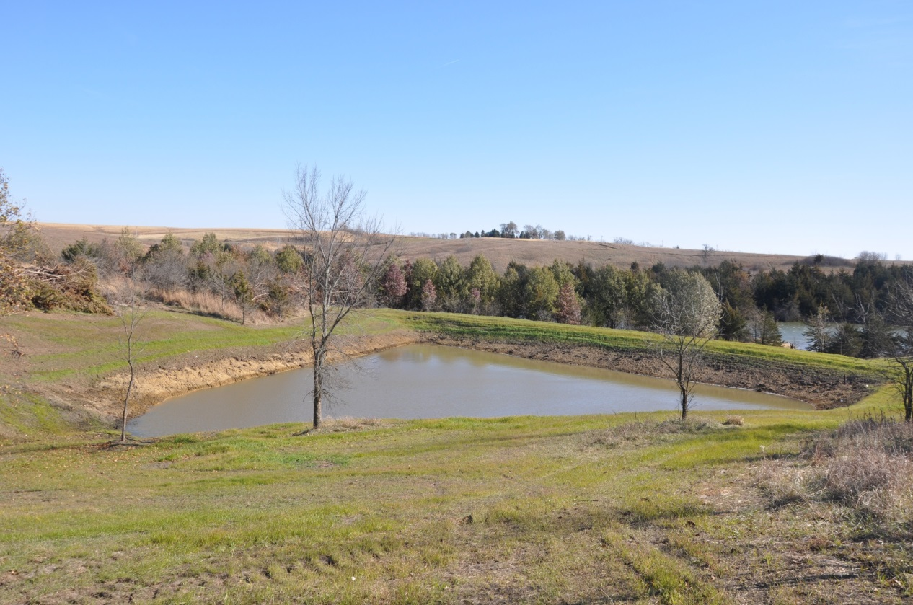
Figure 3. Sediment retention basins constructed on public land within the Three-Mile Lake (Union County, Iowa) watershed by Union County Conservation Board in 2019-2020.
Figure 4. Observed land use within the Three-Mile Lake (Union County, Iowa) watershed in 2018.

Figure 5. Estimated sediment delivery within the Three-Mile Lake (Union County, Iowa) watershed in 2018.

Figure 6. Existing catchment basins and best management practices within the Three-Mile Lake (Union County, Iowa) watershed as of 2018.

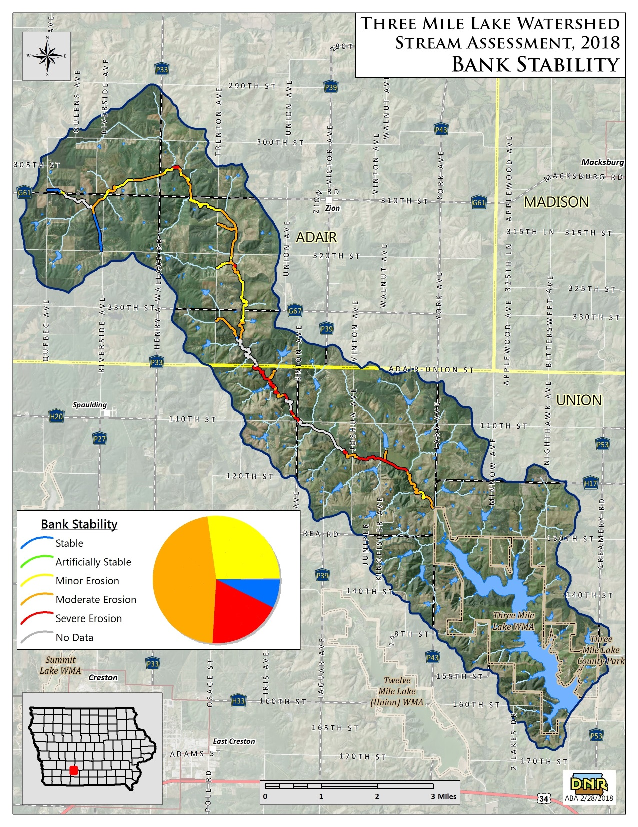
Figure 7. Estimated bank stability within the Three-Mile Lake (Union County, Iowa) watershed in 2018.

Figure 8. Watershed and in-lake improvements planned for Three-Mile Lake (Union County, Iowa) in 2022-2024.

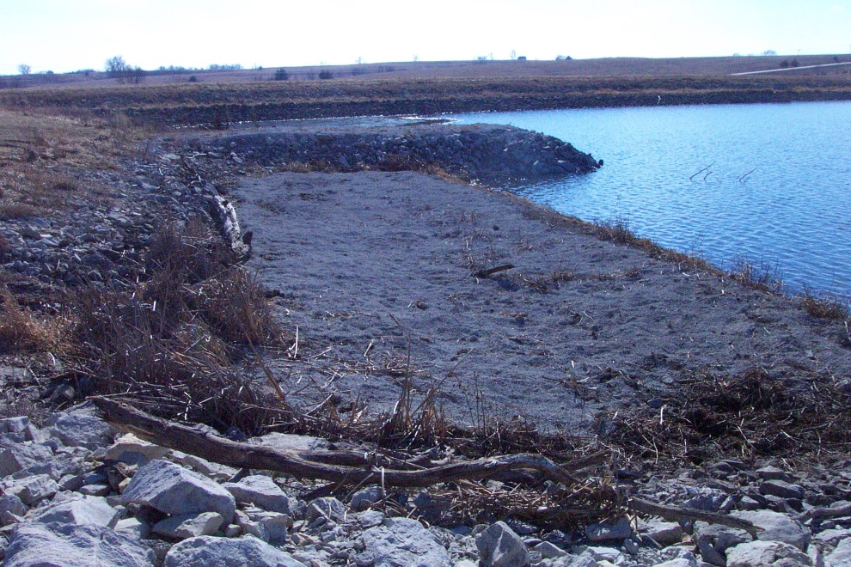
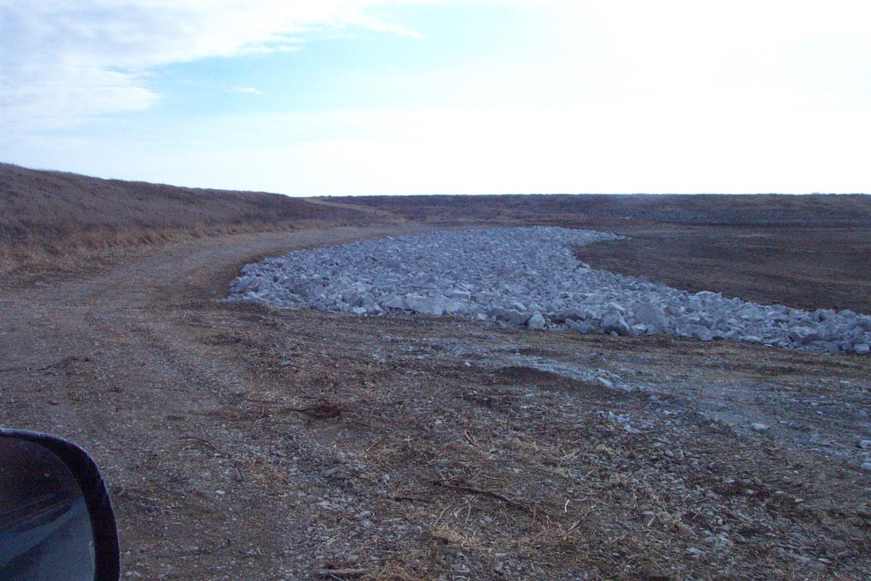
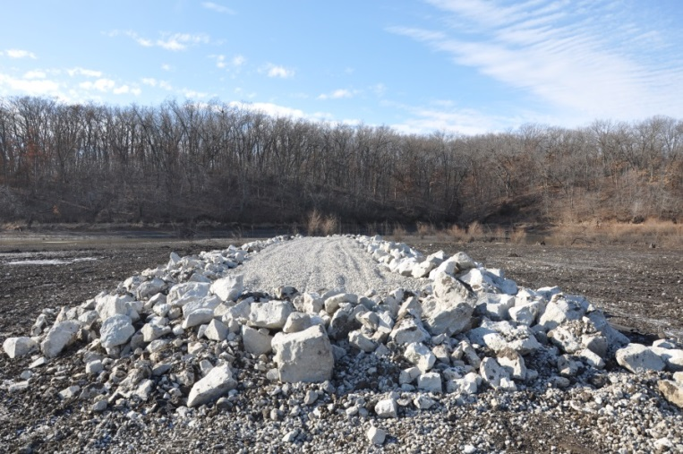
Figure 9. An example of a gravel spawning bed (top, 9a), rock field (middle, 9b), and a rock reef (bottom, 9c).
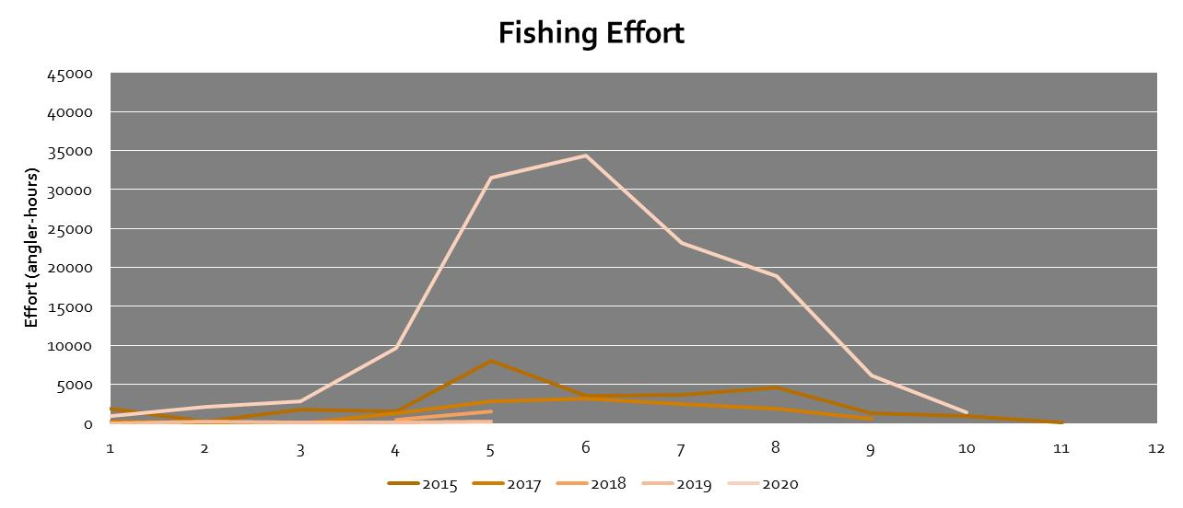
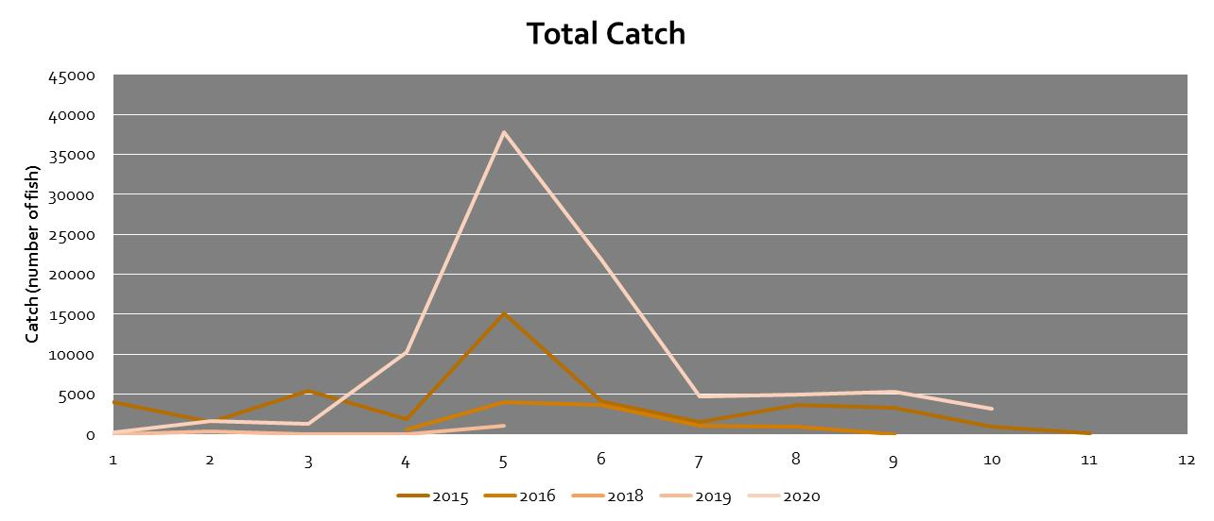
Figure 10. Creel survey results for Three-Mile Lake (Union County, Iowa) from 2015-2020. The top figure is fishing effort (number of angler hours) by month for 2015 through 2020. The bottom figure is total catch (number of fish) by month for 2015 through 2020. Graphs by R. Krogman (Iowa DNR).

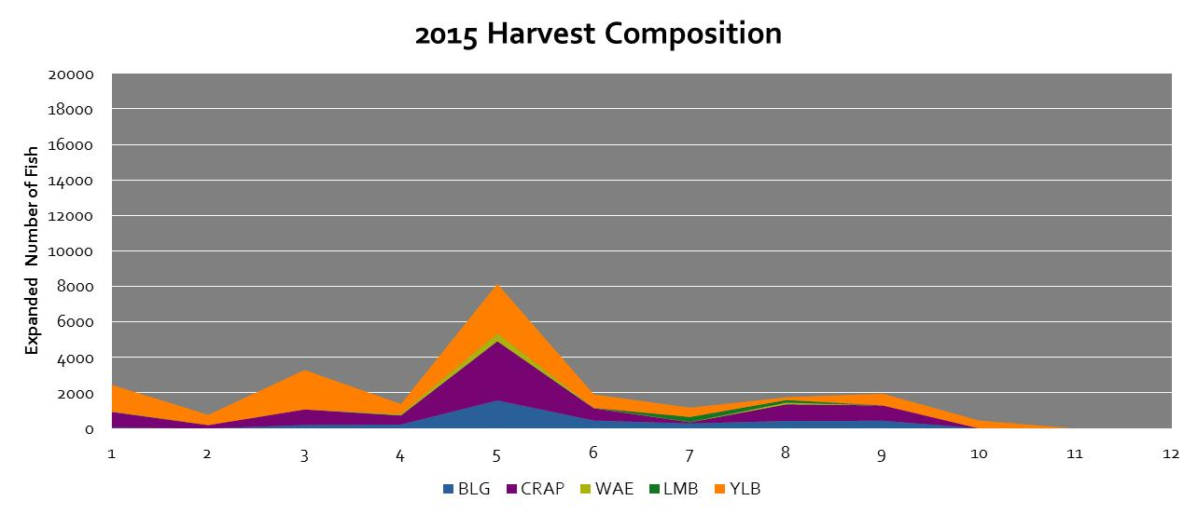
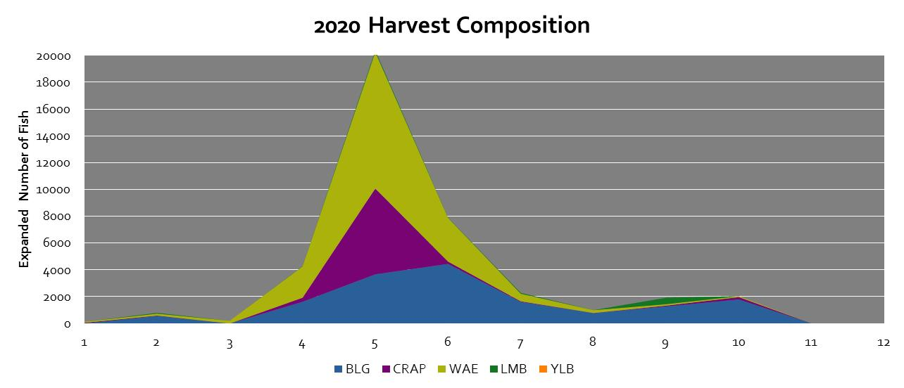

Figure 11. Harvest composition (Fish species; BLG = Bluegill Lepomis macrochirus, CRAP = Crappie Pomoxis nigromaculatus and Pomoxis annularis, WAE = Walleye Sander vitreus, LMB = Largemouth Bass Micropterus salmoides, YLB = Yellow Bass Morone mississippiensis) by month for anglers surveyed at Three-Mile Lake (Union County, Iowa) in 2015 (pre-fish renovation) and 2020 (post-fish renovation). Graphs by R. Krogman (Iowa DNR).

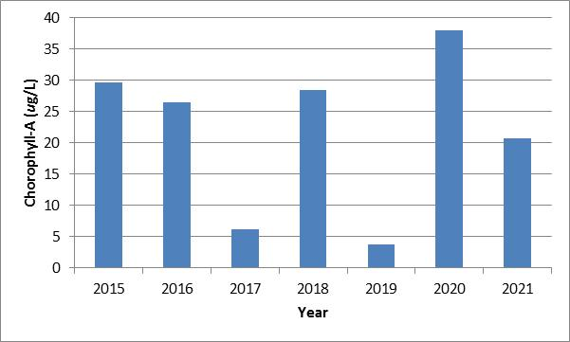
Figure 12. Productivity (chlorophyll-A, ug/L) of Three-Mile Lake (Union County, Iowa) from 2015-2021 as inventoried by the Iowa DNR’s Ambient Lake Monitoring Program (programs.iowadnr.gov/aquia).

