Wildlife Management Plan
Tionesta Lake

FY 2022

Tionesta Lake Overview Description

Tionesta Lake boarders and extends through the Alleghany National Forest located in the Appalachian Mountains of Pennsylvania. The waterway of this project stretches just south of Mayburg bridge located in Kellettville, PA, to Johnston Rd. Bridge in Tionesta, PA. Three campground areas are located on the project, two in Tionesta and one in Kellettville. As a flood risk reduction project, the Tionesta Lake land corresponds with the potential flood water elevation. This land inhabits several aquatic and terrestrial species vital for ecosystem health and recreational usage. The land contains a variety of habitat types including; early successional forests, old growth forests, wetland areas, and grasslands. A large area of this ecosystem has been previously altered due to heavy construction in the 1940s. Since, a large amount of recreational use has created strain on the environment. The Lake has also created pressure for aquatic species due to poor habitat and alters in water flow. The wildlife management plan for the Fiscal Year (FY) 2022 has been created to enhance human fish & wildlife relationships while improving the ecosystem itself.

Purpose

Priorities include the following: (1) Maintain habitat and nesting needs for various waterfowl species, primarily Wood Duck; (2) Food plots will be worked over in all aspects to provide recreational hunting activities as well as habitat improvement geared towards successional flora and fauna species; (3) Wildlife viewing areas for the public will be maintained and also created in areas where invasive flora has flourished; (4) Create and execute a forestry management plan including sustainable forestry and various tree plantings that benefit a multitude of wildlife species; (5) Grouse and Woodcock habitat management throughout the northern bank of Tionesta Creak from Nebraska to Food Plot area; (6) Fish habitat improvement will scale larger than previous years to promote a better fishery in Tionesta Lake; (7) Focus on largely reducing and/or removing Invasive and pest species to promote biodiversity at Tionesta Lake project; (8) Increase public knowledge and participation in wildlife and ecosystem enhancements.

Fish and Wildlife Management (Habitat Improvements)

- Food Plots: It is anticipated that the Newtown Wildlife Management Area (MAP 1) will once again be sown for food crops in May of FY 2022. The intended crop selection is listed in Appendix A. The seed planting, disking, fertilizing, and similar activities are completed by our partnership with the PA Game commission (PGC). The fertilizer will be 10-20-10 at 250 lbs. per acre. A donation from the Kellettville Sportsman Club will be made directly to J and J Feeds and Needs for seed purchase. Additional habitat structures will be implemented into this food plot area as seen in Appendix A with funding from lake project. PGC will perform a controlled burn in mid to late November. Additionally, the Visitor Center Food Plot will continue to be sown for food crops by PGC. During FY 2021 Sorghum was planted in this area to deter invasive species while increasing food source for wildlife. The intended crop selection for future plantings is listed in Appendix A.

- Tree Pruning: Various apple trees were pruned in 2021 to promote a healthier growth pattern. Limbs collected were repurposed into brush piles behind the Ranger and Project offices and was turned into habitat for smaller mammals such as Rabbits, Chipmunks, etc. All apple trees will be pruned by Ranger staff and will document new findings/brush habitat creations. Apple trees will also be planned to be planted in sections up into our 33-acre food plot area.

- Lake improvement: Fish Attractors: The purchase of the Mossback Fish Attractors “Fish City” kit is planned to be purchased in FY22 ($6,400). These structures will be placed throughout the lake in areas that will be the most beneficial to the population of fish and baitfish in the lake. In FY22 we will also be seeking help from Pennsylvania Fish and Boat Commission (PFBC). PFBC will come scan the lake to help us put together a new habitat improvement plan. They will also help us implement new habitat that they believe will be beneficial, along with proposing possible wetland plants to be planted in the shallow sandbar areas up towards Nebraska Bridge. In FY22 we are planning to obtain floating islands as well. The floating islands are islands that are full of living plants that will grow down into the lake providing habitat for fish in the lake while also helping to improve the water quality. These islands will also provide refuge for turtles and other wildlife that will find the island useful. For FY22 we are also working on a obtaining a grant for fish habitat improvement. This work will be conducted with the help from Western PA Conservancy to do work on a tributary running into the lake. The project would help maintain better water quality and provide substantial habitat improvements for various fish species.

- Stream Improvement: The United States Forest Service Allegheny National Forest expressed interest in their proposed “Jug Handle Project” which encompasses a large section of Corps owned land as well as the Tionesta drainage basin itself to promote better habitat. These projects include more large wood projects such as chop and drop as well as plunge pool creations for Brook Trout. Brook Trout serve as a key indicator species, as more timbering occurs, this raises stream temperatures in areas and these fish will migrate to cooler more shaded wooded areas such as Tionesta Lakes Tributaries. Ross Run was worked on in FY21 as a major stream habitat improvement project was completed with the assistance of Western Pennsylvania Conservancy (WPC) and PFBC. In FY22 we hope to do more work with WPC, USFS, and PFBC on stream projects in the Tionesta Creek drainage. Getting together with the Allegheny WINS Coalition could be a good way to get involved and acquire additional funding for these projects. Other targeted groups of interest are Kellettville Sportsman club for Ross Run that assist in stocking and holding events. Trout Unlimited Iron Furnace Chapter will assist in stream rehabilitation projects as volunteers permit. Pennsylvania Fish & Boat Commission is also intending on proposing several stream surveys this FY, exact steams to be determined.

- Grouse and woodcock: Ruffed grouse (Bonasa umbellus) and American woodcock (Scolopax minor) will be monitored and surveyed during breeding months of April and May. These surveys will give a better understanding of woodcock and grouse populations’ sizes, locations, and structures. This information will be used to place habitat enhancements including shrubs and understory trees for proper cover and food source. Tree pruning and cutting will be necessary to ensure understory habitat success. Additional sustainable forestry harvests will be used to enhance grouse and woodcock habitat.

- Pollinators: A European honeybee hive was installed in the visitor center during the summer of 2020. This hive was unsuccessful due to parasitism. Additional beehives will be placed around the dam site area to increase pollinator presence at the project in FY 2022. Additional precautions will be taken to help with survival of hives. Ranger staff and volunteers will be responsible for maintaining hives. To encourage pollinator presence, flower plots will be established and maintained across the project. Pollinator plots will also be used to replace and discourage the presence of invasive plants and animals. These areas will also be used as informational areas for plants, insects and other pollinators.

- Floating Islands: Floating islands create a source of habitat for both terrestrial and aquatic species. The wildlife population in the lake area has become lessened over the years. A large contribution to this problem is the lack of habitat. Floating islands will be installed along the lake shore. Wetland plants will be chosen based on location and target species. The foliage from these plants will provide habitat for several amphibian, reptile, and avian species. The floating islands allow roots to pass through the structure and into the water. This will create exponential habitat for aquatic species.

Natural Resource Studies

- Bald Eagles: The Mid-Winter Bald Eagle surveys will continue during early January of 2022. Educational programs related to the bald eagle (Haliaeetus leucocephalus) will take place at Tionesta Lake to promote wildlife management tactics and success. This program will also be used to increase community support and participation.

- Bluebird Box Surveys: The program will continue with scheduled box inspections (MAP 2 and 3) occurring from April through early September (clean out). Normally two surveys are conducted each month through August and one in September. Rangers and volunteers will monitor and inspect bird boxes. Locate Boy Scout Troop 82 will be installing additional bird boxes along outflow area.

- Purple Martin Boxes: Purple martins contribute to insect control. This species feeds on high flying insects. Tionesta Lake will provide purple martin boxes to entice this species to migrate to the lake area (MAP 4). This habitat enhancement will be installed in early spring and taken down in late fall.

- Wood Duck Boxes: This program will continue in FY 2022. Plans for FY 2022 include the November inspection of all nesting material. In June, the boxes will be inspected for hatchling success. A volunteer or seasonal employee is utilized each June and November in assisting the project wildlife management coordinator with inspections of boxes. Additional and replacement boxes (MAP 7) will be installed in the months of January and February. The boxes are also added into the ArcGIS online database so we can keep track of location and the success rate of boxes in different areas.

- Osprey Nesting Platforms: Tionesta Lake currently has 2 Osprey (Pandion haliaetus) platforms that still show no sign of use. However, staff have observed osprey in the upper reaches of Tionesta lake near Kellettville and Food Plot areas. Surveys and research will be done to decide if and where the osprey nests should be relocated.

- Barred Owl Boxes: Barred owl (Strix varia) boxes will be built and installed by Ranger staff and volunteers. These boxes will be monitored in FY 2022.

- Bat Boxes: Bats are currently suffering from White Nose Syndrome. This disease has caused several bat species to become threated or endangered in PA. To help support the bat populations bat boxes (MAP 5) will be installed and replaced in FY 2022. Bat boxes will be installed in fall months to ensure boxes are in appropriate location by spring of 2022. The Bat condo was installed in the summer of 2019. This condo will continue to be monitored for bat activity. Additional bat boxes will be installed around lake area. This will reduce human bat conflict while providing a stable location for bat nesting.

- Northern Saw whet Owl: Northern Saw whet owls (Aegolius acadicus) will be monitored and surveyed at Tionesta Lake. Ranger staff will reach out to local owl banders to track and band at lake project. This information will be used as a baseline for future habitat enhancements along with public education.

- Songbirds: Songbirds are important for environmental indicators that provide pollination, seed dispersal and several other essential environmental needs. For this reason, songbird surveys will be done starting in April through mid-July. Volunteers and Rangers will participate in these surveys to gather information on species present and locations. This information will be used for future habitat enhancement and environment health assessment.

- Small Mammals: Small mammals provide a large source of food for predators while provided ecological services to the environment. Pit-fall traps will be place around the project to observe species present and location. These traps will be observed by ranger staff or volunteers.

- Trees and vegetation: Trees and vegetation type, age, and health reflect heavily on the overall health of wildlife. Surveys will be done by ranger staff and volunteers to determine the forest type and structure. These surveys will start near project office, hiking trails, and Tionesta creek road. Surveys will be held starting June and ending in September. This will allow easiest indentation due to foliage. Additional tree surveying may be done outside of this time frame in areas of concern or in new habitat instillation areas.

- Sand Trapping: Species diversity is a key component of ecosystem health and fitness. High biodiversity increases production and resilience of an ecosystem. Understanding species present in forested areas creates a better understanding of ecosystem health and is a bases for species management. Sand trapping is a minimally invasive study that collects animal footprints in local areas. This allows researchers to collect data of species located in an area. Sand traps will be used to collect data on all terrestrial species using Tionesta Lake forested areas. These traps will be used in spring through summer in various locations.

Forestry

- Ash Trees: Standing issues revolve around the Ash (Fraxinus) population around the Allegheny National Forest and Tionesta lake. Most Ash trees have run their course here on USACE Property; however few remain in good standing. Funding permitted; we will continue to treat these Ash’s via emamectin benzoate injections. Previous years of using this practice have proven effective in most scenarios depending on the stage of infection.

- Tree Nursery Program: If funds are available, Tionesta Lake has an approximate .25 acre that has been dedicated to restoration of successional tree species as well as the American Chestnut hybrid. The plot is fenced and considered deer proof and could fair well to raise young trees available to transplant later throughout the project and could be used to distribute regionally as well to other Corps facilities, i.e. Woodcock, East Branch Dam. Trees that will be primarily focused on would include Quaking Aspen (Populus tremuloides), Big Tooth Aspen (Populus grandidentata), Elm (Ulmus americana) and Yellow Birch (Betula alleghaniensis). These species are crucial to Ruffed Grouse as well as Woodcock and would be implemented in the above-mentioned area. The nursery will make an immediate impact to replace invasive flora species with the appropriate native species. Other forestry activities to note will be canopy clearing/selective cutting in areas of concern, i.e. roadways and interior forests within Corps land. Selective clearing can and has proven to be of worth in relation to successional species growth and there are several areas that could benefit i.e. near Plantation Trail as well as along Creek Road on the Northern-Eastern section of Tionesta lake. Canopy clearing can allow for suffocated areas to allow sunlight that will help establish a diversity of tree species instead of having a single dominant species in any given area.

- Selective Tree Cutting: Selective cutting is a tree harvest tactic that removes defective or inferior trees. This practice is meant to maintain crop trees with the space and resources for new growth to successfully establish. Many areas along the campground and recreation areas have been unattended to in past years. Tionesta Lake will work with a local tree companies to remove unwanted trees. Additionally, Various tree species will be replanted in the cut areas to insure future forest health. These tree species are listed in Appendix B with approximate quantities needed. Selective tree cutting will take place in sites 2 and 3. Site #2 stretches from the Outflow Campground to Boat Launch Area (Map). Site #3 resideds inside the roadway of spillway road (MAP 6).

- Sustainable Forestry: Sustainable forestry tactics will be used to increase forest vigor and diversity. Tionesta Lake will be partnering with the Foundation for Sustainable Forestry to implement sustainable tree harvesting methods. FY22 will be focused on increasing wildlife habitat for woodcock. Cuttings will take place during fall/winter months to lessen impact on wildlife species. Several precautionary tools will be taken with this forestry management method such as; NEPA reports, historical surveys, threatened and endanger species monitoring, invasive species control methods, and any other tactics that will reduce negative impact on environment.

Land Management

- Tionesta Lake’s land management can be overseen by both staff and volunteers. Also, partnerships play a key role in this program by supplementing work when staffing is either short or tied up with other job duties. Current partners include the Kellettville Sportsman Club and the Pennsylvania Game Commission. Ranger staff have been considering reaching out to Friends of the Allegheny Wilderness for other partnership endeavors as well such as interpretive events and trail work. We have a plethora of volunteer/partner work that can accomplished here including but not limited to the following: building wood duck boxes, clearing invasive/intruding vegetation, fish attractor construction and steam habitat rehabilitation, tree pruning, birdbox inspections, tree planting, wildlife surveys, stream surveys, etc.

- Boundary- Tionesta Lake Project will be heavily investigating boundary line encroachments in FY 2022. Encroachments could potentially lead to habitat loss though intention and unintentional human actions that result in the destruction of property. Additionally, boundary markings create a visual path for habitat enhancements, wildlife contractors, and future potential encroachers. Boundary line areas will be observed and monitored in a fixed rotation. For the FY 2022, boundary on river left will be surveyed and marked starting at Cougar Bob’s and ending at Church Run. An additional focus on encroachments located on Tionesta Creek Road, will be addressed, and monitored to less human wildlife conflict. Possible encroachments outside of this observation area will still be monitored and reviewed to ensure minimal damage is done to Army Corps property. Boundary will be inspected and maintained by Ranger staff. This project can be done year-round but is intended to take place between the months of January and April.

- Soil sampling- Tionesta Lake Project will be investigating soil quality in areas of vegetative growth concern. A large portion of Tionesta’s land has been altered previously due to construction, logging, chemical leakage and more. In some area’s vegetation is minimal and has little change over the past 20 years. New town is an area of concern.

Fish and Wildlife Management Facilities

- Feeding Stations: One bird feeder will be kept filled starting in min-November of 2021 continuing until spring of 2022. This feeder will be located near the project office where the public is likely to view the activity. Hummingbird feeders will be placed at Ranger Office, Visitor Center, and TRA Fee Booth during starting in June and removed in September. The Turkey/deer feeder will be removed behind the government dwellings will be removed and relocated to a more suitable area.

- Nesting Boxes: Additional bluebird boxes will be installed by local Boy Scout Troop. Current nest boxes will continue to be maintained and monitored in FY 2022. Survey information from previous years will be used to determine if nest boxes should be removed or relocated due to lack of use or conflict. New nest boxes will be used to replace old or deteriorating boxes. Several new nest boxes will be constructed for future use.

- Brush Piles: In FY 2022, additional brush piles will be constructed utilizing fallen trees and pruned limbs from the lake projects trees. The number and size of brush piles will be determined by the amount of fallen trees and limbs that are availed that year.

Invasive Species and Pest Control

- Invasive plants: In the FY 2022, there will be a large movement to remove invasive species from project area. This project will start near the visitor center and outflow campground. In future years it is expected to remove invasive species from upstream areas. In FY 2021, Tionesta Lake partnered with local Forest Service to remove knotweed from USACE waterway areas. Tionesta Lake will continue partnership in FY 2022. The species of interest for the FY 2022 include; multiflora rose (Rosa multiflora), autumn olive (Elaeagnus umbellate), Japanese knotweed (Reynoutria japonica), and garlic mustard (Alliaria petiolate). Invasive species will be removed from and converted into native wildlife habitat. This will include the planting of pollinator flowers and native tree species. Additional surveying will be done along Tionesta creek road to locate invasive species for future removal projects.

- Woodchuck: The rodent species woodchuck (Marmota monax) has caused Signiant damage to several field, campground and other grass land areas including the side face of the dam. This species has not been maintained for many years. Population size has drastically increased during this time creating several concerns for the human and wildlife environment. As this is a burrowing species, several holes and underground tunnels have been established in essential project structures. These burrows create structural weakening, hazard walking areas, blocked culvert pipes etc. The population of woodchuck at Tionesta Lake project will be reduced using a combination of techniques including traps, repellents, scare tactics, and deterrents. Plant deterrent species will be used to reduce woodchuck activity but also provide habitat usage for insect and bird species such as pollinators.

- Deer: The Tionesta Lake white tailed deer (Odocoileus virginianus) population has grown considerably over the years. With no natural predators or hunting in the lake and recreational areas, the herd has become overpopulated. This has put a strain on the Tionesta Lake ecosystem. Habitat and food sourced are being lost due to over browsing. This increase in population also raises the concern of potential disease spread. Disabled veteran hunts will be set in place to manage the deer population size. These will take place along plantation trail. The trail will be graved and contain hunting pull off areas so that disabled veterans may reach these areas with small forms of transportation. Additional hunting activities may be held at Newtown food plot. All hunts will follow PGC rules and regulations.

ESTIMATED HOURS/EXPENDITURES FOR FY 2021

FISH AND WILDLIFE MANAGEMENT (HABITAT IMPROVEMENTS)

MANAGEMENT ACITIVTY: | ESTIMATED FACILITY MANHOURS:
- Mowing Plantation Open Areas | Contractor
- Apple Tree release cutting –  Selection of Trees/Marking for Release Cut | 2 hours
- Tree Pruning | 20 hours
- Stream Improvement Project | 20 hours
- Brush Piles | 8 hours
NATURAL RESOURCE STUDIES
- Mid- Winter Eagle & Bird Survey | 32 hours
- Zebra Mussel Survey | 4 hours
- Blue Bird Box Survey | Volunteers
- Wood Duck Box Surveys | 32 hours
- Purple Martin Box Inspections | 24 hours
- Osprey Nesting Platforms | 6 hours
- Barred Owl Box Inspection | 8 hours
- Bat Boxes | 32 hours
- Pollinator | 24 hours
- Northern Saw whet Owl | 8 hours
- Songbirds | 8 hours
- Small Mammals | 40 hours
- Trees and vegetation | 40 hours1112199
FORESTY
Possible Tree Planting | 32 hours
LAND MANAGEMENT
- Annual Wildlife Management Plan | 8 hours
- Volunteer Coordination for Wildlife Management | 16 hours
- Other Related Wildlife Reports | 8 hours
- Boundary | 40 hours
Other Operation Activities
- Nuisance Wildlife Management Control | 24 hours
FISH AND WILDLIFE MANAGEMENT CONTROL
- Feeding Stations | 4 hours
- Nesting Boxes: Maintenance/Replacement 40 hours
- Brush Piles | 50 hours
INSPECTING CONTRACTORS WILDLIFE WORK  - Horse Crossings | 30 hours
INVASIVE SPECIES AND PEST CONTROL
- INVASIVE SPECIES REMOVAL | 40 hours
- PEST CONTROL AND MEDIGATION | 80 hours

Appendix A

Newton Wildlife Management Area Food Plots
- Proposed FY 2022 Plantings
- 10-20-10 Fertilizer to be utilized at 250 lbs. per acre
- Lime should be applied as recommend from previous soil sample results.
- Aspen, birch, elm, black berry bushes, shrubs, and other understory species should be planted on outer area of food plot to create habitat edging effect.

Plot #1: Buckwheat 120 lb/ac
Plot #2: Millet, Sorghum 75 lb/ac
Plot #3: Wildlife Mix 50 lb/ac
Plot #4: Clover 10 lb/ac – Planted in 2020.
Plot #5: Wildlife Mix 50 lb/ac
Plot #6: Millet, Sorghum 75 lb/ac
Plot #7: Buckwheat 120 lb/ac
Plot #8: Oats 80 lb/ac

Visitor Center Wildlife Management Area Food Plot
- Purposed FY 2022 Planting
- 10-20-20 Fertilizer to be utilized at 250 lbs. per acre.
- Soil sample should be used to determine future fertilizer and limestone use.

Year 1#: Common Sunflower (Helianthus annuus)
Year 2#: Soybean
Year 3#: Sorghum

Appendix B
Tree planting management
- Proposed FY 2022 Tree Nursery

Tree Harvest Replacement Vegetation
Common Name: | Latin Name: | Quantity
Pin Oak | Quercus palustris | 20
White Oak | Quercus alba | 30
Northern Red Oak | Quercus rubra | 30
Yellow Birch | Betula alleghaniensis | 10
Boxelder | Acer negundo | 10
Red Maple | Acer rubrum | 20
Hemlock | Tsuga canadensis | 10
Shagbark Hickory | Carya ovata | 25
American Chestnut | Castanea dentata | 20
European Larch | Larix decidua | 15
White Ash | Fraxinus americana | 10
Sugar Maple | Acer saccharum | 15
Black Cherry | Prunus serotina | 30
Quaking Aspen | Populus tremuloides | 20
Bigtooth Aspen | Populus grandidentata | 20
Hemlock | Tsuga canadensis | 20
White Pine | Pinus strobus | 15
Sycamore | Plantanus occidentalis | 10
Black Locust | Robinia pseudoacacia | 15
 | Total Trees: | 345

MAP

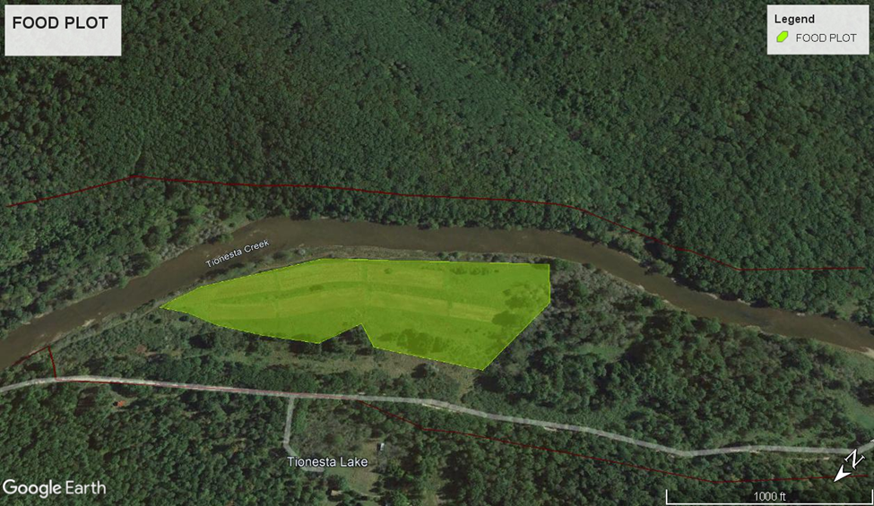
(MAP 1: New town food plot located at 41°31’16.96”N 79°17’45.03”)

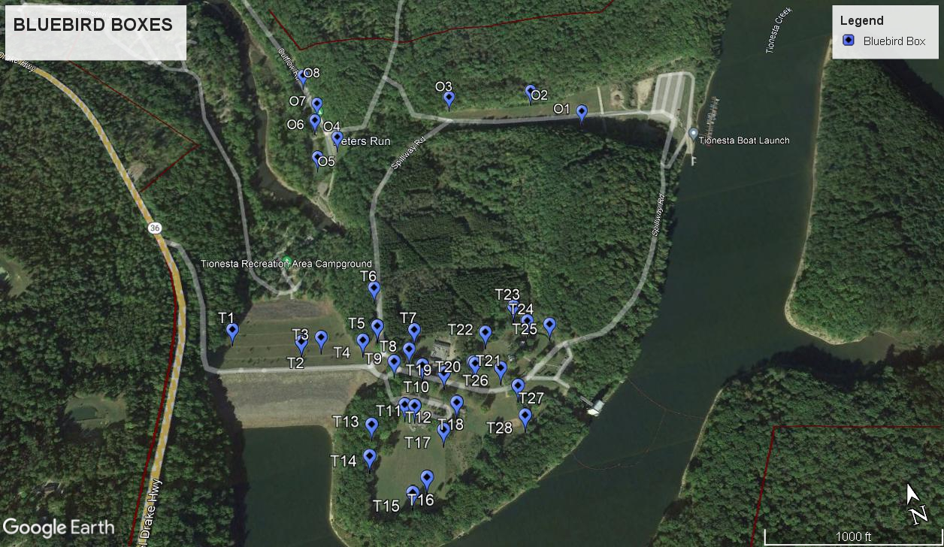
(MAP 2 bluebird boxes located at Tionesta)

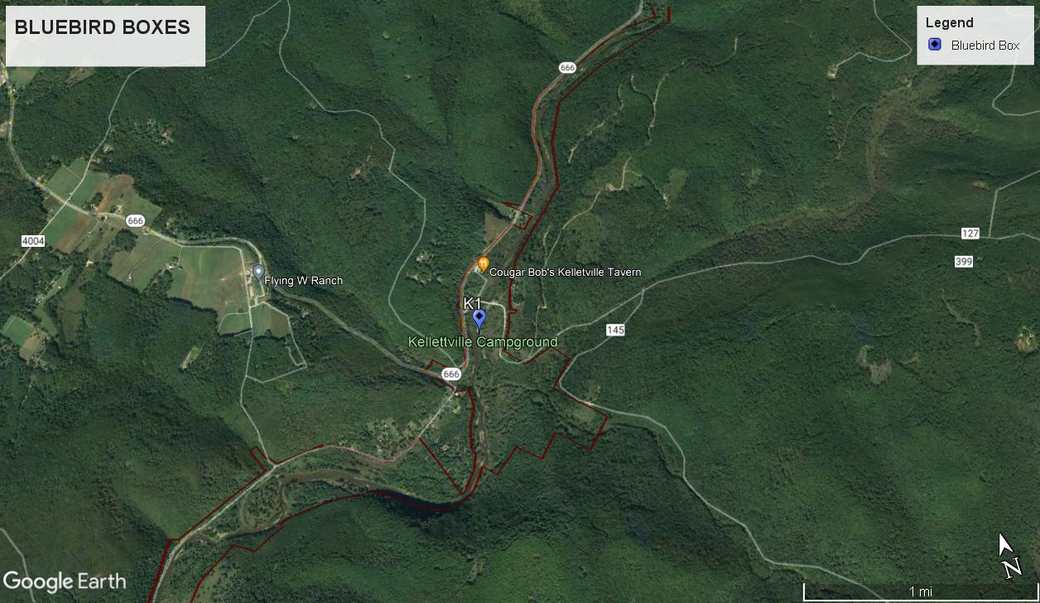
(MAP 3: Bluebird box located at Kellettville)

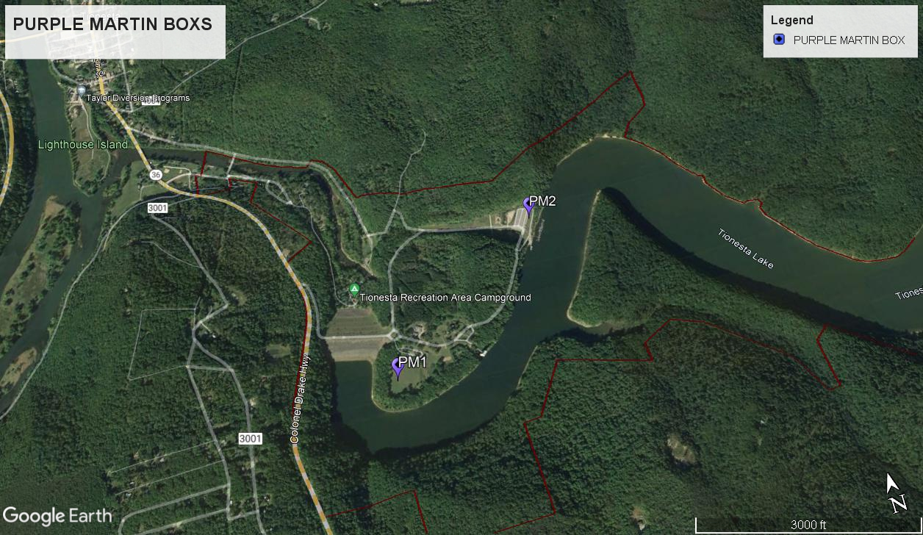
(MAP 4: Purple Martin Boxes)

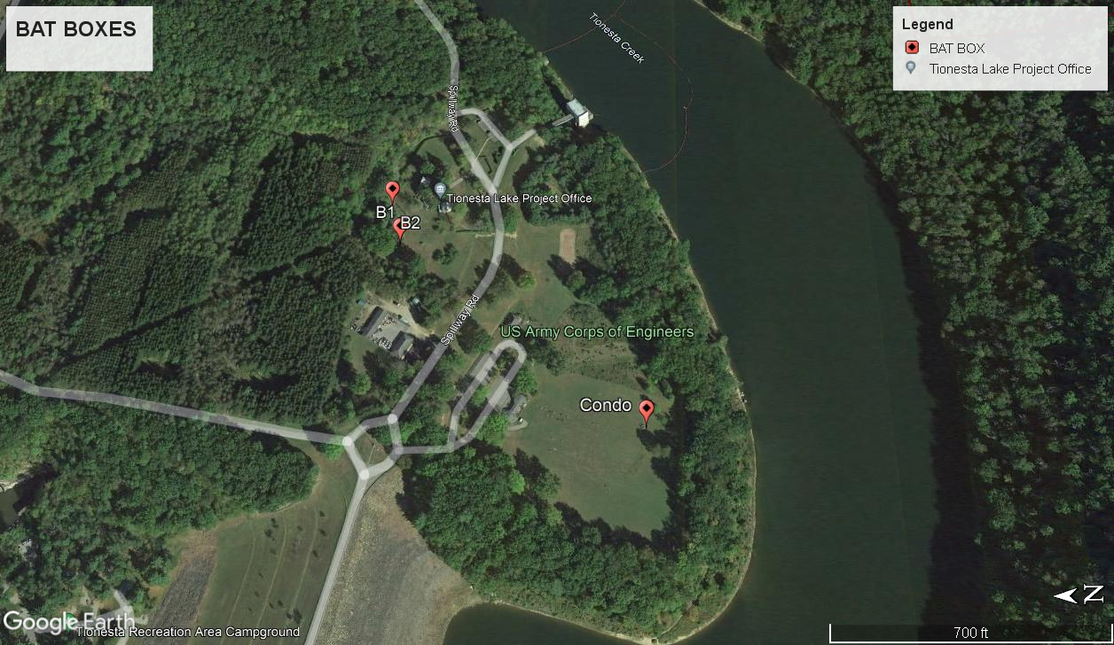
(MAP 5: Bat boxes and condo)

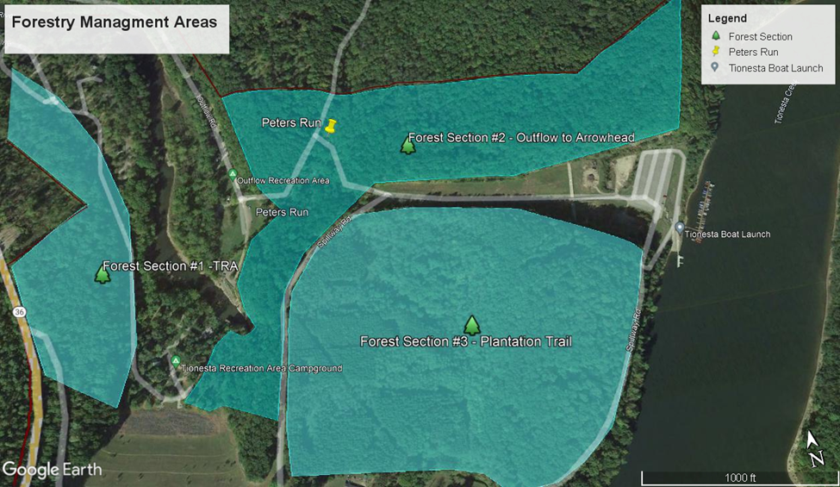
(MAP 6: Forestry management areas)

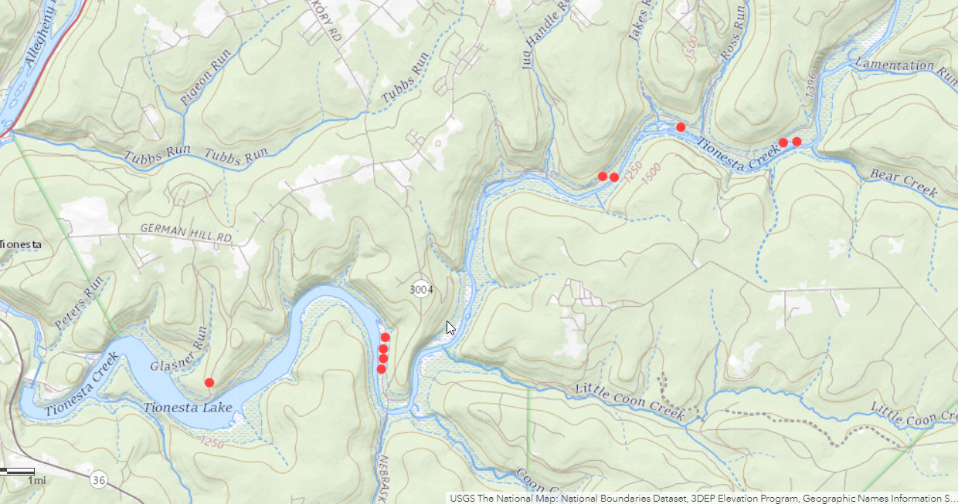
(MAP 7: Wood duck boxes)

