February 4, 2022

Jeff Boxrucker
Reservoir Fisheries Habitat Partnership
9321 E. State Highway 9 Norman, OK 73026
(405) 659-1797
jboxrucker@sbcglobal.net

Dear Mr. Boxrucker:

It is my pleasure to write this letter to support the proposal titled, “Three-Mile Lake Restoration Project: Fish Habitat Enhancement.” The Lake Restoration Program (LRP) has been working with the local community and many city, county, other state partners since 2016 to improve water quality and recreational opportunities at Three Mile Lake.

Establishing and enhancing quality fish habitat is integral to the overall restoration of Three Mile Lake, and funding this proposal would help project partners expand on one of the best and fastest growing fisheries in the state. The lake was chemically renovated in 2016 to improve the fishery, which had been negatively impacted by common carp and yellow bass. While the lake was lowered for the renovation, over two miles of shoreline was stabilized, and numerous fish habitat features were installed.

Since the fishery renovation, Three Mile Lake has become one of the most popular fishing destinations within the state, drawing visitors from hundreds of miles away. Water quality in the lake remains very good; however, increased sedimentation in the upper end of the lake threatens the long-term health of this reservoir. To address pollution from sediment and nutrient inputs, project partners completed a watershed assessment in 2018, and in 2020, began working on a comprehensive restoration plan for the lake that will ensure the lake remains a great resource for years to come.

Restoration work planned for the next three years includes stabilizing and additional 1,300 feet of shoreline, installing two new grade stabilization structures to address critical gully erosion near the lake, renovating three existing ponds near the lake, and increasing the capacity of the in-lake silt basin at the upper end of the reservoir. While this restoration plan will ensure water quality in the lake remains excellent for years to come, additional fish habitat structures are needed to ensure the longevity of the fishery. The restoration plan calls for over 50 new habitat features to be installed, but additional funding is needed to complete this element of the overall restoration project. DNR’s Lake Restoration Program has committed over $2.8 Million for the construction of additional shoreline, watershed, and in-lake work, in addition to the $220,500 already expended for the fishery renovation. We fully support this grant application and know that any funds provided would help provide new opportunities for anglers and one of the most popular fishing destinations in Iowa.

Thank you,
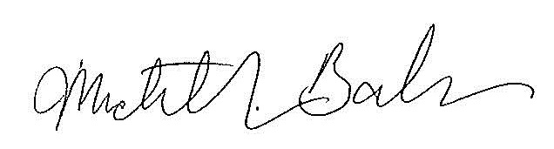
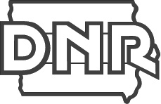 | Michelle Balmer | Lake Restoration Program  Iowa Department of Natural Resources  P 515-238-2458 | 502 E. 9th St., Des Moines, IA 50319  Michelle.balmer@dnr.iowa.gov  www.iowadnr.gov

