February 15, 2023

Doug Nygren, Coordinator
Friends of Reservoirs
PO Box 134
Garden Plain, KS 67050-9118

RE: 2023 Request for Proposals,
Reservoir Fisheries Habitat Partnership
FOR Large Grant Program, Paintsville Lake, Paintsville, Kentucky

Dear Mr. Nygren:

The Kentucky Department of Fish and Wildlife Resources (KDFWR) fully supports the proposed habitat improvement efforts sponsored by the Anglers for Improving Opportunities at Paintsville Lake. KDFWR in conjunction with the U.S. Army Corps of Engineers manages the fisheries resources of Paintsville Lake. Being a popular fishery for black bass and crappie, Paintsville Lake will benefit greatly from the proposed habitat enhancement work. As with many aging reservoirs, habitat in Paintsville Lake has declined over time due to sedimentation and degradation of physical structure. Habitat improvement will not only benefit the fishery but will increase angler satisfaction.

In addition to adding physical structure, this project will also manage existing nuisance aquatic vegetation in the lower end of the lake through herbicide application to allow for more beneficial fish usage. This could allow for better bass foraging and assist in the desired goal of increasing bass growth and condition.

Finally, this project will attempt to increase the fertility of the lake through fertilizer application. If successful, benefits would include support for a higher density forage base, including the addition of Threadfin Shad, and reduction of nuisance vegetation growth through plankton bloom shading. Threadfin Shad will be stocked concurrently with the lake fertilization, and stocking success, recruitment, and overwinter survival will be monitored in 2024.

KDFWR will work with Anglers for Improving Opportunities through use of our staff and equipment to conduct much of the project’s “on the ground” work and evaluation.

We look forward to working with the Anglers for Improving Opportunities on habitat enhancement activities, in addition to increasing partnership efforts with a common goal of improving reservoir habitat. If you have questions or require additional information, please call me at (502) 892-4469.

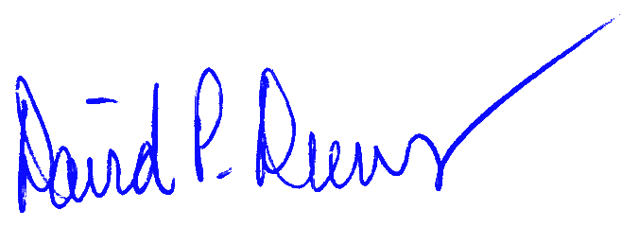
Sincerely,

David Dreves
Director, Fisheries Division, KDFWR

