Travis Voyles
Acting Secretary of Natural and Historic Resources

COMMONWEALTH of VIRGINIA
Department of Wildlife Resources Ryan J. Brown
Executive Director

Virginia Department of Wildlife Resources 1796 Highway 16
Marion, VA 24354

July 18, 2022

Mr. JeffBoxrucker Coordinator
Friends of Reservoirs

Re: Mossback/Friends of Reservoirs Small Projects Grant Program - Claytor Lake, Virginia Dear Mr. Boxrucker:
I am writing in support of an application by the Virginia BASS Nation for a Mossback/Friends of Reservoirs Small Projects grant. As the regional fisheries manager for southwest Virginia, where Claytor Lake is located, I can attest to the need for additional fish habitat installation at this popular reservoir.

Since 2012, the Virginia Department of Wildlife Resources (VDWR) has been engaged in fish habitat projects at Claytor Lake with Appalachian Power Company under their Federal Energy Regulatory Commission Habitat Management Plan. Under this Habitat Management Plan, annual work plans have addressed fish habitat needs using tree felling, Christmas tree fish attractors, repurposed concrete from deconstruction of a dam spillway, native aquatic vegetation plantings, and adding Mossback fish attractors in key offshore locations. Claytor Lake anglers have particularly appreciated the Mossback fish attractors as reliable locations to catch fish. Multiple partners have participated in in these habitat projects, including Claytor Lake State Park, Friends of Claytor Lake, Virginia BASS Nation, VDWR, Appalachian Power Company, Virginia Master Naturalists, and local anglers.

Accomplishing our annual fish habitat goals requires outside grant funding to leverage available annual funding from Appalachian Power Company. The additional funding from this grant source would allow us to enhance more fish habitat for the benefit of the reservoir, its fish populations, and the anglers that enjoy this resource. Therefore, I endorse the efforts of the Virginia BASS Nation to obtain the Mossback/Friends of Reservoirs Small Projects grant for FY 2023. VDWR will be fully involved in planning work under this grant with Virginia BASS Nation.
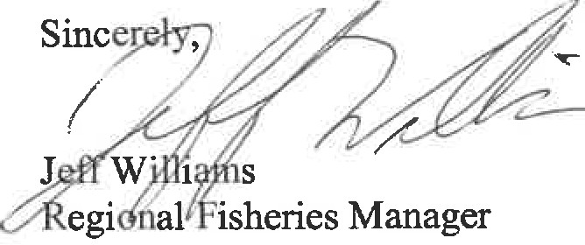

7870 VILLA PARK DRIVE, SUITE 400, P.O. BOX 90778, HENRICO, VA 23228
Equal Opportunity Employment, Programs and Facilities

