Reservoir Fisheries Habitat Partnership –
Small Project Grant Program

Name of Friends of Reservoirs Member Sponsoring Project: Canyon Bass Club of San Marcos, Texas (FOR Chapter) (CBCSM)
Project Leader Contact Information: Dave Terre, Habitat Project Coordinator, 6505 Freesia Ct. Austin, TX 78739. Email: dterre@texasbass.org; Phone: (903) 279-9155

Location of Project: Canyon Reservoir (29 52.074’N 98 11.893’W) is an 8,308-acre impoundment of the Guadalupe River located in Comal County. It was constructed in 1964 by the U.S. Army Corp of Engineers for purposes of flood control, water conservation and recreation. The reservoir is open to the public without any discrimination
Project Objectives: Canyon Reservoir lacks complex forms of fish cover. Woody types of habitats were limited at the time of impoundment. Furthermore, those have slowly degraded because of natural reservoir aging processes.
Fluctuating water levels, steep topography, and hard rock substrates limit aquatic plant growth in the main body of this reservoir, which make large-scale native aquatic vegetation planting projects both difficult and impractical. Rock habitats are abundant in this reservoir but do not provide adequate cover for largemouth bass, the most popular game fish species. Because of the fluctuating water levels, the habitat enhancements are placed in deep water (15-25 feet), so they are not exposed during drawdowns.
Since 2005, the addition of live cedar tree piles and artificial habitat structures have increased habitat availability for fish and greatly enhance fishing opportunities on the reservoir. The Reservoir Fisheries Habitat Partnership has identified the lack of structural habitat as a major impairment common to Texas reservoirs. The need for habitat improvement has also been emphasized in a 2019 Fisheries Management Survey prepared for Canyon Reservoir by the Texas Parks and Wildlife Department (see Canyon Reservoir (texas.gov)
The objectives of this project are to:
- Combat losses of natural structural fish habitat by adding new artificial and/or natural woody structures at up to four (4) priority deployment sites, depending on funding and/or availability of natural woody habitat.
- Maintain or enhance fishing opportunities for Canyon Reservoir anglers by providing locations that attract fish
- Promote a long-term partnership between anglers, private industry, NGO’s, Friends of Reservoirs, and state/federal governmental agencies as a successful model to improve reservoir fish habitat and make fishing better in Texas.
Description of Methods: This project has grown to more than 40 habitat placement sites on the reservoir (see figure below). The effective area of these habitat sites is large, covering the entire length of the reservoir. Sites are easily located by anglers because each of them is geo-referenced and promoted to the public online (see Canyon Lake Fish Attractors (texas.gov))
Because of the difficulty in maintaining 44 fish habitat sites (given current levels of project funding and manpower) a decision was made to reduce our project scope and prioritize 10 of 44 existing sites for future growth and expansion. A survey of local anglers and project partners was conducted in 2021 and used to determine priority sites; four were enhanced with artificial structures in 2022. In 2023, we intend to continue our efforts to enhance these same sites using artificial and/or natural woody structures, depending on funding and availability.
Because cedar trees deteriorate every few years, our sites need to be supplemented annually to maintain suitable fish habitat. The advantage of the artificial structures is that it lasts much longer, so our current priorities will focus on the use of artificial habitat until our 10 priority sites become well established and a consistent source of live cedar trees can be identified. In the past, we’ve been able to get live cedar trees from public park land surrounding the reservoir, thanks to the USCOE. Current availability of those trees is unknown due to park closures and new park management entities. Ultimately, our desire is for each site to contain both a mixture of natural and artificial habitat structures to increase habitat complexity.
Given the experience that the Canyon Bass Club has working on this project, volunteers have become efficient and effective at building and placing large amounts of habitat in a very short time period. The current methodology represents a best management practice for this particular reservoir.
Grant funding from Friends of Reservoirs will be used to: 1) to purchase, construct and deploy artificial fish habitat structures and/or 2) provide materials necessary to purchase/assemble/gather and deploy live cedar trees, or other forms of natural woody structural habitat.
The expected outcomes would be to enhance/increase structural fish habitat (cover) available for fish and increase angler success at the reservoir. Another outcome would be to make our existing habitat sites larger, much more structurally complex, and easier to find/maintain in the future.
Letter of Support: (see attached letter from TPWD biologist, Patrick Ireland)
What Species will the Project Affect? All cover seeking species, including: Largemouth bass, Guadalupe Bass, Smallmouth Bass, all species of sunfish (Bluegill, Redear, Redbreast, etc), White Crappie, Black Crappie, Channel Catfish, Blue Catfish, and Flathead Catfish. Other non-game species will use these habitats as well.
Outreach Plan: The CBCSM will work with all project partners and TPWD to publicize our work in press releases, partner websites, partner newsletters, fishing forums, partner social media platforms and written/on-line publications. Coordinates for the improved habitat sites will be updated and posted on the TPWD website for use by the general public.
We know that good publicity encourages interest in new projects and additional volunteers to support habitat improvement objectives in other areas. Below are web links to some promotions in 2022 (a statewide press release and a video):
News Release: Feb. 25, 2022: Twenty-five New Fish Habitat Structures Added to Canyon Lake - TPWD (texas.gov)
https://www.facebook.com/watch/?v=921062301917561

Project Partners (N=7):
- Canyon Bass Club of San Marcos (CBCSM - FOR Chapter Affiliate),
- Texas B.A.S.S. Nation (TBN), State Conservation Director
- U.S. Army Corps of Engineers (USACE)
- Water Oriented Recreational District of Comal County (WORD)
- The Texas Parks and Wildlife Department (TPWD)
- Hays County Master Naturalists
- Local Boy Scout Troops (BSA)
Current Canyon Reservoir Habitat Sites (2022)
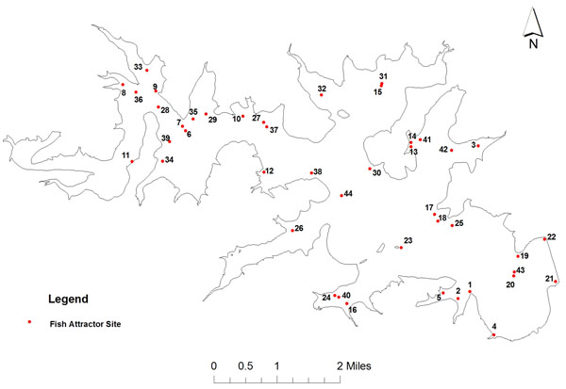

Budget (2023 budget):
Partner | Cash Contribution* | In-kind Contribution | In-kind Value
FOR | $2,000
TPWD | $0 | 5-7 employees and additional volunteers, trucks and boats, fuel, equipment | $1,551
WORD | $5000 (est)
USACE | $0 | Labor, coordination for possible tree removals, boat ramp, parking, park use/access | $1,000
CBCSM | $0 | 25-30 volunteers, hand and power tools, materials, trailers/trucks, fuel, labor (360-man hours @ $18/hour) (Includes Hays County Master Naturalists) | $7,480
TBN | $0 | Project management costs (labor, food, promotion, reports) | $800
BSA | $0 | Volunteer labor (amount to be determined) | TBD
*Cash Funds provided by FOR and WORD would be used to purchase or construct artificial fish habitats, purchase supplies, materials, equipment rentals (such as chain saws and flatbed trailers, if necessary), construction and assembly materials for natural or artificial fish habitat.

