***Griffy Lake***

***2021 Aquatic Vegetation Management Plan Update-Draft***

***Monroe County, Indiana***

October, 2021

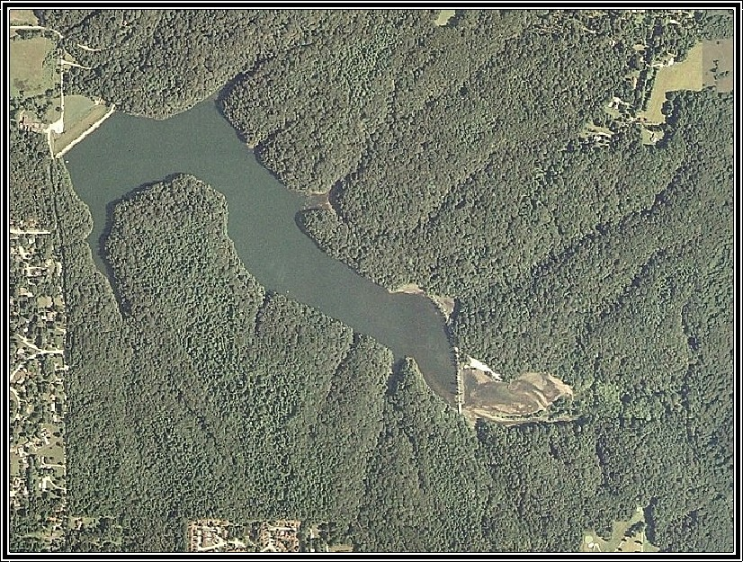

**Prepared for:**

City of Bloomington Parks & Recreation

401 N. Morton St. Suite 250

Bloomington, IN 47402

**Prepared by:**



**PO Box 100**

**Seymour, Indiana 47274**

## Executive Summary

Griffy Lake is a 109-acre reservoir located within the 1,180-acre Griffy Lake Nature Preserve in Monroe County. The lake has a maximum depth of 31 feet and an average depth of 14 feet. Public access, in the form of a boat ramp, is in the southeast corner of the lake. The site is managed by Bloomington Parks and Recreation. Boating is limited to electric motors only. The lake has been colonized by invasive Eurasian watermilfoil (*Myriophyllum spicatum*) and curly-leaf pondweed (*Potamogeton crispus*). Invasive Brazilian elodea (*Egeria densa*) was documented in past surveys but was declared eradicated from the lake in 2009 following Indiana Department of Natural Resources (IDNR) funded herbicide applications. These invasive plants can produce dense mats that hinder recreational activities and impact the ecology of the reservoir.

Plant management on the lake has consisted of milfoil weevil stocking in 2000-2002, a spot treatment with diquat herbicide for control of Brazilian elodea around the boat ramp in 2004, two fluridone treatments for eradication of Brazilian elodea in 2006-2007, and treatment of curly-leaf pondweed and Eurasian watermilfoil in 2008-2009. The lake was drawn down in 2012 and high use areas on the east end were dredged in 2013. Plant sampling and an aquatic vegetation management plan update were completed 2005-2009 and 2017. Invasive plant management was not performed from 2010-2016. Spring and summer sampling in 2016 detected vegetation in 65% and 70% of the littoral zone. Eurasian watermilfoil was found at 18% and 22% of sample sites. Bloomington Parks received LARE grants for treatment of Eurasian watermilfoil, plant surveys, and plan updates from 2017 through 2019. The 2019 treatment was competed using ProcellaCOR at 2-3 Prescription Dose Units (PDUs). In 2020, Bloomington Parks received a LARE grant for vegetation surveys, a plan update, and treatment of Eurasian watermilfoil. Eurasian watermilfoil was mapped and treated with ProcellaCOR at 1-3 PDU’s. Eurasian watermilfoil was not collected during the August Tier 2 survey and coontail and slender naiad were the only native species collected.

In 2021, Bloomington Parks received the unused LARE grant money from 2020 for vegetation surveys and a restricted budget for vegetation treatment. Eurasian watermilfoil was found growing in 3.58 acres of the lake on April 30. These areas were treated on June 1 with Renovate at 2 ppm. Eurasian watermilfoil was only collected at one site during the Summer Tier 2 survey. Coontail was the most abundant plant was found at 32% of the sites.

A similar management plan is recommended for 2021, however ProcellaCOR was not used in 2021 so it will be available for use in 2022. It is important that the survey and treatment be completed in April or May of 2022. It is estimated that 15 or more acres of Eurasian watermilfoil may require treatment. A summer Tier 2 survey and two invasive surveys in spring and late summer should also be completed. This information can be used to update the management plan. The cost of the surveys, treatments, and plan update is estimated to be $10,500. If a grant is received, the city will be responsible for covering 20% of these costs.

## Table of Contents

Executive Summary i

Table of Contents ii

List of Figures ii

List of Tables ii

1.0 Problem Statement and Management History 1

1.1 Problem Statement 1

1.2 Goals and Objectives 1

1.3. Plant Management History 2

2.0 Aquatic Plant Community Characterization 5

2.1 Methods 5

2.2 Sampling Results 6

2.3 Plant Sampling Discussion 8

3.0 Plant Management Discussion and Action Plan 9

4.0 Public Involvement 11

5.0 References Cited 12

6.0 Appendix 13

6.1 LARE Tier 2 Data Comparison by Depth Range 13

6.2 LARE Tier 2 Raw Data 15

6.3 Aquatic Plant List 16

## List of Figures

Figure 1. Illustrations Eurasian watermilfoil (a), and curly-leaf pondweed (b) (Illustrations provided by Applied Biochemist). 1

Figure 2. Eurasian watermilfoil treatment areas, May 26, 2020. 4

Figure 3. Tier 2 sample sites. 6

Figure 4. Tier 2 sample sites where brittle naiad was collected, August 3, 2020. 7

## List of Tables

Table 1. Griffy Lake vegetation management history. 3

Table 2. Treatment area details for 2020 Eurasian watermilfoil treatment at Griffy Lake. 4

Table 3. Griffy Lake Tier 2 Survey Results, August 3, 2020. 8

Table 4. Griffy Lake Tier 2 Summer Survey Results 2004-2020 9

Table 5. Estimated 4-Year vegetation management budget for Griffy Lake 11

## 1.0 Problem Statement and Management History

### 1.1 Problem Statement

In previous plans and updates that followed, additional species of concern were addressed but the primary species of concern is the invasive Eurasian watermilfoil. Invasive curly-leaf pondweed is also present in Griffy Lake (Figure 1). Densely matted beds of these invasive species can create navigational problems, especially in a lake where electric motors are commonly used. In addition, there is the potential that these species could displace native plants and interfere with fishing and other recreational activities. Dense monocultures of invasive vegetation may also have impacts on the fish population and water quality.

a.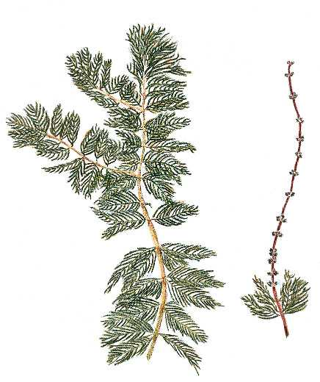 b.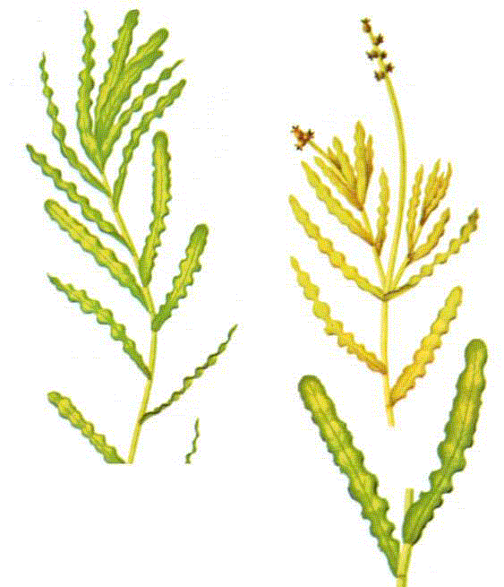

Figure 1. Illustrations Eurasian watermilfoil (a), and curly-leaf pondweed (b) (Illustrations provided by Applied Biochemist).

### 1.2 Goals and Objectives

An effective aquatic vegetation management plan needs to have clearly defined goals and objectives. The vegetation management goals for Indiana public lakes, which were created by IDNR, are as follows:

* Develop or maintain a stable, diverse aquatic plant community.
* Direct efforts to preventing and/or controlling the negative impacts of aquatic invasive species.
* Provide reasonable public recreational access while minimizing the negative impact on plants, fish, and wildlife resources.

In order to achieve these goals and measure the success of the actions, the plan needs to define some clear, achievable, and measurable management objectives. The following objectives have been created based on lake user input, past sampling data, and aquatic plant management best management practices:

1. Reduce and maintain Eurasian watermilfoil to below 10% frequency of occurrence.
2. Maintain plant coverage at 50% of Tier 2 sample sites.
3. Improve native plant diversity to 6 native species collected in summer Tier 2 surveys and a native plant diversity index of 0.75.
4. Maintain adequate navigational lanes from the boat ramp to the main lake.

### 1.3. Plant Management History

The first documented effort to control invasive vegetation on Griffy Lake was a milfoil weevil stocking program which occurred from 2000-2002. The effort resulted in limited success as there was no conclusive evidence of any control from the weevils (Scribalio & Alix 2003). IDNR treated the boat launch area with contact herbicides in 2004 for control of Brazilian elodea. This treatment temporarily reduced growth in the area thus lowering the risk of spread to other lakes in the region. IDNR then funded an eradication effort in 2007 and 2008 where the whole lake was treated with low rates of fluridone. These treatments eradicated invasive Brazilian elodea. Invasive curly-leaf pondweed and Eurasian watermilfoil colonized many of the areas once dominated by Brazilian elodea. The Parks Department received LARE funding and completed selective treatment of Eurasian watermilfoil and curly-leaf pondweed in 2008 and 2009. These treatments controlled the targeted species in the treatment year, but, due to the abundance of curly-leaf pondweed reproductive structures and the presence of Eurasian watermilfoil in the watershed, these species returned the following seasons. The reservoir was drawn down nearly completely in 2012 - 2013 to allow for repairs to the dam. During this time, high use areas on the east end were dredged thus providing some relief of invasive plant growth when the lake began to refill in 2014. Drawdowns are used in some reservoir systems to expose sediments, roots, rhizomes, tubers, turions, seeds and other vegetative plant structures to desiccation and freezing events that help to reduce viability when the lake is refilled (Cooke et al. 2005, Hoyer and Canfield, 1997). Eurasian watermilfoil is especially susceptible to these type of control measures. In 2017, Bloomington Parks received a grant of $17,200 for treatment of up to 30 acres of Eurasian watermilfoil, plant surveys, and a plan update. The plan called for completing the invasive survey and treatment in April or early May. There were delays in the contractor selection and contract creation process, so the invasive survey and treatment was also delayed until June 13th. The invasive survey found 28.6 acres of Eurasian watermilfoil and 1.6 acres of curly-leaf pondweed. Due to the already late start, treatments for control of Eurasian watermilfoil were completed on the same day. Granular 2,4-D herbicide (trade name: Navigate) was applied at a rate of 2.0 ppm. This product was applied with a calibrated granular blower mounted on an 18-foot Carolina Skiff. In 2018, Bloomington Parks received a grant of $11,600 for treatment of up to 20 acres of Eurasian watermilfoil, plant surveys, and a plan update. The plan called for completing the invasive survey and treatment in April or early May. The invasive survey found 20.6 acres of Eurasian watermilfoil. Treatments for control of Eurasian watermilfoil were completed on May 4th. Granular 2,4-D herbicide (trade name: Navigate) was applied at a rate of 2.0 ppm. This product was applied with a calibrated granular blower mounted on an 18-foot Carolina Skiff. In 2019, Bloomington Parks received a grant of $11,600 for treatment of up to 20 acres of Eurasian watermilfoil, plant surveys, and a plan update. The plan called for completing the invasive survey and treatment in April or early May. The invasive survey found 23 acres of Eurasian watermilfoil. Due to inclement weather and high water obstructing the launch site, the treatment was postponed to May 26th. Treatments for control of Eurasian watermilfoil were completed using liquid Florpyrauxifen-benzyl herbicide (trade name: ProcellaCOR EC) and was applied at a rate of 2-3 PDUs. This product was applied with a calibrated high-volume pump system via subsurface injection at the back of the boat. Table 1 summarizes control activities since 2000. In 2020, Bloomington Parks received a grant of $11,600 for treatment of up to 20 acres of Eurasian watermilfoil, plant surveys, and a plan update. The plan called for completing the invasive survey and treatment in April or early May. The invasive survey was completed on May 26th and found 8.92 acres of Eurasian watermilfoil. Treatments for control of Eurasian watermilfoil were completed on June 1st. Liquid Florpyrauxifen-benzyl herbicide (trade name: ProcellaCOR EC) was applied at a rate of 1-3 PDUs. This product was applied with a calibrated high-volume pump system via subsurface injection at the back of the boat.

In 2021, Bloomington Parks received a grant for treatment of Eurasian watermilfoil, plant surveys, and a plan update. The plan called for completing the invasive survey and treatment in April or early May. The invasive survey was completed onApril 30th and found 3.58 acres of Eurasian watermilfoil (Figure 2). Treatments for control of Eurasian watermilfoil were completed on June 1st. Liquid Triclopyre (trade name: Renovate 3) was applied at a rate of 2 ppm (Table 2).

###### Table 1. Griffy Lake vegetation management history.

|  |  |  |  |
| --- | --- | --- | --- |
| **Year** | **Control Technique** | **Acres** | **Species Targeted** |
| 2000-2002 | Milfoil weevils | n/a | Eurasian watermilfoil |
| 2004 | Diquat | 2.0 | Brazilian elodea |
| 2006 | Whole lake fluridone | 109 | Brazilian elodea |
| 2007 | Whole lake fluridone | 109 | Brazilian elodea |
| 2008 | endothall & triclopyr | 15.7 (clp) 2.9 (ewm) | Curly-leaf pondweed & Eurasian watermilfoil |
| 2009 | endothall & triclopyr | 17.8 (clp) 25.2 (EWM) | Curly-leaf pondweed & Eurasian watermilfoil |
| 2017 | 2,4-D granular (Navigate) | 28.6 | Eurasian watermilfoil |
| 2018 | 2,4-D granular (Navigate) | 20.6 | Eurasian watermilfoil |
| 2019 | Florpyrauxifen-benzyl (ProcellaCOR) | 23.0 | Eurasian watermilfoil |
| 2020  2021 | Florpyrauxifen- benzyl  (ProcellaCOR)  Triclopyr (Renovate 3) | 8.9  3.58 | Eurasian watermilfoil  Eurasian Watermilfoil |



Figure 2. Eurasian watermilfoil treatment areas, June 1, 2021.

###### Table 2. Treatment area details for 2021 Eurasian watermilfoil treatment at Griffy Lake.

|  |  |  |  |  |
| --- | --- | --- | --- | --- |
| **Bed ID** | **Avg Depth (ft)** | **Acres EWM** | **Acre Feet** | **Renovate 3**  **(ppm)** |
| G1 | 2 | 1.55 | 3.1 | 2 |
| G2 | 3 | 0.31 | 0.93 | 2 |
| G3 | 3 | 0.1 | 0.3 | 2 |
| G4 | 3 | 0.11 | 0.33 | 2 |
| G5 | 5 | 0.74 | 3.7 | 2 |
| G6 | 5 | 0.32 | 1.6 | 2 |
| G7 | 4 | 0.26 | 1.04 | 2 |
| G8 | 4 | 0.14 | 0.56 | 2 |
| Total |  | **3.53** | **11.56** |  |

## 2.0 Aquatic Plant Community Characterization

Aquatic vegetation sampling must be completed to create an effective aquatic vegetation management plan. Sampling provides valuable data that allows managers to accomplish several tasks: locate areas of nuisance and beneficial vegetation; monitor changes in abundance of native and invasive species; monitor and react to changes in the overall plant community; monitor the effectiveness of management techniques; and compare the plant communities to other populations. In 2021, invasive species mapping surveys were completed on MayApril 30th and August26th. A Tier 2 survey was completed in conjunction with the August26th invasive mapping.

### 2.1 Methods

The Tier 2 survey helps meet the following objectives:

1. To document the distribution and abundance of submersed and floating-leaved

aquatic vegetation.

1. To compare present distribution and abundance with past distribution and

abundance within select areas.

Sample sites are selected based on a stratified random methodology. Once a site is reached the boat was slowed to a stop. A depth measurement is taken by dropping a two-headed standard sampling rake that is attached to a rope marked off in 1-foot increments. An additional ten feet of rope is released and the boat is reversed at minimum operating speed for a distance of ten feet. Once the rake is retrieved the individual plant abundance on the rake is scored with either a 0 (no plants retrieved), 1 (1-19% of rake teeth filled), 3 (20-99% of rake teeth filled), or 5 (100% of rake teeth filled) (IDNR 2018). Fifty sample sites were surveyed on Griffy Lake (Figure 3).



Figure 3. Tier 2 sample sites.

### 2.2 Sampling Results

A Tier 2 survey was completed onAugust26th. Fifty sample sites, distributed through several 5-foot depth contours down to a depth of 20 feet, were included in the survey. Plants were present at 17 of the 50 sample sites. Coontail, brittle naiad, sago pondweed, Eurasian watermilfoil, and slender naiad were collected to a maximum depth of 12 feet. Coontail was collected at the highest percentage of sample sites (32%), brittle naiad (Figure 4) and sago pondweed each at 4%. Eurasian watermilfoil was collected at a single location (Figure 5). Other species observed include primrose, pickerelweed, cattails, arrowhead, American pondweed, Hibiscus, and water stargrass. The results of the survey of can be found in Table 3.

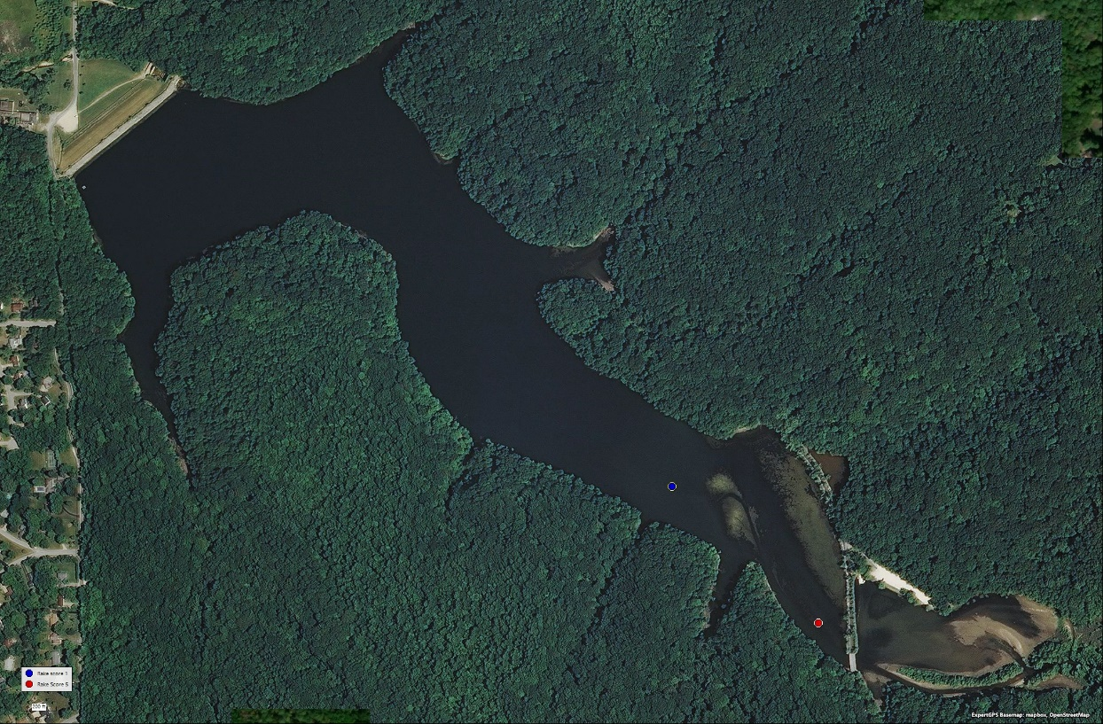

Figure 4. Tier 2 sample sites where brittle naiad was collected, August 26, 2021.

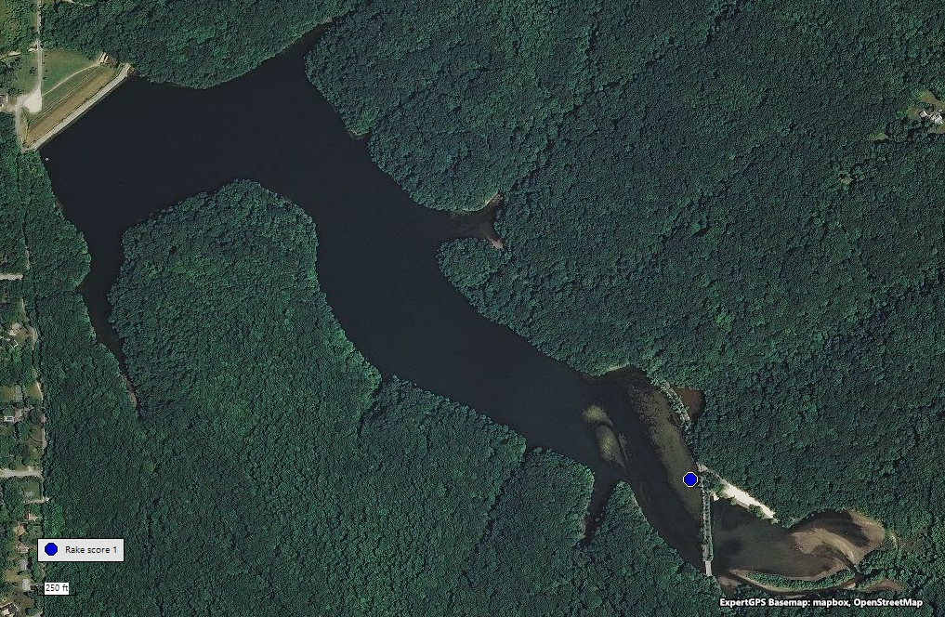

Figure 5. Tier 2 sample sites where Eurasian watermilfoil was collected, August 26, 2021.

###### Table 3. Griffy Lake Tier 2 Survey Results, August 29, 2021.



### 2.3 Plant Sampling Discussion

Table 4 compares results of summer Tier 2 surveys completed from 2004-2009 and 2016-2021 (a complete data-set including spring surveys, broken down by depth contour, can be found in the Appendix). There has been significant variation in the plant community over the past 14 years. A lot of the variability seen from 2004-2009 is likely attributed to the Brazilian elodea eradicating whole-lake Sonar treatments that occurred in 2006 and 2007. The native plant population predictably required a few years to recover from the eradication treatments. By the late summer of 2009 the population was almost back to pre-treatment levels. No surveys nor treatments occurred from 2010-2015 primarily due to the lake being drawn down. Data collected in 2016 showed a sharp decrease in native diversity followed by improvement in 2017 and a large decline again in 2018 to zero in 2019. Results from the 2020 Summer Tier 2 survey suggest that the native species diversity (0.48) is closer to the 2017 findings. The 2021 Summer Tier 2 survey Showed a decrease in native species diversity (0.28) and an increase in sites with native plants (17), percentage of sites with plants (34%), and percent littoral coverage (52%). A Secchi reading of 8.0 feet was recorded in the summer of 2021. Plants were collected at a maximum depth of twelve feet.

Invasive species have been documented to impact native diversity. In 2021, Eurasian watermilfoil was observed at 2% of the sample sites during the Summer Tier 2 survey. The native submersed plant coontail, has been frequently observed to grow at extreme densities and was present in 36.0% of all sites, an increase from 6.0% in 2020. Many sample sites are hard, rocky shorelines where establishment of submersed aquatic vegetation is difficult. Very few areas in Griffy Lake may provide suitable substrate for growth of submersed vegetation. The best suited areas are on the east end of the lake, the shallow shelf west of the causeway, and north of the channel.

###### Table 4. Griffy Lake Tier 2 Summer Survey Results 2004-2021



## 3.0 Plant Management Discussion and Action Plan

For 2022 it is recommended that the city continue with a similar management approach which includes a spot treatment of Eurasian watermilfoil, monitoring of the plant population, and continued education of the lake users. ProcellaCOR, according to label restrictions, should not be used in the same area(s) more than two consecutive years in a row. ProcellaCOR was not used in 2021 so it will be eligible for use again in 2022. Treatments in 2022 should be completed with ProcellaCOR at 1-3 PDU or Navigate at 2ppm. The herbicide treatment should be completed in spring 2022. Treatment areas should be mapped out in April or early May with an invasive survey. It is estimated that the cost of this treatment will be $7,000. Up to 15 acres may require treatment. This treatment will require permitting from IDNR. A copy of the permit will need to be signed and submitted along with a check for $5.00. This should be completed in January, 2022 and is due before February 15, 2021.

In addition to the herbicide treatment, it is also recommended that invasive plant mapping be conducted in the spring and late summer to assess the treatment effectiveness. Sampling should include an invasive species survey in the spring of 2021 and an invasive and Tier 2 survey in late summer. This data can then be used to assess the treatment effectiveness and impacts on native vegetation and to update the vegetation management plan. Sampling and plan updates will cost approximately $3,500. LARE funding may be available for sampling and plan updates. A grant application will need to be signed and submitted prior to January 15, 2022.

The public needs to be made aware of the treatment. Posting of signage informing lake users of the treatment will be required. In addition, lake users need to be encouraged to keep new invasive plants out of the lake. At a minimum signage should be maintained at the launch sites to inform boaters of the need to clean off their equipment before entering or leaving the lake. A public meeting should be held in late summer to inform lake users of the treatment and sampling results, best management practices, and future plans.

This update has focused on management of vegetation. Vegetation issues and the overall water quality of Griffy Lake are impacted by what occurs in the watershed. It would benefit the longevity and health of Griffy Lake if Parks personnel continue their efforts to improve and maintain the reservoir’s watershed.

The action plan is summarized below, and a budget estimate can be found in Table 5:

1. Complete treatment of invasive Eurasian watermilfoil with ProcellaCOR at 1-3 PDU and/or Navigate at 2ppm. Treatment should be completed following a spring invasive survey.

1. Complete Tier 2 and invasive surveys in late summer to assess the effectiveness of the treatment and need for additional actions. In addition, this survey can also be used to monitor the spread of other, less problematic, invasive species like curly-leaf pondweed and brittle naiad. This information should be used to update the vegetation management plan each season.

1. Annually monitor depths within the dredged channel leading to the main lake, insuring there is adequate water depth for navigation. Consider budgeting for dredging this area every 10-15 years.
2. Educate lake users of the importance of cleaning boats before entering and leaving Griffy Lake with the use of signage and public meetings. Lake users and local stakeholders should also be reminded that it is not only environmentally irresponsible, but also illegal to dump aquaria and release fish from other locations into the lake. This information can be posted at access sites as well as mentioned at public meetings to increase awareness. Working with stakeholders upstream of Griffy Lake may also be an effective way to reduce Eurasian watermilfoil abundance and continual re-infestation in Griffy Lake and the watershed.
3. Continue to work to improve and maintain the Griffy Lake watershed. Potential improvements include periodic rough fish removal and /or planting plugs or sods of native submersed plants to Griffy Lake.

###### Table 5. Estimated 4-Year vegetation management budget for Griffy Lake

|  |  |  |  |  |
| --- | --- | --- | --- | --- |
| **Plan Item** | **2022** | **2023** | **2024** | **2025** |
| Invasive Species Treatment (2,4-D) | $7,000 | $8,000 | $6,000 | $5,000 |
| Vegetation Sampling and Plan Update | $3,500 | $3,500 | $3,500 | $3,500 |
| Total Cost | $10,500 | $11,500 | $9,500 | $8,500 |
| City's Share if LARE Grant Awarded (20%) | $2,100 | $2,700 | $2,300 | $1,900 |

In order to obtain and maintain funding for this project the City will have to complete a few tasks. The following tasks are listed chronologically below:

* Submit a completed LARE grant application by January 15, 2022.
* Submit a signed permit application with a $5.00 check to IDNR by February 1, 2022.
* If selected to receive a grant, submit bid request forms (provided by IDNR) to a minimum of 3 contractors by March 2022.
* Select a contractor by April 1, 2022.
* Submit contractor invoices to IDNR for 80% payment collection.

## 4.0 Public Involvement

## 5.0 References Cited

Aquatic Control, Inc. 2021. Griffy Lake Aquatic Vegetation Management Plan 2017-

2021. Prepared for the City of Bloomington Parks & Recreation. Bloomington, IN.

Cooke, G.D., E.D. Welch, S.A. Peterson, S.A. Nichols. 2005. Restoration and Management

of Lakes and Reservoirs. 3rd edition. Taylor and Francis. 2005 p. 591.

Hoyer, M.V., and D.E. Canfield Jr. 1997. Aquatic Plant Management in Lakes and

Reservoirs. Report prepared by the North American Lake Management Society and

Aquatic Plant Management Society. Madison, WI.

IDNR. 2018. Tier II Aquatic Vegetation Survey Protocol. IN Department of Natural Resources, Division of Fish

and Wildlife

Scribalio, R.W., and M.S. Alix. 2003. Final Report on the Weevil Release

Study for Indiana Lakes. Department of Botany and Plant Pathology. Purdue University. West Lafayette, IN.

## 6.0 Appendix

### 6.1 LARE Tier 2 Data Comparison by Depth Range



**6.1 Continued**



### 6.2 LARE Tier 2 Raw Data



### 6.3 Aquatic Plant List

|  |  |
| --- | --- |
| ***Scientific Name*** | ***Common Name*** |
| *Ceratophyllum demersum* | coontail |
| *Chara sp.* | chara |
| *Egeria densa* | Brazilian elodea |
| *Elodea canadensis* | Canada waterweed |
| *Heteranthera dubia* | water stargrass |
| *Hibiscus palustris* | Hibiscus |
| *Justicia americana* | Water willow |
| *Ludwigia peploides* | Creeping water primrose |
| *Myriophyllum spicatum* | Eurasian watermilfoil |
| *Najas flexillis* | slender naiad |
| *Najas guadalupensis* | southern naiad |
| *Najas minor* | brittle naiad |
| *Pontederia cordata* | pickerelweed |
| *Potamogeton crispus* | curly-leaf pondweed |
| *Potamogeton foliosus* | leafy pondweed |
| *Potamogeton nodosis* | American pondweed |
| *Potamogeton pusillus* | small pondweed |
| *Potamogeton zosteriformis* | flat-stemmed pondweed |
| *Stuckenia pectinata* | sago pondweed |
| *Typha sp.* | cattail |
| *Vallisneria americana* | eel grass |
| *Zannichellia palustris* | horned pondweed |